Review question w/c 11 January
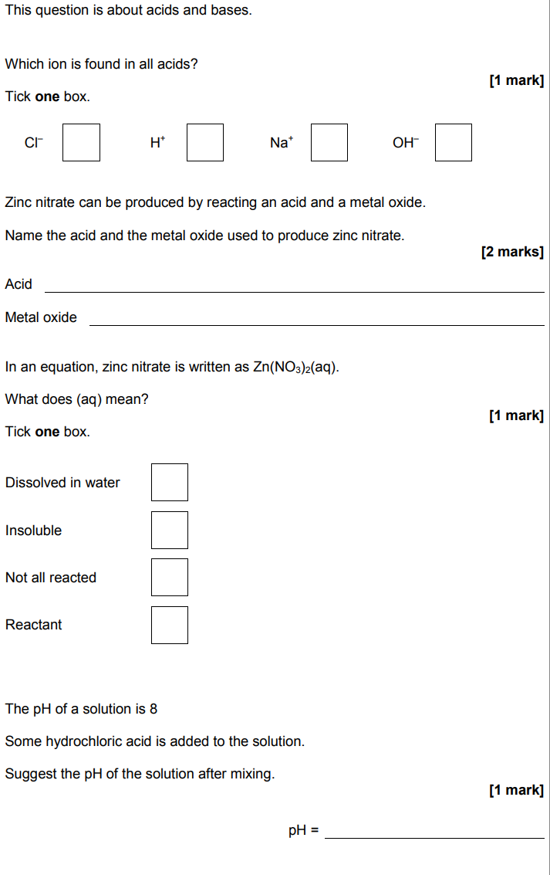

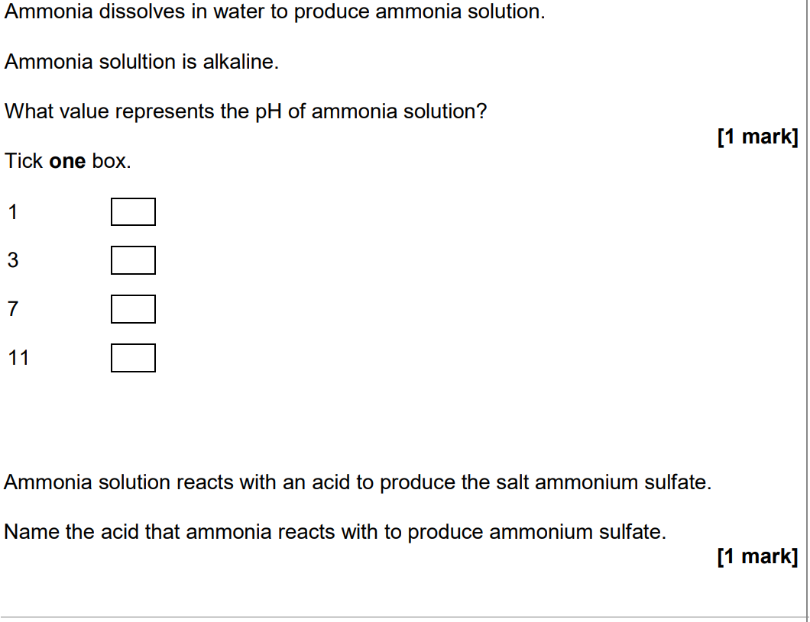
Write a word equation and name the products produced for the following reactions.

- Hydrochloric acid + copper oxide

____________________ + _______________ ___________________ + ___________

- Nitric acid + Iron

____________________ + _______________ ___________________ + ___________

- Sulphuric acid + Sodium Carbonate
_______________ + ____________________ ____________________ + __________ + _________________
(6 marks)

