Name: _______________________
Teacher: _____________________
Set: _________________________

GCSE Biology (Triple)
Last-Minute Checks Revision Guide

Foundation

B1
Eukaryotes are cells which have a nucleus; the main two types of eukaryotes are animal and plant cells.
Organelle | Function | Animal Cell | Plant Cell
Nucleus | Controls the cell (and holds the DNA) | Y | Y
Cytoplasm | Site of chemical reactions | Y | Y
Cell Membrane | Controls what enters and leaves the cell | Y | Y
Mitochondria | Supplies energy and the site of aerobic respiration | Y | Y
Ribosomes | Site of protein synthesis | Y | Y
Cell Wall | Provides structure and support (made of cellulose) |  | Y
Vacuole | Provides structure and support (and stores sugar) |  | Y
Chloroplasts | Where photosynthesis happens. |  | Y
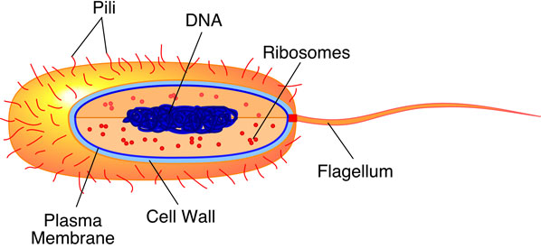
Prokaryotic Cells
An example of a prokaryotic cell is a bacterium; they share somethings in common with a eukaryote but also have differences:
Differences:
- Prokaryotes do not have a nucleus.
- Prokaryotes always have a cell wall.
- DNA is not in the nucleus; it sits in circular chromosomes in the cytoplasm.
- They sometimes have a flagellum to help it to move.
- They are always single-celled organisms.

Specialised Cells
Sperm Cell | Many mitochondria to supply energy. Tail to help it swim towards the egg.
Nerve Cell | Long to transmit electrical impulses across a distance.
Muscle Cell | Contain protein fibres that contract when energy is available, making the cells shorter.
Root Hair Cell | Long extension to provide a large surface area for water & mineral absorption - thin cell wall.
Xylem Cell | Cells are hollow to allow water through; contain spirals of lignin to provide structure and support.
Phloem Cell | Companion cells (next to the phloem) have a lot of mitochondria to supply energy for active transport. End plates between the phloem have broken down to form sieve plates for a continuous flow of sugar.

Cellular Transport
- Diffusion is the movement of particles from an area of high to low concentration. Example – gas exchange in the alveoli.
- Osmosis is the movement of water from an area of high to low concentration, through a partially permeable membrane. Example – water moving into the root hair cell from the soil.
- Active transport is the movement of particles against the concentration gradient from an area of low to high concentration, which requires energy from respiration. Example – the movement of mineral ions into the roots from the soil.
Exchange Surface
Efficient exchange surfaces have the following:
- Having a large surface area – achieved by having a folded surface.
- A thin membrane (one-cell thick), to provide a short diffusion distance.
- (in animals) having an efficient blood supply due to an extensive capillary network (provides a steep concentration gradient)
- (in animals, for gaseous exchange) being ventilated to maintain a steep concentration gradient.

B1 - Quick-Fire Questions
Cover the knowledge on the previous page to check your understanding of these simple questions; then look back to mark and correct your work
1 | In which organelle does aerobic respiration occur?
2 | Name one difference between a prokaryotic and eukaryotic cell.
3 | State how a muscle cell is adapted to its function.
4 | Diffusion is the movement of particles from a _______ to ________ concentration.
5 | In which organelle does protein synthesis occur?
6 | State one adaptation of an exchange surface
7 | Give an example of active transport in a plant.
8 | State how the xylem is adapted to its function.
9 | State three organelles found only in a plant cell.
10 | Osmosis is the movement of water from an area of high to low concentration, through a ____________

B1 – Exam Questions

Q1. Living organisms are made of cells.
(a) Animal and plant cells have several parts. Each part has a different function.
Draw one line from each cell part to the correct function of that part.
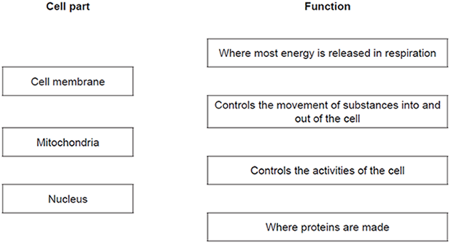
(3)

(b) The diagram below shows a cell from a plant leaf.
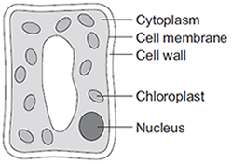
Which two parts in the diagram above are not found in an animal cell?
1. _________________________________________________________________
2. _________________________________________________________________
(2)
(Total 5 marks)
Q2. Plant roots absorb water from the soil by osmosis.
(a) What is osmosis?
___________________________________________________________________
___________________________________________________________________
___________________________________________________________________
___________________________________________________________________
___________________________________________________________________
___________________________________________________________________
(3)
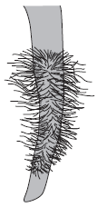
(b) The image below shows part of a plant root.
The plant root is adapted for absorbing water from the soil.
Use information from the diagram to explain how this plant root is adapted for absorbing water.
______________________________________________________________
______________________________________________________________
______________________________________________________________
______________________________________________________________
___________________________________________________________________
___________________________________________________________________
(3)
(Total 6 marks)

Mark scheme on page 41
B2
Each cell in the human body has a nucleus with 46 chromosomes (or 23 pairs). It’s essential that our cells divide for:
- Growth
- Replace old and damaged cells.
- Reproduction.
There are two types of cell division; mitosis and meiosis (must be spelt correctly). Mitosis is a type of division which produces genetically identical cells with 46 chromosomes. Meiosis is a topic in Paper 2.
Mitosis
Cells divide in a series of stages called the cell cycle. During the cell cycle the genetic material is doubled and then divided into two identical cells.
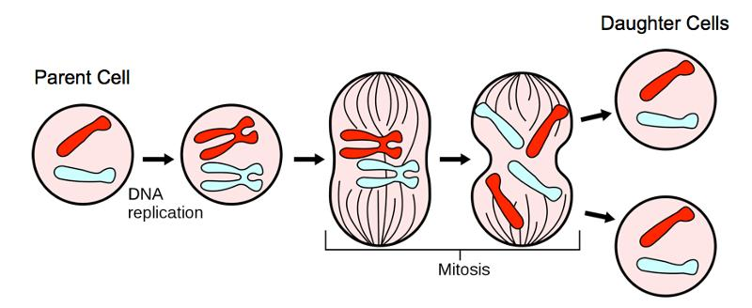
Stage 1: Organelles (e.g. – ribosomes) all double and the DNA replicates to form two copies of each chromosome.

Stage 2: One set of chromosomes is pulled to each end of the cell and the nucleus divides.

Stage 3: Finally, the cytoplasm and cell membranes divide (cytokinesis) to form two identical cells.

Stem Cells
A stem cell is an unspecialised cell that can become any other type of cell. Stem cells can be obtained from embryos, umbilical cords and adult bone marrow.
It is hoped that stem cells could be used to make new nerve cells that could then be implanted into patients suffering from paralysis. They are also hoped to be able to treat diabetes.

Embryonic stem cells are very useful as they can turn into any type of cell, however, people are against the use of them due to the fact that they kill future life (embryos) and they can turn into cancerous cells.
Adult stem cells have fewer ethical dilemmas as humans can give their consent, however adult stem cells are not as useful as they can only turn into a few types of cell.

Stem cells differentiate to form specialised cells, such as: sperm cells, muscle cells, xylem, etc.

Therapeutic Cloning
In therapeutic cloning, an embryo is made with the same DNA as the patient. This means that stem cells from the embryo will not be rejected by the patient’s body, so they can be used as a medical treatment.

B2 - Quick-Fire Questions
Cover the knowledge on the previous page to check your understanding of these simple questions; then look back to mark and correct your work
1 | Define what a stem cell is.
2 | State two diseases stem cells can treat.
3 | Which type of cell division makes identical cells.
4 | What occurs in stage 1 of the cell cycle?
5 | In which stage does the nucleus divide?
6 | What does differentiate mean?
7 | State one reason people are against the use of embryonic stem cells.
8 | State one reason people are for the use of embryonic stem cells.
9 | State why embryonic stem cells are preferred to adult
10 | State one benefit of therapeutic cloning.

B2 – Exam Questions
Q1. Cells divide in a series of stages called the cell cycle.
Stage 2 of the cycle is mitosis.
The diagram below shows a simplified cell cycle for a human body cell.
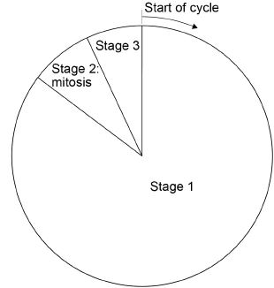
(a) Draw one line from each stage in the cell cycle to what happens during that stage.

Stage in the cell cycle |  | What happens during that stage
Stage 1 |  | Nucleus divides
Stage 2 |  | Cell divides into two
Stage 3 |  | Copies of the DNA are made
(2)
(b) The mass of DNA in a human body cell at the start of the cell cycle is 6 picograms.
What mass of DNA will be in each of the new cells produced by this cell division?
Tick one box.

3 picograms
6 picograms
9 picograms
12 picograms
(1)
(c) Stem cells are undifferentiated cells.
Which statement about stem cells is correct?
Tick one box.

Animal stem cells are found in meristems
Animal stem cells divide by meiosis
Meristem cells in plants can differentiate throughout the life of the plant
Meristem cells in plants can only differentiate into one type of cell
(1)
Stem cells from human embryos can differentiate into most types of human cell.
Research is being done into the use of embryonic stem cells in medical treatments.
The long-term effects of using embryonic stem cells in patients are not well understood.
In therapeutic cloning, human embryos are produced using a donated human egg cell and a cell from the patient.
• The embryo produced contains the same genetic information as the patient.
• Stem cells are taken from the embryo and stimulated to divide to form cells the patient needs.
• The embryo is then destroyed.
(d) Suggest two advantages of therapeutic cloning.
1. _________________________________________________________________
___________________________________________________________________
2. _________________________________________________________________
___________________________________________________________________
(2)
(e) Suggest two disadvantages of therapeutic cloning.
1. _________________________________________________________________
___________________________________________________________________
2. _________________________________________________________________
___________________________________________________________________
(2)
(Total 8 marks)
Q2. The diagram shows how cells from human embryos can be used to grow ‘replacement body parts’ for humans.
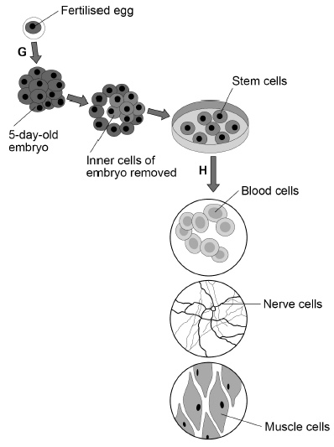

(a) How many chromosomes are in a fertilised human egg?
Tick one box.

12 |  | 23 |  | 46 |  | 92
(1)
(b) What is the process labelled G?
Tick one box.

Fertilisation |  | Meiosis
Inheritance |  | Mitosis
(1)
(c) When the embryo is three days old, it contains eight cells.
How many times has the fertilised egg cell divided by day three?
Tick one box.

2 |  | 3 |  | 4 |  | 8
(1)
(d) Stem cells become specialised in the process labelled H in the diagram.
What is the process labelled H?
Tick one box.

Differentiation |  | Genetic modification
Evolution |  | Selective breeding
(1)
(e) Which two parts would be found in all the cells in the diagram. Tick two boxes.

Cell membrane |  | Cytoplasm
Cell wall |  | Plasmids
Chloroplasts
(2)
(f) Why might stem cells from human embryos be more useful than stem cells from adults?
___________________________________________________________________
___________________________________________________________________
(1)
(g) Some parents have stem cells from the umbilical cord of their baby collected and stored.
These stem cells can be used to treat diseases in the child later in life.
Why might stem cells from their own umbilical cord be used rather than stem cells from another embryo?
Tick one box.

Less risk of rejection of umbilical cord stem cells.
Stem cells from another embryo can treat more diseases.
Umbilical cord stem cells are older.
(1)
(h) Some medical uses of stem cells are still experimental.
Why do some scientists have concerns about the use of stem cells?
___________________________________________________________________
___________________________________________________________________
(1)
(i) Some people object to the use of embryonic stem cells because of religious beliefs.
Give one other ethical concern about the use of embryonic stem cells?
___________________________________________________________________
___________________________________________________________________
(1)
(Total 10 marks)

Mark scheme on page 42

B3
Tissue – a group of similar cells working together to perform the same function.
Organ – a group of tissues working together to perform the same function.
Organ system – a group of organs working together to perform the same function.

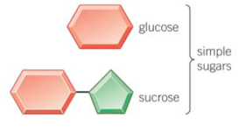
Carbohydrates
Glucose
Test: Heat with benedict’s, will turn from blue to orange.

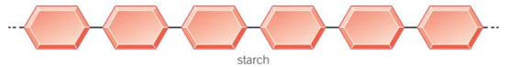
Starch
Starch is made of glucose.
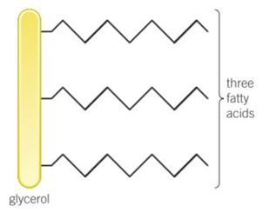
Broken down by the enzyme amylase (salivary glands and pancreas)
Test: add iodine, will turn from brown to blue/black.

Lipids (fats)
Made of x1 glycerol and x3 fatty acid chains.
Broken down by the enzyme lipase (pancreas, stomach and small intestine)
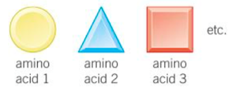
Test: Shake with ethanol, will turn from clear to cloudy white.

Protein
Made of a chain of amino acids.
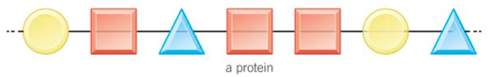
Broken down by the enzyme protease (pancreas and small intestine)
Test: Add biuret solution, will turn from blue to purple.

Enzymes
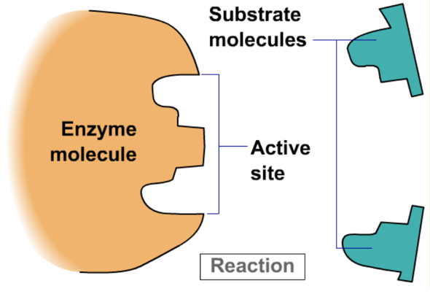
An enzyme is a protein which acts as a biological catalyst which increases the rate of reaction without being used up or changed in the process.

Each enzyme will only speed up one reaction as the shape of the enzyme molecule needs to match the shape of the substrate molecule (it must have a complimentary fit). This is called the ‘lock and key hypothesis’.
The part of the enzyme molecule which matches to a substrate is called the active site.

The rate at which an enzyme works depends on many factors, including the temperature and the pH.
If conditions stray too far from the enzymes optimum conditions the protein strands which make up the enzyme will denature, the active site will change shape and the enzyme and substrate will no longer have a complimentary fit.
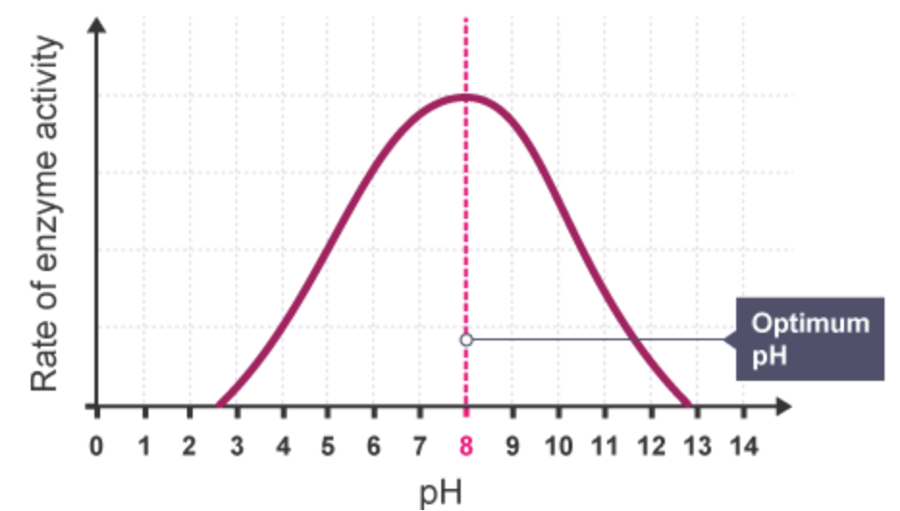
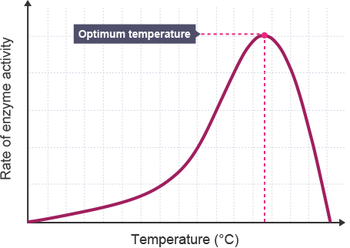
B3 - Quick-Fire Questions
Cover the knowledge on the previous page to check your understanding of these simple questions; then look back to mark and correct your work
1 | Define the term ‘tissue’
2 | State how to test for glucose.
3 | Describe the structure of a lipid.
4 | In which organ are all enzymes made?
5 | Which part of an enzyme has a specific shape?
6 | State what occurs to an enzyme if the pH changes.
7 | State the colour change for a protein food test.
8 | Enzymes and substrates have a __________ fit.
9 | The optimum temp. of enzymes in the human body is:
10 | Where does digestion of starch begin?

B3 – Exam Questions
Q1. The diagram below shows the human digestive system.
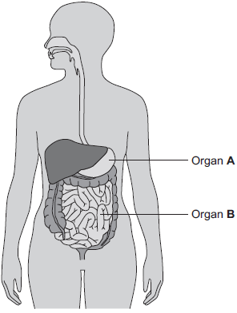
(a) (i) What is Organ A?
Draw a ring around the correct answer.
gall bladder liver stomach
(1)
(ii) What is Organ B?
Draw a ring around the correct answer.
large intestine pancreas small intestine
(1)
(b) Digestive enzymes are made by different organs in the digestive system.
Complete the table below putting a tick (✓) or cross (✕) in the boxes.
The first row has been done for you.

 |  | Organ producing enzyme
 |  | salivary glands | stomach | pancreas | small intestine
Enzyme | amylase | ✓ | ✕ | ✓ | ✓
 | lipase
 | protease
(2)
(c) The stomach also makes hydrochloric acid.
How does the acid help digestion?
___________________________________________________________________
___________________________________________________________________
(1)
(d) Draw one line from each digestive enzyme to the correct breakdown product.

Digestive enzyme |  | Breakdown products
 |  | amino acids.
Amylase breaks down starch into……
 |  | bases.
Lipase breaks down fats into…
 |  | fatty acids and glycerol.
Protease breaks down proteins into…
 |  | sugars.
(3)
(Total 8 marks)

Q2. Bread contains starch, protein and fat.
(a) Complete each sentence by choosing the correct words from the box.

amino acids | protein
fat | starch
fatty acids | sugar
Amylase speeds up the digestion of _________________ . The product of this
digestion is _____________ . Protease speeds up the digestion of _____________ .
The product of this digestion is _______________________ .
(4)
(b) Why do molecules of starch, protein and fat need to be digested?
______________________________________________________________
______________________________________________________________
(2)
(c) In which part of the digestive system does the digestion of starch begin?
Draw a ring around your answer.
large intestine mouth small intestine stomach
(1)
(d) What do we call substances like amylase and protease which speed up chemical reactions?
______________________________________________________________
(1)
(Total 8 marks)

Mark scheme on page 44

B4
Components of the Blood
Red blood cells – carry oxygen around the body. Contains the red pigment haemoglobin.
White blood cells – defends the body from pathogens.
Platelets – Cause the blood clot.
Plasms – Transports waste products around the body, e.g – carbon dioxide, urea.

Vessel | Where | Adaptation
Artery | Away from heart (a-away) | Thick muscular, elastic walls to withstand the high pressure blood (to prevent bursting).
Vein | To the heart, from the body. | Thin walls, wide lumen. Have valves to prevent backflow.
Capillary | Exchanges of materials at tissues | One cell thick for a short diffusion distance and large surface area.
Blood Vessels

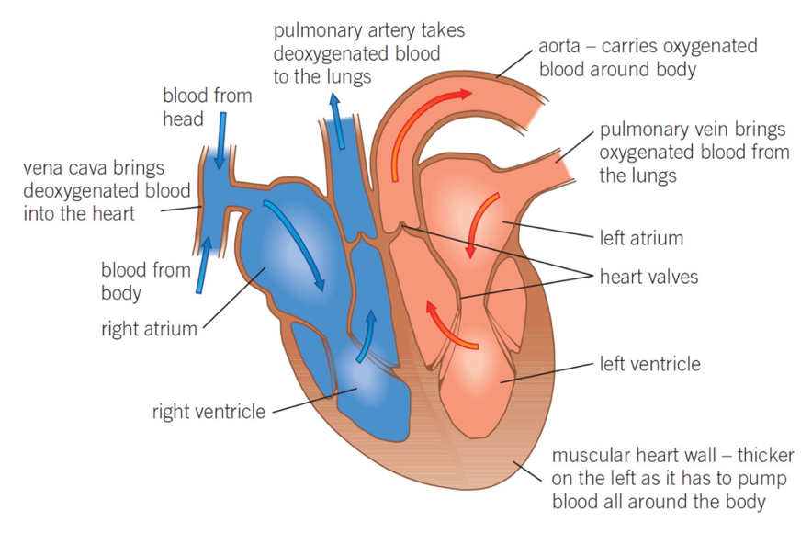
The Heart
It’s important that you know the labels for the heart.
The heart is called a double pump, as the left side pumps it to the body whereas the right side pumps it to the lungs.
The left ventricle wall is much thicker than the right as it has to pump the blood a longer distance.

Coronary Heart Disease
CHD is where cholesterol builds up in the coronary artery (on the surface of the heart). This causes a reduction in blood flow, therefore there is a reduced amount of oxygen available to the heart. This results in reduced respiration and less energy for muscle contraction – if left to build up it can cause a heart attack.

Treatments for CHD
- Statins: These are drugs which help to lower cholesterol in the blood. They do this by lowering its production in the liver. Negatives: They need to be taken every day and there are many side effects. Positives: You don’t need an operation.
- Stent: Mesh cylinder which is inserted into the artery to widen it, to restore blood blow. Negatives: Risk from infection after the operation. Positives: Short recovery time and only has to be done once.
Waxy Cuticle – this is transparent to maximise the amount of light passing through to the leaf. Its waxy texture also allows water to run off the leaf and to the roots.
Palisade – packed full of chloroplasts (contain chlorophyll) for absorption of sunlight; close to the surface of the leaf, packed together
Spongy Mesophyll – contains air spaces to ensure efficient gaseous exchange between carbon dioxide and oxygen.
Stoma – small pores on the underside of the leaf which open and close to allow gases to enter and leave the leaf and water vapour to leave.
Guard Cells – these cells control the opening and closing of the stomata.
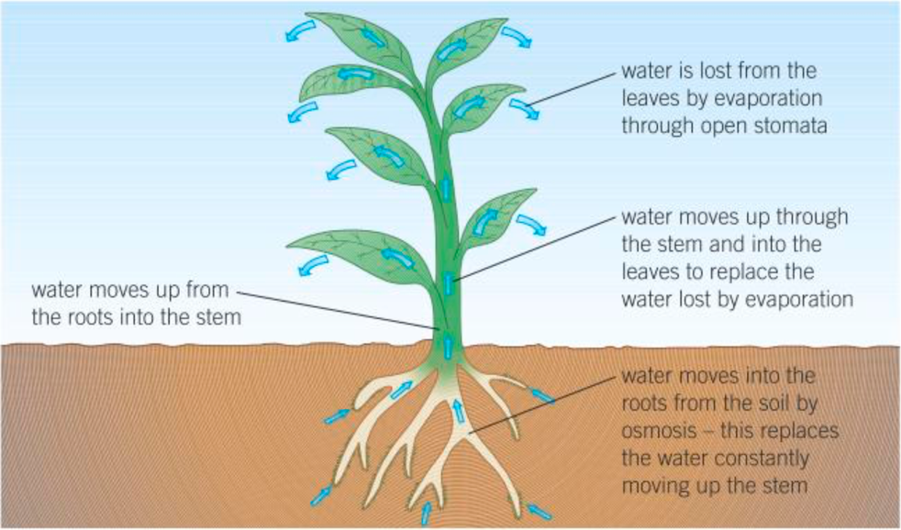
Transpiration: the evaporation of water from a leaf, out of the stomata.

Transpiration stream: the constant movement of water molecules through the xylem from the root to the leaves.

Things which effect the rate of transpiration:
- Temperature (increase)
- Humidity (decrease)
- Wind (increase)
- Light (increase)

Translocation: the movement of sugars up and down the phloem. This moves sugars from where they’re made in the leaves to where they’re stored in the roots. In the winter, the sugars are moved from the roots to the leaves when they’re needed.

B4 - Quick-Fire Questions
Cover the knowledge on the previous page to check your understanding of these simple questions; then look back to mark and correct your work
1 | What is the function of the plasma?
2 | Why does the artery have thick walls?
3 | Which chamber of the hear has thickest walls?
4 | Which blood vessels takes blood to the lungs?
5 | Where in the body is the coronary artery?
6 | What builds up in this artery to cause CHD?
7 | State one way a palisade cell is adapted to its function
8 | What is transpiration?
9 | State the factor which decreases transpiration.
10 | Why is translocation important to a plant?

B4 – Exam Questions
Q1. (a) (i) Blood is part of the circulatory system. Draw one line from each part of the blood to its correct function.
Part of the blood |  | Function
carry glucose around
the body
White blood cells
carry oxygen around
the body
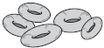
Red blood cells
 |  | help the blood to clot
Platelets
destroy
microorganisms
(3)
(ii) Name one waste product that is transported by the blood plasma.
______________________________________________________________
(1)
(b) The heart is also part of the circulatory system.
Figure 1 shows a section through the human heart.
Figure 1
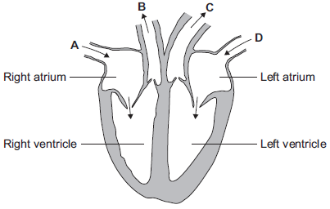
(i) Which arrow, A, B, C or D, shows blood leaving the heart in the pulmonary artery to go to the lungs?
(1)
(ii) Which arrow, A, B, C or D, shows blood from the lungs entering the heart in the pulmonary vein?
(1)
(iii) Valves in the circulatory system make sure blood only travels in one direction.
Name the type of blood vessel that has valves.
______________________________________________________________
(1)
(c) A person’s coronary artery has become narrower.
The person has a heart attack. A doctor puts a stent into the person’s coronary artery. Figure 2 shows a stent inside a coronary artery.
Figure 2
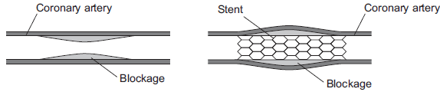
(i) How does the stent help to prevent another heart attack?
Give one way.
______________________________________________________________
______________________________________________________________
(1)
(ii) Figure 3 shows a surgeon putting a stent into a patient.
Figure 3
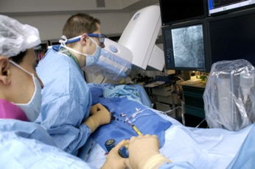
© Science Photo Library
The surgeon puts the stent into an artery in the leg. He moves the stent through the artery to the coronary artery.
Suggest two possible risks of this operation.
1. ____________________________________________________________
______________________________________________________________
2. ____________________________________________________________
______________________________________________________________
(2)
(Total 10 marks)

Q2. Some students used the apparatus shown in the diagram to measure the rate of water uptake by a plant cutting.
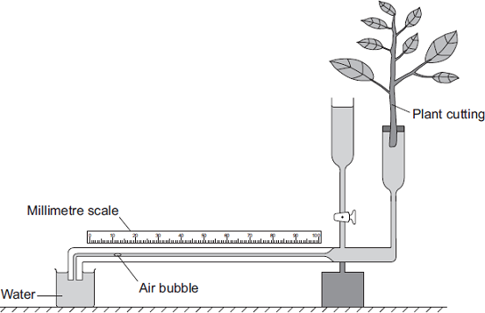
The students set up the apparatus in three different conditions:
• no wind at 15°C
• no wind at 25°C
• wind at 25°C
For each experiment, the students recorded the movement of the air bubble along the scale.
(a) (i) Name the two variables the students chose to change in these experiments.
1. ____________________________________________________________
2. ____________________________________________________________
(2)
(ii) It was important to use the same plant cutting each time to make these experiments fair.
Explain why.
______________________________________________________________
______________________________________________________________
(1)
(b) The graph shows the students’ results.
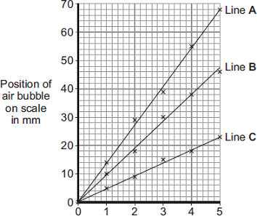
Time in minutes
Which line on the graph, A, B or C, shows the results for each of the three different experiments?
Write each of the letters, A, B and C, in the correct boxes in the table.

Conditions | Letter
No wind at 15°C
No wind at 25°C
Wind at 25°C
(2)
(c) Water is lost from the leaves of the plant cutting.
Name this process.
Draw a ring around one answer.

distillation | respiration | transpiration
(1)
(Total 6 marks)

Mark scheme on page 46

B5
Pathogens: bacteria, virus, fungi, protist.

Virus: viruses make us ill by damaging/destroying our cells. They are small so go inside the cell, replicate thousands of times until the cell burst.
Bacteria: bacteria secrete toxins to make us ill. They are large and so sit on top of cells, this means that they can be destroyed by antibiotics.

Disease | Symptoms | Spread by
Salmonella | Fever, stomach cramps, vomiting, diarrhoea | Eating contaminated food | B
Gonorrhoea | Pain when urinating, yellow / green discharge from penis / vagina | STD – sexual contact | B
Measles | Red rash, fever, can lead to pneumonia or encephalitis (brain infection) | Droplets from an infected sneeze or cough | V
HIV | Flu-like, attacks immune cells | Sexual contact, or sharing bodily fluids | V
Tobacco Mosaic Virus (TMV) | A mosaic pattern on leaves and discolouration – leads to less photosynthesis | Plant contact, | V
Rose black spot | Black or purple spots meaning photosynthesis can’t be carried out, so stunted growth. | Water or by wind | F
Malaria | Repeating episodes or fever. Can be fatal | Vectors – mosquitos | P

Human Defence:
- Skin – makes a scab if cut to prevent infection, produces antimicrobial secretions to kill pathogens.
- Nose – hairs and mucus trap pathogens and prevents them entering the body.
- Trachea – cilia (small hairs) line the trachea and waft mucus to the back of the throat, where it’s swallowed or removed.
- Stomach – contains hydrochloric acid (pH2) which destroys pathogens which are swallowed.

White Blood Cells:
WBCs form a key part of the immune system and they have three different roles:
- Lymphocytes – make Y-shaped antibodies which have a complimentary fit to antigens on the surface of pathogens. Once the antibodies bind to the antigen it can no longer cause harm.
- Phagocytes – engulf and destroy pathogens (phagocytosis)
- Antitoxins – releases antitoxins which bind to the toxins released by bacteria, making them no threat.

TRIPLE ONLY:
Plants can be infected by a range of viral, bacterial and fungal pathogens as well as by insects. Plants can be damaged by a range of ion deficiency conditions:
• stunted growth caused by nitrate deficiency
• chlorosis caused by magnesium deficiency.

Plants also have a range of defence responses:
- Physical defence responses: cellulose cell walls, a tough waxy cuticle on leaves and layers of dead cells around stems (bark on trees) which fall off.
- Chemical plant defence responses: they release antibacterial chemicals and poisons to deter herbivores.
- Mechanical adaptations: thorns and hairs deter animals, leaves which droop or curl when touched and mimicry to trick animals.

B5 - Quick-Fire Questions
Cover the knowledge on the previous page to check your understanding of these simple questions; then look back to mark and correct your work
1 | Which pathogen causes salmonella?
2 | Which pathogen causes rose black spot?
3 | State one symptom of gonorrhoea.
4 | State the vector for malaria.
5 | State how bacterial diseases can be treated.
6 | State how the trachea is adapted to prevent infection.
7 | What is phagocytosis?
8 | What is a symptom of nitrate deficiency in plants?
9 | State one physical defence response of a plant.
10 | State one mechanical defence response of a plant.

B5 – Exam Questions
Q1. Figure 1 shows one type of white blood cell.
Figure 1
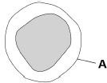
(a) What is structure A?
Tick one box.

Cell membrane |  | Cytoplasm
Cell wall |  | Nucleus
(1)
(b) White blood cells help to defend the body against pathogens.
How do the white blood cells do this? Tick three boxes.

Clone pathogens |  | Produce antibodies
Engulf pathogens |  | Produce antitoxins
Produce antibiotics |  | Produce toxins
(3)
Measles is a serious disease. A person can die from measles.
Figure 2 shows the number of cases of measles in England and Wales between 2012 and 2015
Figure 2
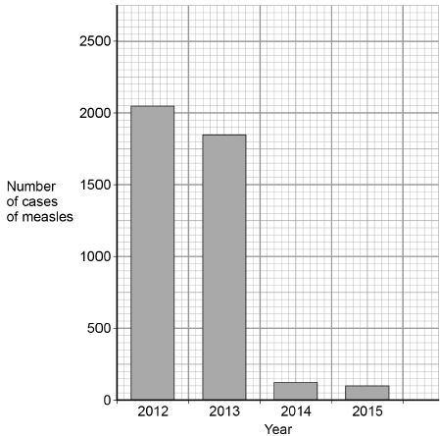
(c) Use Figure 2 to calculate the decrease in the number of cases of measles between 2012 and 2015
___________________________________________________________________
___________________________________________________________________
Answer = ______________________ cases
(2)
(d) Suggest one reason for the decrease in the number of cases of measles between 2012 and 2015
___________________________________________________________________
___________________________________________________________________
(1)
(e) Antibiotics cannot be used to treat measles.
Suggest why.
___________________________________________________________________
___________________________________________________________________
(1)
(f) Gonorrhoea is a disease caused by a bacterium.Gonorrhoea can be treated with antibiotics.
Give one other way to control the spread of gonorrhoea.
___________________________________________________________________
___________________________________________________________________ (1)
(Total 13 marks)
Q2. Some diseases are communicable.
(a) What does communicable disease mean? Tick one box.

A disease that can be spread from one person to another. |  | A disease that is not spread from animals to humans.
A disease that cannot be treated with antibiotics. |  | A disease that is passed on through genes.
(1)
(b) A woman becomes ill and has the following symptoms:
• pain when urinating
• thick yellow discharge from vagina.
Which communicable disease does the woman have?
Tick one box.

Gonorrhoea |  | Measles
HIV |  | Salmonella
(1)
Tuberculosis is a bacterial infection that affects the lungs. Tuberculosis causes severe discomfort.
(c) What type of medicine should be used to kill the tuberculosis bacteria?
___________________________________________________________________
(1)
(d) What type of medicine should be used to treat the symptoms of TB?
___________________________________________________________________
(1)
(e) Describe the ways in which the human body defends itself against the tuberculosis bacterium.
___________________________________________________________________
___________________________________________________________________
___________________________________________________________________
___________________________________________________________________
___________________________________________________________________
________________________________________________________ (4) (Total 8 marks)
Mark scheme on page 48
B6

Vaccinations are dead or weakened form of the pathogen which are injected into the patient, which contain a specific antigen.

This causes the immune system, specifically the white blood cells, to produce complementary antibodies, which target and attach to the antigen. When a white blood cell engulfs and digests a pathogen it is called phagocytosis.

The body will then develop memory cells, so that if the body encounters the same pathogen again it will be able to respond and destroy it before the pathogen can harm us.
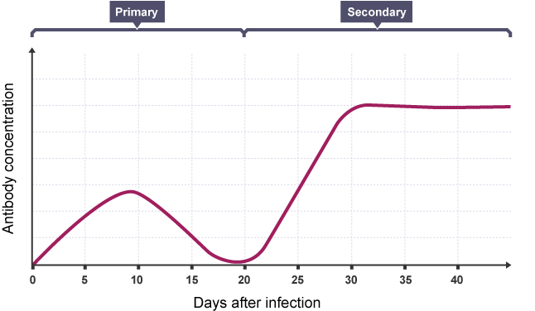
The bodies first exposure to a pathogen is called the primary response. During the primary infection the number of antibodies in the blood increase slowly, peak at around ten days and then gradually decrease.
If the same person is then exposed to the same pathogen again the white blood cells will be able to respond quickly in order to produce lots of the relevant antibodies, which prevents infection. This response is much faster and so destroys the pathogen before any symptoms occur.

Herd Immunity
If 95% of a population have been vaccinated against a disease, we say that the population has reached herd immunity. This means that the 5% of the population who have not been vaccinated are protected from catching the disease, as the change of them coming into contact with someone who is infected is much lower.

Drug Discovery
Many of the drugs which we use today are based on traditional medicines which were extracted from plants and microorganisms. You must know these three examples for your exam:
- The heart drug digitalis originates from foxgloves.
- The painkiller aspirin originates from willow.
- Penicillin was discovered by Alexander Fleming from the Penicillium mould.

Drug Development
Thalidomide is a medical drug that caused unexpected and serious damage to unborn babies in the 1950s and 1960s. Thalidomide was developed as a sleeping pill, but it was also thought to be useful for easing morning sickness in pregnant women. Unfortunately, it had not been tested for use in this way and caused pregnant women to give birth to children with birth defects. Thalidomide is now used as a treatment for leprosy and bone cancer.

Modern Drug Testing (this would be a 6-mark question)
- Test on animals to test for toxicity (does it kill the animal? If so, it will not be used on humans).
- Test on a small number of healthy volunteers at low doses to test for side effects.
- Complete tests on patients with the disease to test for the optimum dosage (how much drug should be given).
- This should be a double-blind trial to reduce bias, where patients are randomly allocated to a group.
- One group should be given a placebo, which is a fake drug.
- All data should be peer reviewed (looked at by someone else), to prevent false claims.

(All underlined points would be on a mark scheme!)

TRIPLE ONLY:
Monoclonal Antibodies

Monoclonal antibodies are produced from a single clone of cells. The antibodies are specific to one binding site on one protein antigen and so are able to target a specific chemical or specific cells in the body.

They are produced by stimulating mouse lymphocytes to make a particular antibody. The lymphocytes are combined with a particular kind of tumour cell to make a cell called a hybridoma cell. The hybridoma cell can both divide and make the antibody.
Single hybridoma cells are cloned to produce many identical cells that all produce the same antibody. A large amount of the antibody can be collected and purified.

Uses of monoclonal antibodies:
- For diagnosis such as in pregnancy tests
- In laboratories to measure the levels of hormones and other chemicals in blood, or to detect pathogens
- In research to locate or identify specific molecules in a cell or tissue by binding to them with a fluorescent dye
- To treat some diseases: for cancer the monoclonal antibody can be bound to a radioactive substance, a toxic drug or a chemical which stops cells growing and dividing. It delivers the substance to the cancer cells without harming other cells in the body.

Monoclonal antibodies create more side effects than expected. They are not yet as widely used as everyone hoped when they were first developed.

B6 - Quick-Fire Questions
Cover the knowledge on the previous page to check your understanding of these simple questions; then look back to mark and correct your work
1 | What is in a vaccine?
2 | What do white blood cells produce after a vaccine?
3 | Which scientist discovered penicillin?
4 | What is thalidomide used for today?
5 | What % need to be vaccinated for herd immunity?
6 | What natural source does aspirin come from?
7 | What natural source does digitalis come from?
8 | What is a placebo?
9 | What is the benefit of peer reviewing drug trial data?
10 | Why do we test on animals before humans?

B6 – Exam Questions

Q1. Polio is a disease caused by a virus. In the UK, children are given polio vaccine to protect them against the disease.
(a) In the sentences below, draw a ring around the correct words in each box.
(i) It is difficult to kill the polio virus inside the body

because the virus | is not affected by drugs  lives inside cells  produces antitoxins
(1)

(ii) The vaccine contains an | active  infective  inactive | form of the polio virus.
(1)
(iii) The vaccine stimulates the white blood cells to

produce | antibiotics  antibodies  drugs | which destroy the virus.
(1)

(b) The graph shows the number of cases of polio in the UK between 1948 and 1968.
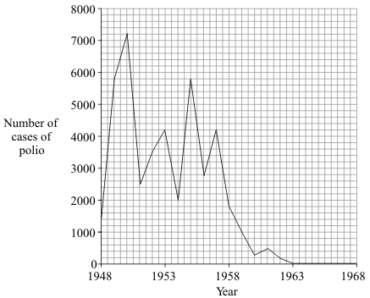
(i) In which year was the number of cases of polio highest?
______________________________________________________________
(1)
(ii) Polio vaccination was first used in the UK in 1955.
How many years did it take for the number of cases of polio to fall to zero?
______________________________________________________________
(1)
(iii) There have been no cases of polio in the UK for many years. But children are still vaccinated against the disease.
Suggest one reason for this.
______________________________________________________________
______________________________________________________________
(1)
(Total 6 marks)
Q2. (i) Give two ways in which white blood cells protect us from disease.
1. _________________________________________________________________
___________________________________________________________________
2. _________________________________________________________________
___________________________________________________________________
(2)

(ii) Explain, as fully as you can, how immunisation protects us from disease.
___________________________________________________________________
___________________________________________________________________
___________________________________________________________________
___________________________________________________________________
___________________________________________________________________
___________________________________________________________________
(3)
(Total 5 marks)

Mark scheme on page 51

B7
A non-communicable disease is one that is not caused by a pathogen and cannot be spread between organisms, e.g. – asthma, arthritis.

- Health is the state of physical and mental well-being.
- Diseases, both communicable and non-communicable, are major causes of ill health. Other factors including diet, stress and life situations may have a profound effect on both physical and mental health.

Different types of disease may interact.
- Defects in the immune system mean that an individual is more likely to suffer from infectious diseases.
- Viruses living in cells can be the trigger for cancers.
- Immune reactions initially caused by a pathogen can trigger allergies such as skin rashes and asthma.
- Severe physical ill health can lead to depression and other mental illness.

Risk factors are anything which increases your likelihood of getting a disease. They can be:
- Aspects of a person’s lifestyle
- Substances in the person’s body or environment.

A causal mechanism is when we can prove when a risk factor causes a disease. Such as:
- The effects of diet, smoking and exercise on cardiovascular disease.
- Obesity as a risk factor for Type 2 diabetes.
- The effect of alcohol on the liver and brain function.
- The effect of smoking on lung disease and lung cancer.
- The effects of smoking and alcohol on unborn babies.
- Carcinogens (anything which increases the risk of developing cancer), including ionising radiation.
Cancer
Cancer occurs as a result of changes in a cell’s DNA which leads to uncontrolled growth and division. There are two types of tumours, benign and malignant.
Benign tumours are growths of abnormal cells which are contained within a membrane (do NOT say cell membrane). Because of this, they do not invade other parts of the body.
Malignant tumour cells are cancers which do not have a membrane. Small clumps of cells break off the tumour and spread to different parts of the body in the blood, where they form secondary tumours.
Scientists have identified lifestyle risk factors for various types of cancer, such as smoking and exposure to ionising radiation (UV rays from the sun, x-rays). There are also genetic risk factors for some cancers.

B7 - Quick-Fire Questions
Cover the knowledge on the previous page to check your understanding of these simple questions; then look back to mark and correct your work
1 | What is a non-communicable disease?
2 | Give an example of a non-communicable disease.
3 | State an example of where two diseases interact.
4 | Give one risk factor for diabetes.
5 | What is a causal mechanism?
6 | What is a carcinogen?
7 | Why does a benign tumour not spread?
8 | How do malignant tumours move around the body?
9 | What is a secondary tumour?
10 | State one risk factor for cancer.

B7 – Exam Questions
Q1. Scientists estimate that about one third of cancers in the UK may be linked to obesity.
Name two diseases linked to obesity.
Do not give cancer as one of your answers.
1. _____________________________________________________________________
2. _____________________________________________________________________
(Total 2 marks)
Q2.The number of people in the UK with tumours is increasing.
(a) (i) Describe how tumours form.
______________________________________________________________
______________________________________________________________
(1)
(ii) Tumours can be malignant or benign.
What is the difference between a malignant tumour and a benign tumour?
______________________________________________________________
______________________________________________________________
(1)
(b) Describe how some tumours may spread to other parts of the body.
___________________________________________________________________
___________________________________________________________________ (1)

(c) People from Northern Europe have fair skin and many people have malignant melanoma skin cancer.
The graph shows how the number of people in the UK with malignant melanoma changed between 1985 and 2008.
The bars on the graph show the number of people in the UK who travelled abroad and the number who took cheap holidays in the sun in 1985 and 2005.
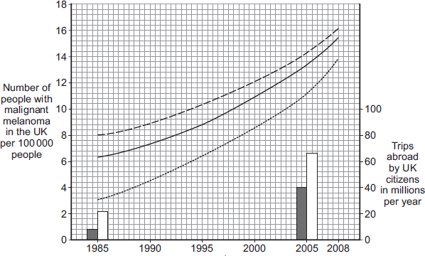
Years

Key
Mean for all areas  Mean for people from rich areas  Mean for people from poor areas | Total number of trips abroad  Number of cheap holidays in  the sun
(i) Describe the trends in the number of people with malignant melanoma skin cancer between 1985 and 2008.
______________________________________________________________
______________________________________________________________
______________________________________________________________
______________________________________________________________ (3)
(ii) Use the data about the number of trips abroad to suggest an explanation for the trends you have described in part (c)(i).
______________________________________________________________
______________________________________________________________
______________________________________________________________
______________________________________________________________ (2)
(Total 8 marks)
Mark scheme on page 52

B8
Photosynthesis is a chemical reaction which allows a plant to produce its own glucose, which it needs for respiration.
Photosynthesis is summarised by the equation:

Carbon dioxide + water glucose + oxygen
6CO₂ + 6H₂O C₆H₁₂O₆ + 6 O₂
During photosynthesis:

Light energy is absorbed by a green substance called chlorophyll, which is found in chloroplasts in some plant cells and algae. This energy is used by converting carbon dioxide (from the air) and water (from the soil) into sugar (glucose), Oxygen is released as a by-product.

Photosynthesis as an endothermic reaction as it takes in energy from the environment (in the form of light).

Rate of photosynthesis
The rate of photosynthesis may be limited by:

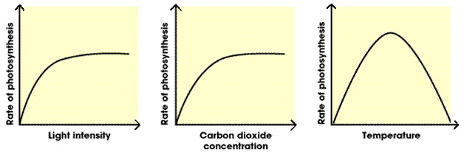
- shortage of light
- low temperature
- shortage of carbon dioxide.

Light, temperature and the availability of carbon dioxide interact and in practice any one of them may be the factor that limits photosynthesis.

Uses of Glucose from Photosynthesis
The glucose produced in photosynthesis may be:
- Used for respiration.
- Converted into insoluble starch for storage.
- Used to produce fat or oil for storage.
- Used to produce cellulose, which strengthens the cell wall.
- Used to produce amino acids for protein synthesis.

B8 - Quick-Fire Questions
Cover the knowledge on the previous page to check your understanding of these simple questions; then look back to mark and correct your work
1 | State the word equation for photosynthesis.
2 | State the balanced symbol equation for photosynthesis.
3 | Where in a plant cell does photosynthesis occur?
4 | What is the role of the green pigment?
5 | Is photosynthesis exothermic or endothermic?
6 | State the by-product of photosynthesis.
7 | State one use of glucose by plants.
8 | State one limiting factor of photosynthesis.
9 | Which type of energy is needed for photosynthesis?
10 | Where does a plant get water from for photosynthesis?

B8 – Exam Questions
Q1. (a) Complete the word equation for photosynthesis.

carbon dioxide + water | energy | glucose + ______
(1)
(b) Draw a ring around the correct answer to complete each sentence.

(i) | The energy needed for photosynthesis comes from | light.  osmosis.  respiration.
(1)

(ii) | Energy is absorbed by a green pigment called | chloride.  chloroplast.  chlorophyll.
(1)

(iii) | If the temperature is decreased the rate of photosynthesis will | decrease.  increase.  stay the same.
(1)

(c) Give three ways in which plants use the glucose made in photosynthesis.
1. _________________________________________________________________
___________________________________________________________________
2. _________________________________________________________________
___________________________________________________________________
3. _________________________________________________________________
___________________________________________________________________
(3)
(Total 7 marks)
Q2. Photosynthesis uses carbon dioxide to make glucose.
(a) (i) Complete the equation for photosynthesis.
carbon dioxide + _____________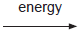 glucose + _____________
(2)
(ii) What type of energy does a plant use in photosynthesis?
______________________________________________________________
(1)
(iii) Which part of a plant cell absorbs the energy needed for photosynthesis?
______________________________________________________________
(1)
(b) The graph shows the effect of the concentration of carbon dioxide on the rate of photosynthesis in tomato plants at 20 °C.
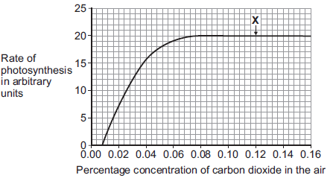
(i) What is the maximum rate of photosynthesis of the tomato plants shown in the graph?
_____________ arbitrary units
(1)
(ii) At point X, carbon dioxide is not a limiting factor of photosynthesis.
Suggest one factor that is limiting the rate of photosynthesis at point X.
______________________________________________________________
(1)
(c) A farmer plans to grow tomatoes in a large greenhouse.
The concentration of carbon dioxide in the atmosphere is 0.04%.
The farmer adds carbon dioxide to the greenhouse so that its concentration is 0.08%.
(i) Why does the farmer use 0.08% carbon dioxide?
Tick () one box.

To increase the rate of growth of the tomato plants
To increase the rate of respiration of the tomato plants
To increase water uptake by the tomato plants
(1)
(ii) Why does the farmer not use a concentration of carbon dioxide higher than 0.08%?
Tick () two boxes.

Because it would cost more money than using 0.08%
Because it would decrease the temperature of the greenhouse
Because it would not increase the rate of photosynthesis of the
tomato plants any further
Because it would increase water loss from the tomato plants
(2)
(Total 9 marks)
Mark scheme on page 53

B9

Cellular respiration is an exothermic reaction (gives out energy) which is continuously occurring in all living cells 24/7 (plants and animals). The energy transferred supplies all the energy needed for living processes.

Organisms need energy for:
- chemical reactions to build larger molecules
- movement
- keeping warm.

Aerobic Respiration
Aerobic respiration is the type of respiration which uses oxygen to create a large amount of energy per glucose molecule; this occurs in the mitochondria. We say that the glucose has been fully oxidised.

Aerobic respiration is represented by the equation:

Glucose + oxygen carbon dioxide + water
C₆H₁₂O₆ + 6O₂ 6CO₂ + 6H₂O

Anaerobic respiration
This type of respiration does not use oxygen and it happens in the cytoplasm of cells. This type of respiration is the least preferred type of respiration as the oxidation of glucose is incomplete so there is much less energy transferred than in aerobic respiration.

Anaerobic respiration in muscles is represented by the equation:

Glucose lactic acid

Anaerobic respiration in yeast cells is called fermentation and has economic importance in the manufacture of bread (CO₂ causes the bread to rise) and alcoholic drinks (ethanol). The equation for fermentation is represented by:
Glucose carbon dioxide + ethanol

Response to exercise
During exercise the human body needs more energy for muscle contraction. To accommodate this the heart rate, breathing rate and breath volume increase during exercise to supply the muscles with more oxygenated blood. This means that the cells can aerobically respire more to supply the energy needed for muscle contraction.

If insufficient oxygen is supplied anaerobic respiration takes place in muscles. The incomplete oxidation of glucose causes a build-up of lactic acid and creates an oxygen debt. During long periods of vigorous activity muscles become fatigued and stop contracting efficiently.

Blood flowing through the muscles transports the lactic acid to the liver where it is converted back into glucose. The oxygen debt is the amount of extra oxygen the body needs after exercise to react with the lactic acid and remove it from the cells.

Metabolism
Metabolism is the sum of all the reactions in a cell or the body.
The energy transferred by respiration in cells is used by the organism for the continual enzyme controlled processes of metabolism that synthesise new molecules.
Metabolism includes:
- Conversion of glucose to starch, glycogen and cellulose
- The formation of lipid molecules from a molecule of glycerol and three molecules of fatty acids
- The use of glucose and nitrate ions to form amino acids which in turn are used to synthesise proteins
- Respiration
- Breakdown of excess proteins to form urea for excretion.

B9 - Quick-Fire Questions
Cover the knowledge on the previous page to check your understanding of these simple questions; then look back to mark and correct your work
1 | State the word equation for aerobic respiration.
2 | State the balanced symbol equation for aerobic respiration.
3 | Where in the cell does aerobic respiration occur?
4 | State the word equation for anaerobic respiration.
5 | Where in the cell does anaerobic respiration occur?
6 | Which type of respiration produces more energy?
7 | What is the name of anaerobic respiration in yeast?
8 | State the importance of this process to the economy.
9 | What is metabolism?
10 | Give an example of a metabolic reaction.

B9 – Exam Questions
Q1. Respiration can happen aerobically or anaerobically. Respiration transfers energy from glucose.
(a) Draw one line from each type of respiration in human cells to the correct information.

Type of respiration  in human cells |  | Information
 |  | Produces ethanol
Aerobic respiration |  | Uses oxygen
Anaerobic respiration |  | Uses carbon dioxide
 |  | Produces lactic acid
(2)
(b) The table below shows the amount of energy released by aerobic and anaerobic respiration.

Energy in kJ transferred
from 1 g of glucose
Aerobic respiration | 16.1
Anaerobic respiration | 1.2
Suggest why human cells might respire anaerobically, even though only a small amount of energy is transferred.
___________________________________________________________________
___________________________________________________________________
(1)
(c) Yeast is used in the brewing and baking industries.
Why is yeast used in these industries?
___________________________________________________________________
___________________________________________________________________
___________________________________________________________________
___________________________________________________________________
___________________________________________________________________
___________________________________________________________________
___________________________________________________________________
___________________________________________________________________
(4)
(Total 7 marks)
Q2. One type of training exercise involves alternating periods of walking and running.
The graph shows how an athlete’s heart rate changed during one 30-minute training session.
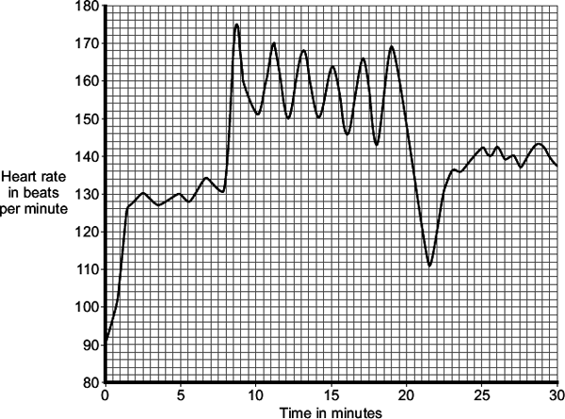
(a) (i) The athlete ran 6 times during the 30-minute training session.
Describe the evidence for this in the graph.
______________________________________________________________
______________________________________________________________
(1)
(ii) Immediately after the final run, the athlete rested for a short time before he started to walk again.
For how many minutes did this rest last?
____________________ minutes
(1)
(b) The heart rate increases during exercise.
This increase in heart rate increases blood flow to the muscles.
Explain, as fully as you can, why this increase in heart rate is necessary.
___________________________________________________________________
___________________________________________________________________
___________________________________________________________________
___________________________________________________________________
___________________________________________________________________
___________________________________________________________________
___________________________________________________________________
___________________________________________________________________
___________________________________________________________________
___________________________________________________________________
(4)
(Total 6 marks)

Mark scheme on page 54

B1 - Mark Scheme
Q1.
(a) 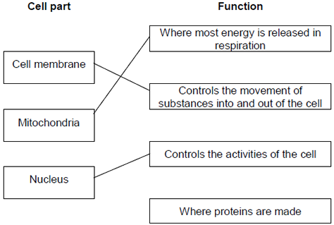
extra lines cancel
3
(b) Cell wall
in either order
1
Chloroplast
allow (permanent) vacuole
1
[5]
Q2. (a) any three from:
• (water through a) partially permeable
accept ‘semi permeable’ / selectively permeable
• membrane
• from dilute to (more) concentrated solution
allow ‘from a high concentration of water to a lower concentration (of water)’
allow ‘from high water potential to low water potential’
allow ‘down a concentration gradient of water’
do not accept ‘along a concentration gradient of water’
• (it‘s a) passive (process)
allow requires no energy
3
(b) (there are) many hairs or thin hairs or hairs are one cell thick
1
(which gives) large / increased surface area or short diffusion pathway
1
(so there is) more diffusion / osmosis (of water into the root)
ignore absorption
1
[6]
B2 – Mark Scheme
Q1. (a)
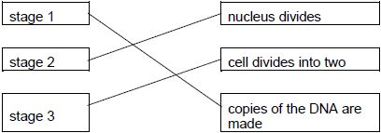
allow 1 mark for 1 or 2 correct
credit can be given where students have matched the boxes correctly, for example numbering the boxes
2
(b) 6 picograms
1
(c) meristem cells in plants can differentiate throughout the life of the plant
1
(d) any two from:
• may cure / treat diseases
or
cure medical conditions
or
produce replacement cells / tissues / organs
allow example e.g. diabetes / paralysis
allow cells can be stored for future use
ignore used in medical treatments
ignore patient makes / grows cells / tissues / organs
• cells unlikely to be rejected by patient)
ignore same genetic information
• cells / tissues of any type can be produced
ignore differentiated into most types of cells
• many cells produced
• cells produced could be used for research
• would reduce waiting time for transplants
2
ignore references to cost
ignore all reference to producing babies / IVF
(e) any two from:
• (potential) life is killed / destroyed
allow embryo is killed
ignore embryo is destroyed
ignore embryo is a life / becomes a baby
• shortage of donors / eggs
• egg donation / collection has risks
• do not yet know risks / side effects of the procedure on the patient
ignore long term effects are not well understood
allow may cause tumours / cancer
• may transfer (viral) infection
• poor success rate
allow in terms of viable egg / embryo / cell / tissue / organ production
2
ignore references to cost
ignore unethical unqualified
Ignore reference to religion / beliefs
[8]
Q2. (a) 46
1
(b) mitosis
1
(c) 3
1
(d) differentiation
1
(e) cell membrane
1
cytoplasm
1
(f) (stem cells from embryos) can become more types of cell
allow converse
allow (stem cells from embryos) are pluripotent
1
(g) less risk of rejection of umbilical cord stem cells
1
(h) could cause cancer
1
(i) any one from:
• embryos are created (for this purpose)
• embryos are destroyed
• the embryos do not develop into a foetus / child
ignore religious objections
1

B3 - Mark Scheme
Q1.(a) (i) stomach
1
(ii) small intestine
1
(b)

 | salivary glands | stomach | pancreas | small intestine
amylase | ✓ | ✕ | ✓ | ✓
lipase | ✕ | ✕ | ✓ | ✓
protease | ✕ | ✓ | ✓ | ✓
1 mark per correct row
or
if no correct row max 1 mark for any one correct column
2
(c) enzyme / protease / pepsin most effective in acid conditions / low pH
accept optimum / correct pH
do not accept ref to incorrectly named enzymes
ignore killing bacteria
ignore acid breaks down food
1
(d) Enzyme Breakdown products
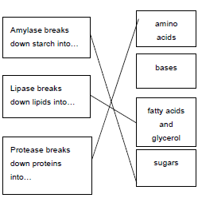
3
[8]
Q2.(a) in sequence
starch
1
sugar
1
protein
1
amino acids
1
(b) (too) large or insoluble
do not accept “breaking up”
do not accept complex
accept ‘need to make molecules
smaller / soluble’ – reverse argument
1
cannot be absorbed or
cannot enter blood or
cannot pass through wall / lining of
intestine / gut or villi
“body” not enough
not large intestine
1
(c) mouth
accept positive indication
1
(d) enzymes
allow catalysts
do not accept catalase
1
[8]

B4 - Mark Scheme
Q1. (a) (i)
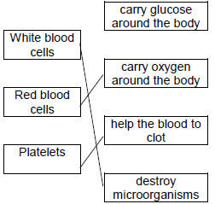
one mark for each line
extra line negates a mark
3
(ii) any one from:
• carbon dioxide / CO₂
• urea
do not allow urine
ignore water
ignore ions
1
(b) (i) B
1
(ii) D
1
(iii) vein
accept correct named
examples
1
(c) (i) any one from:
• keeps artery / blood vessel open or widens artery / blood vessel
• allows (more) blood to heart / cardiac muscle
• (allows) blood to flow more easily
• allows (more) oxygen to heart / cardiac muscle
1
(ii) any two from:
• bleeding
allow blood clots
• infection
• damaging blood vessels
• damaging the heart
• risk from anaesthetic
2
[10]
Q2. (a) (i) wind
answers in either order
1
temperature
ignore weather
1
(ii) different plants have different sizes
ignore reference to validity
/ different numbers of leaves
/ different sizes of leaves
/ different plants take up different amounts of water
/ different number of stomata
/ different surface area
allow different plants need different amounts of water
1
(b) in table, in sequence:
C
B
A
all 3 correct = 2 marks
2 correct = 1 mark
0 or 1 correct = 0 marks
max 2
(c) transpiration
1
[6]

B5 - Mark Scheme
Q1. (a) cell membrane
extra ticks negates marks
1
(b) engulf pathogens
1
produce antibodies
1
produce antitoxins
1
extra ticks negates marks
(c) 2050 − 100
1
= 1950
allow 1 mark for a correct subtraction of incorrect values
1
an answer of 1950 scores 2 marks
(d) any one from:
• (more) people vaccinated
ignore injections / treatments / medicines unqualified
allow vaccine produced
allow (more people given) MMR (vaccine)
do not allow antibiotics
• (more) people immune
• no new measles strain
1
(e) any one from:
• measles is (caused by) a virus
allow measles is not caused by a bacterium
• viruses cannot be killed / destroyed by antibiotics
allow antibiotics only kill / destroy bacteria
ignore harmed / treated
1
(f) any one from:
• use of a barrier method of contraception
ignore use of diaphragm
• use of a condom
ignore use protection / safe sex
• vaccination / immunisation
• avoid sexual intercourse / contact
do not accept less sexual intercourse / contact
1 [9]
Q2. (a) a disease that can be spread from one person to another
1
(b) gonorrhoea
1
(c) antibiotics
1
(d) painkillers allow aspirin, paracetamol, ibuprofen and other correct brand names
1
(e)
Level 2: Scientifically relevant facts, events or processes are identified and given in detail to form an accurate account. | 3-4
Level 1: Facts, events or processes are identified and simply stated but their relevance is not clear. | 1-2
No relevant content | 0
Indicative content
• skin stops the bacterium (entering the body)
• blood clots to stop bacteria entering (through cuts)
• stomach acid will kill the bacterium (if it is in food)
• nose / trachea have mucus to trap the (tuberculosis) bacteria
• nose / trachea have cilia / hair to move mucus out
• white blood cells destroy the bacteria if infected
• by phagocytosis
• by antibodies
• by antitoxins
4
[8]

B6 - Mark Scheme
Q1. (a) (i) lives inside cells
1
(ii) inactive
1
(iii) antibodies
1
(b) (i) 1950
1
(ii) 8 (years)
1
(iii) any one from: eg
• disease could be reintroduced (from abroad)
disease might come back insufficient
• disease would spread if it came back
• protection on holiday abroad
• high proportion of immune people needed to prevent epidemic
1
[6]
Q2.
(i) 2 of:
ingest microbes; )allow higher level answers
produce antibodies; )allow cause and effect
produce antitoxins )eg antitoxins neutralise poisons = 2
each for 1 mark
2
(ii) injection of dead/weak microbes;
stimulates antibody production;
these can be produced again quickly on new infection
or remain for long time to ‘combat’ new infection
each for 1 mark
3
[5]

B7 - Mark Scheme
Q1. any two from:
• arthritis
ignore descriptions
• diabetes
• high blood pressure
• heart / blood vessel disease
ignore cholesterol
[2]
Q2. (a) (i) (as a result of) uncontrolled / abnormal growth / division of cells
ignore mutation
allow cells dividing with no contact inhibition
1
(ii) benign tumours do not invade / spread to other tissues / do not form secondary tumours
accept converse for malignant
accept benign tumours do not metastasise
1
(b) via the blood / circulatory system
accept via lymphatic system
1
(c) (i) incidence is increasing
1
more rapidly (over the years)
ignore figures
1
difference between rich and poor areas is getting less
or
the incidence is rising fastest in people from poor areas
1
(ii) risk factor is UV from sunlight
ignore ionising radiation
1
more UK citizens going abroad or taking holidays in the Sun
or
poorer people can afford holidays in the Sun
or
more poorer people are taking holidays in the Sun
1 [8]
B8 - Mark Scheme
Q1. (a) oxygen
allow O₂ / O2
do not accept O² or O
1
(b) (i) light
1
(ii) chlorophyll
1
(iii) decrease
1
(c) any three from:
• for respiration / energy
do not accept use energy for photosynthesis
• to make cellulose / starch
accept named carbohydrate other than glucose
• to make lipid / fat / oil
accept fatty acid / glycerol
• to make protein
accept named protein / amino acid / named amino acid
• to build big molecules from small molecules / metabolism
if no other marks awarded for making molecules allow 1 mark for growth / repair / new cells
3
[7]
Q2. (a) (LHS) water / H₂O
allow H2O
do not accept H²O
1
(RHS) glucose / sugar / C₆H₁₂O₆
allow starch / carbohydrate
allow C6H12O6
do not accept C⁶H¹²O⁶
1
(b) (i) 1 arbitrary unit
extra box ticked – cancel
1
(ii) 210
1
(iii) carbon dioxide / CO₂ / CO2
or
temperature / heat / warmth
ignore water
1 [5]
B9 - Mark Scheme
Q1. (a)
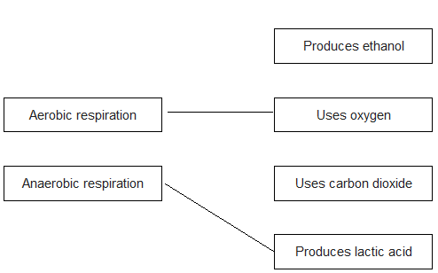
an extra line from a LH box negates that mark
2
(b) any one from:
• not enough oxygen present (for aerobic respiration)
• more energy required for exercise (than can be transferred by aerobic respiration)
1
allow named example for exercise
(c) produces carbon dioxide
1
produces ethanol
1
plus any two from:
• (carbon dioxide) makes bread rise
• (carbon dioxide) makes beer / cider / (some) wines fizzy
allow for alcoholic drinks / named drink
• (ethanol) is the alcohol in beer / cider / wine / spirits
2
[7]
Q2. (a) (i) 6 peaks in heart rate
accept 6 increases / spikes or goes very high 6 times
allow heart rate increases each time he runs
1
(ii) 2.5 / 2½
allow 2 minutes 30 seconds
do not accept 2.3 / 2:3 / 2.30
1
(b) more / faster / a lot must be stated at least once for full marks
(more) oxygen supplied / needed
allow less anaerobic (respiration)
or (more) aerobic respiration
or prevents oxygen debt
1
(more) glucose / sugar / food supplied / needed
ignore feeding
1
(more) energy needed / released
allow energy produced / made
1
(more) carbon dioxide / heat / lactic acid removed (from muscles) or more cooling
or less lactic acid formed
1
[6]

