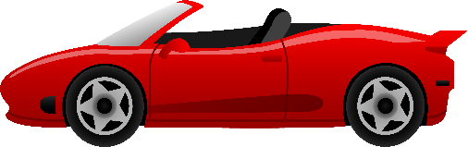

………………………………………………………………………………………………………………………………………………………………………………………………………….

………………………………………………………………………………………………………………………………………………………………………………………………………….

………………………………………………………………………………………………………………………………………………………………………………………………………….

**Use the boxes below to work out what the resultant force is for each car and describe its motion.**

**Forces**

Weight: 15 000 N

Reaction Force: 15 000 N

Driving Force: 7000 N

Air Resistance & Friction: 10000 N

**Forces**

Weight: 15 000 N

Reaction Force: 15 000 N

Driving Force: 15 000 N

Air Resistance & Friction: 9000 N

**Forces**

Weight: 15 000 N

Reaction Force: 15 000 N

Driving Force: 7000 N

Air Resistance & Friction: 7000 N

Resultant Force

6 000 N

Resultant Force

3000 N

Resultant Force

0 N

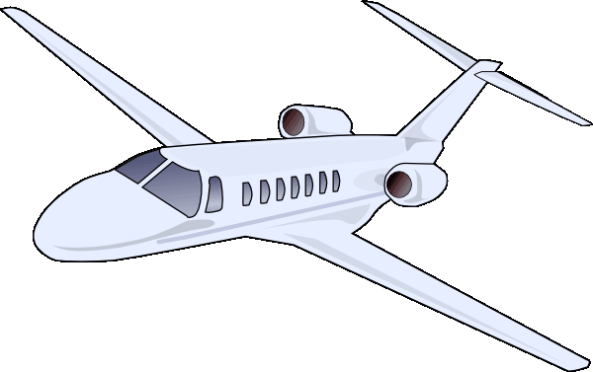

………………………………………………………………………………………………………………………………………………………………………………………………………….

………………………………………………………………………………………………………………………………………………………………………………………………………….

………………………………………………………………………………………………………………………………………………………………………………………………………….

**Use the boxes below to work out what the resultant force is for each plane and describe its motion.**

**Forces**

Weight: 250 000 N

Lift: 750 000 N

Driving Force: 500 000 N

Air Resistance & Friction: 500 000 N

**Forces**

Weight: 250 000 N

Lift: 250 000 N

Driving Force: 500 000 N

Air Resistance & Friction: 500 000 N

**Forces**

Weight: 250 000 N

Lift: 150 000 N

Driving Force: 100 000 N

Air Resistance & Friction: 100 000 N

Resultant Force

0 N

Resultant Force

500 000 N

Resultant Force

100 000 N

Force

0 N



