St Bedes Catholic Voluntary Academy

Physics Paper 1 Higher Revision Booklet

Name:…………………………………………………………….
Class:………………………………………………………………

The figure below shows a rollercoaster.
1
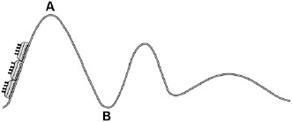
The rollercoaster car is raised a vertical distance of 35 m to point A by a motor in 45 seconds.
The mass of the rollercoaster is 600 kg.
The motor has a power rating of 8 000 W.
- Calculate the percentage efficiency of the motor.
Gravitational field strength = 9.8 N / kg.
........................................................................................................................
........................................................................................................................
........................................................................................................................
........................................................................................................................
........................................................................................................................
........................................................................................................................
........................................................................................................................
Efficiency = ................................... %
(5)

- The rollercoaster rolls from point A to point B, a drop of 35 m.
Calculate the speed of the roller coaster at point B.
Assume that the decrease in potential energy store is equal to the increase in kinetic energy store.
........................................................................................................................
........................................................................................................................
........................................................................................................................
........................................................................................................................
........................................................................................................................
........................................................................................................................
........................................................................................................................
Speed at point B = ................................... m / s
(6)

(Total 11 marks)

The farmers in a village in India use solar powered water pumps to irrigate the fields.
2
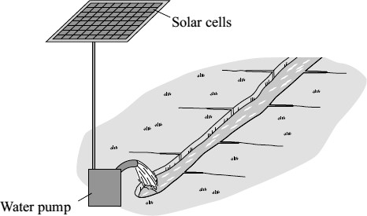
On average, a one square metre panel of solar cells receives 5 kWh of energy from the Sun each day.
The solar cells have an efficiency of 0.15
- (i) Calculate the electrical energy available from a one square metre panel of solar cells.
Show clearly how you work out your answer.
...............................................................................................................
...............................................................................................................
Electrical energy = ................................................... kWh
(2)

(ii) On average, each solar water pump uses 1.5 kWh of energy each day. Calculate the area of solar cells required by one solar water pump.
Area = ......................................................... square metres
(1)
- Give one reason why the area of solar cells needed will probably be greater than the answer to part (a)(ii).
........................................................................................................................
........................................................................................................................
(1)
(Total 4 marks)
The figure below shows a cool box.
3
A cool box is used to keep food colder than the surroundings. The cool box consists of plastic walls with a layer of polyurethane foam between them.
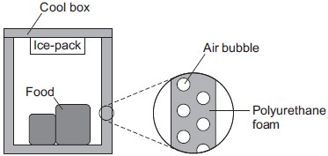
- The polyurethane foam has a low U-value.
Why does the polyurethane foam need to have a low U-value?
........................................................................................................................
........................................................................................................................
(1)
- The polyurethane foam contains air bubbles.
Explain how the air bubbles reduce energy transfer through the walls of the cool box.
You should refer to the processes of energy transfer in your answer.
........................................................................................................................
........................................................................................................................
........................................................................................................................
........................................................................................................................
........................................................................................................................
........................................................................................................................
(3)
- An ice-pack can be placed inside the cool box. An ice-pack contains a material with a veryhigh specific heat capacity. The ice-pack is frozen in a freezer and cooled to –18 °C before being put in the cool box.
The ice-pack keeps the contents of the cool box cooler than the surroundings for a long time.
Describe how.
........................................................................................................................
........................................................................................................................
........................................................................................................................
........................................................................................................................
........................................................................................................................
........................................................................................................................
(3) (Total 7 marks)

A student finds some information about energy-saving light bulbs.
4
(a) A 30W light bulb uses 600J of electrical energy in a certain period of time. In that time, it produces 450 J of light energy. The rest of the energy is wasted.
(i) Calculate the energy wasted by the light bulb in this period of time.
................................................................................................................
Wasted energy = ................................. J

(1)
(ii) What happens to the energy wasted by the light bulb?
................................................................................................................
................................................................................................................

(1)
(iii) Calculate the efficiency of this light bulb.
................................................................................................................
................................................................................................................
Efficiency = ............................................................

(2)
(iv) Calculate the period of time, in seconds, during which the 600 J is provided to the 30 W light bulb.
................................................................................................................
................................................................................................................
Time = ......................... s

(2)

(b) A company that makes light bulbs provides information about some of their products.
The table shows some of this information.

 | Power in watts | Lifetime in hours | Cost of bulb in £
Filament bulb | 60 | 1250 | 2.00
LED bulb | 12 | 50 000 | 16.00

(i) Suggest why it is important to confirm this information independently.
................................................................................................................

(1)
- A homeowner is thinking about replacing his filament bulbs with LED bulbs.
A 12 W LED bulb gives the same light output as a 60 W filament bulb.
Suggest reasons why the homeowner is likely to choose LED bulbs.
Use the information given in the table.
................................................................................................................
................................................................................................................
(2)
- State one factor, other than efficiency, that is important when considering the choice of a bulb for lighting in the home.
................................................................................................................
................................................................................................................
- (Total 10 marks)

(a) An electricity company claims to generate all of its electricity from environmentally friendly
5
energy sources.
The energy sources used by the company are shown in the pie chart.
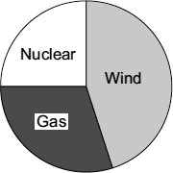
Do you think that the claim made by the company is correct?
Draw a ring around your answer.

Yes No Maybe
Explain the reasons for your answer.
........................................................................................................................
........................................................................................................................
........................................................................................................................
........................................................................................................................
(2)
(b) The government is committed to increasing the amount of electricity generated from renewable sources. A newspaper reported that: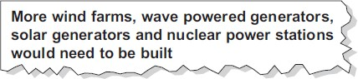
Why is the statement made in the newspaper incorrect?
........................................................................................................................
........................................................................................................................
(1)

(Total 3 marks)
Figure 1 shows a kettle a student used to determine the specific heat capacity of water.
6
Figure 1
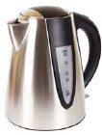
© vladimirkim3722/iStock/Thinkstock
The student placed different masses of water into the kettle and timed how long it took for the water to reach boiling point.
The student carried out the experiment three times.
The student’s results are shown in the table below.

 | Time for water to boil in seconds
Mass of water in kg | 1 | 2 | 3 | Mean | Mass × change in temperature in kg°C | Energy supplied in kJ
0.25 | 55 | 60 | 63 | 59 | 20 | 131
0.50 | 105 | 110 | 116 | 110 | 40 | 243
0.75 | 140 | 148 | 141 | 143 | 60 | 314
1.00 | 184 | 190 | 183 | 182 | 80 | 401
1.25 | 216 | 215 | 211 | 214 | 100 | 471
1.50 | 272 | 263 | 266 | 267 | 120 | 587
1.75 | 298 | 300 | 302 |  | 140
- Suggest how the student was able to ensure that the change in temperature was the samefor each mass of water.
........................................................................................................................
........................................................................................................................
........................................................................................................................
(2)
- Calculate the uncertainty in the student’s measurements of time to boil when the mass ofwater was 1.75 kg.
........................................................................................................................
........................................................................................................................
Uncertainty = ....................................... s
(2)
- The power rating of the kettle is 2.20 kW.
Calculate the average electrical energy used by the kettle, in kJ, for 1.75 kg of water to reach boiling point.
........................................................................................................................
........................................................................................................................
........................................................................................................................
Average energy = ........................................... kJ
(2)
- Use information from the table above to calculate the change in temperature of the waterduring the investigation.
........................................................................................................................
........................................................................................................................
Change in temperature = ................................. °C
(2)
- The student plotted a graph of energy supplied in kJ against mass × change in temperaturein kg °C.
Figure 2 shows the graph the student plotted.
Figure 2
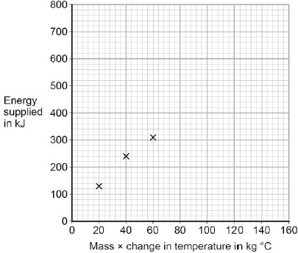
Use data from the table above to plot the four missing points.
Draw a line of best fit on the graph.
(3)
- Use the graph to determine the mean value of the specific heat capacity of water, for thestudent’s investigation.
........................................................................................................................
........................................................................................................................
........................................................................................................................
........................................................................................................................
........................................................................................................................
Specific heat capacity of water = ........................... J / kg °C
(4)
- The student’s value for the specific heat capacity of water was greater than the acceptedvalue.
Suggest why.
........................................................................................................................
........................................................................................................................
(1)
- The kettle used in the experiment had a label stating that the power rating of the kettle was
2.2 kW.
The student did not measure the power of the kettle.
Suggest why measuring the power of the kettle may improve the student’s investigation.
........................................................................................................................
........................................................................................................................
(1) (Total 17 marks)
- Describe the difference between an alternating current (a.c.) and a direct current (d.c.).
7
........................................................................................................................
........................................................................................................................
........................................................................................................................
........................................................................................................................
(2)
- The diagram shows how the electric supply cable is connected to an electric kettle.The earth wire is connected to the metal case of the kettle.
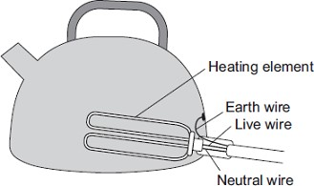
If a fault makes the metal case live, the earth wire and the fuse inside the plug protect anyone using the kettle from an electric shock.
Explain how.
........................................................................................................................
........................................................................................................................
........................................................................................................................
- (Total 4 marks)

The diagram shows a type of electric immersion heater in a hot water tank. These hot water
8tanks are normally found in airing cupboards.
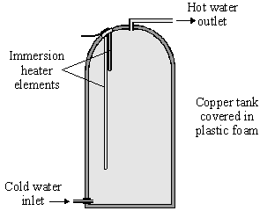
Information on the immersion heater states:
230 V
10 A
- (i) What is the equation which shows the relationship between power, current andvoltage?
...................................................................................................................
(1)
  - Calculate the power of the heater. Show clearly how you get to your answer and givethe units.
...................................................................................................................
Power = ......................................................
(2)
- (i) What rating of fuse should be in the immersion heater circuit?
...................................................................................................................
(1)
  - There are three wires in the cable to the immersion heater. Two of the wires areconnected to the immersion heater. The third wire is connected to the copper tank.
Explain the function of this third wire and the fuse in the circuit.
...................................................................................................................
...................................................................................................................
...................................................................................................................
(3)
- (i) What is the equation which shows the relationship between resistance, current andvoltage?
...................................................................................................................
(1)
  - Calculate the resistance of the heater. Show clearly how you get to your answer andgive the units.
...................................................................................................................
Resistance = ....................................................
(2)
(Total 10 marks)
An electric current is a flow of electrical charge through a circuit.
9
- Complete the sentence.
Use a word from the box.

atoms | electrons | ions | molecules
Metals are good conductors of electricity because electrical charge is transferred
by delocalised ...................................................
(1)
- Draw one line from each symbol to the name of the component.
Standard symbol Name of component
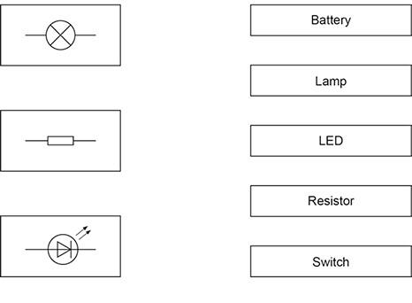
(3)
- The table below shows information about some electrical appliances.

Electrical appliance | Power in watts
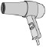  Hairdryer | 1500
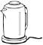  Kettle | 2500
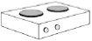  Electric hob | 3000
Television | 360
A student plugs all four of the appliances into one multi-way socket.
The mains electricity is 230 V.
The highest safe current in the socket is 30 A.
Explain why it is not safe to use all four appliances at the same time.
In your answer you should:
  - calculate the total power needed
  - use the equation current = power ÷ potential difference to calculate the total current needed.
.
........................................................................................................................
........................................................................................................................
........................................................................................................................
........................................................................................................................
........................................................................................................................
........................................................................................................................
(4)
- The figure below shows how electrical power is transferred from power stations toconsumers using the National Grid.
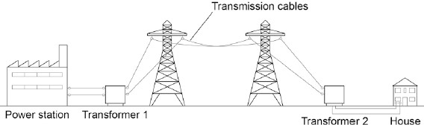
Transformer 1 is a step-up transformer.
Explain why step-up transformers are used in the National Grid.
........................................................................................................................
........................................................................................................................
........................................................................................................................
(3)
- What is the purpose of Transformer 2?
........................................................................................................................
........................................................................................................................
(1)
- In a power station 900 MJ of thermal energy were released by burning natural gas.
Write down the equation that links efficiency, useful input energy transfer and useful output energy transfer.
........................................................................................................................
(1)
- In a power station 900 MJ of thermal energy were released by burning natural gas.
Only 405 MJ was generated.
Calculate the efficiency of this energy transfer.
........................................................................................................................ Efficiency = .................................
(2) (Total 15 marks)

(a) The resistance of a 24 W, 12 V filament lamp depends on the current flowing through the
10 lamp. For currents up to 0.8 A, the resistance has a constant value of 2.5 Ω.
  - Use the equation in the box to calculate the potential difference across the lamp whena current of 0.8 A flows through the lamp.

potential difference = current × resistance
Show clearly how you work out your answer.
...............................................................................................................
...............................................................................................................
Potential difference = ............................................................ V
(2)
  - When the potential difference across the lamp is 12 V, the current through the lamp is2 A.
On the axes below, draw a current–potential difference graph for the filament lamp over the range of potential difference from 0 to 12 volts.
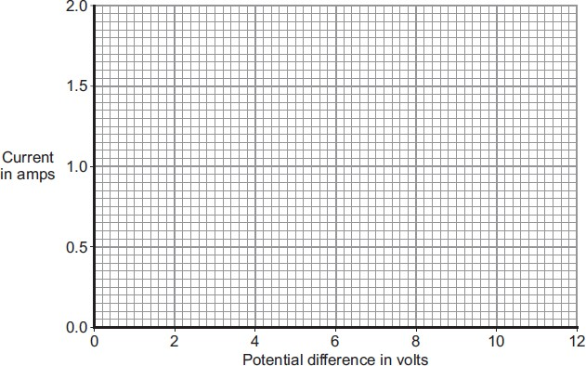
(2)
  - Why does the resistance of the lamp change when the current through the lampexceeds 0.8 A?
...............................................................................................................
...............................................................................................................
(1)
(b) The lamp is now included in a circuit. The circuit is switched on for 2 minutes. During this time, 72 coulombs of charge pass through the lamp.
Use the equation in the box to calculate the energy transformed by the lamp while the circuit is switched on.

energy transformed = potential difference × charge
Show clearly how you work out your answer.
........................................................................................................................
........................................................................................................................
Energy transformed = ............................................................ J
(2)
(Total 7 marks)
- The diagram shows the voltage-current graphs for three different electrical components.
11
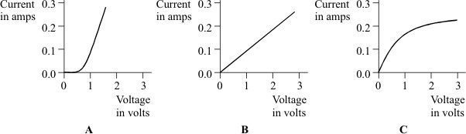
Which one of the components A, B or C could be a 3 volt filament lamp? Explain the reason for your choice.
.............................................................................................................................
.............................................................................................................................
.............................................................................................................................
.............................................................................................................................
(3)
- Using the correct symbols draw a circuit diagram to show how a battery, ammeter andvoltmeter can be used to find the resistance of the wire shown.
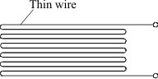
(3)
- When correctly connected to a 9 volt battery the wire has a current of 0.30 amperes flowingthrough it.
  - Give the equation that links current, resistance and voltage.
...................................................................................................................
(1)
  - Calculate the resistance of the wire. Show clearly how you work out your answer andgive the unit.
...................................................................................................................
...................................................................................................................
Resistance = .........................................................
(3)
  - When the wire is heated, the current goes down to 0.26 amperes. State how theresistance of the wire has changed.
...................................................................................................................
...................................................................................................................
(1)
The diagram shows a simple type of car rear window heater. The six heating elements are
12
exactly the same.
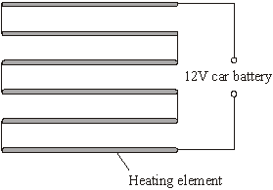
Each heating element has a resistance of 5 Ω. The current passing through each element is 0.4 A.
- Calculate the total resistance of the six heating elements.
Show clearly how you work out your answer.
.............................................................................................................................
.............................................................................................................................
Total resistance = .............................. ohms
(2)
- Why is the current passing through each element the same?
.............................................................................................................................
.............................................................................................................................
(1)
- What is the total current passing through the whole circuit?
.............................................................................................................................
(1)
- How is the 12 volt potential difference of the car battery shared between the six heatingelements?
.............................................................................................................................
.............................................................................................................................
(1)
(Total 5 marks)
(Total 11 marks)
A student is investigating some electrical components.
13
- Describe how the student could set up a circuit to find the resistance of a lamp.
You should include a circuit diagram in your answer.
........................................................................................................................
........................................................................................................................
........................................................................................................................
........................................................................................................................
........................................................................................................................
........................................................................................................................
........................................................................................................................
(4)
- The student is given an electrical component in a sealed box.
She has to find out what the electrical component is by experiment.
The student records the current and the potential difference for the component. Her results are shown in the figure below.
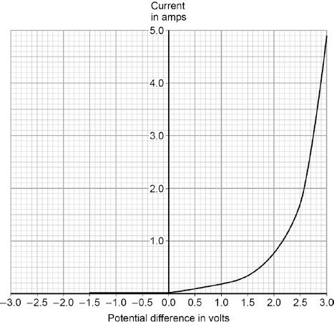
Explain how the student could know that the electrical component in the sealed box is not an ohmic conductor.
........................................................................................................................
........................................................................................................................
........................................................................................................................
........................................................................................................................
(2)
- What is the electrical component in the sealed box?
Explain your answer.
Component .................................................................................................
Explanation .................................................................................................
........................................................................................................................
........................................................................................................................
........................................................................................................................
(3)
- Use the graph to determine the resistance of the component at 2.3 V.
........................................................................................................................
........................................................................................................................
........................................................................................................................
........................................................................................................................
........................................................................................................................
........................................................................................................................
........................................................................................................................
Resistance = ................................... Ω
(4)

(Total 13 marks)

In this question you will be assessed on using good English, organising information
14
clearly and using specialist terms where appropriate.
The information in the box is about the properties of solids and gases.

Solids:
- have a fixed shape
- are difficult to compress (to squash).

Gases:
- will spread and fill the entire container • are easy to compress (to squash).
Use your knowledge of kinetic theory to explain the information given in the box.
You should consider:
- the spacing between the particles
- the movement of individual particles
- the forces between the particles.
.................................................................................................................................
.................................................................................................................................
.................................................................................................................................
.................................................................................................................................
.................................................................................................................................
.................................................................................................................................
.................................................................................................................................
.................................................................................................................................
.................................................................................................................................
.................................................................................................................................
.................................................................................................................................
.................................................................................................................................
(Total 6 marks)
A beta particle is a high-energy electron.
15
- Which part of an atom emits a beta particle?
.............................................................................................................................
(1)
- How does the composition of an atom change when it emits a beta particle?
.............................................................................................................................
(1)
(Total 2 marks)

- When an atom of thorium-232 decays, an alpha (α) particle is emitted from the nucleus.
16
An atom of radium is left behind.
An alpha particle consists of two protons and two neutrons.
We can represent this radioactive decay in a special kind of equation:
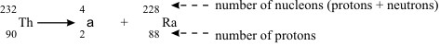
Thorium-228 is also radioactive.
Atoms of this isotope also decay by emitting an alpha particle and producing an isotope of radium.
Complete the equation for this decay.
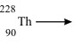
(4)
- An atom of radium-228 decays by emitting a beta (β) particle from the nucleus.
A beta particle is in fact an electron (symbol).
The effect of this is to change a neutron into a proton.
An atom of actinium remains.
This type of decay can also be represented by an equation:
This isotope of actinium is radioactive.
An atom of actinium-228 also decays by emitting a beta particle.
An isotope of thorium is left behind.
Complete the equation for this decay.
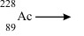
(4)
- Thorium-232 eventually decays to the stable isotope lead-208.
All the steps in this process can be shown on a diagram.
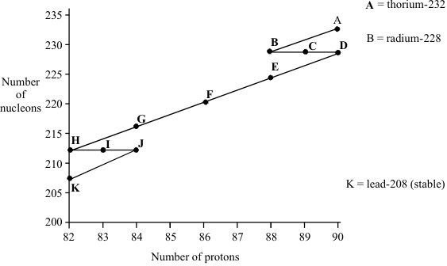
- Complete the sentences:
During the decay from (A) to (B) a .................... particle is emitted.
During the decay from (B) to (C) a .................... particle is emitted.
During the decay from (E) to (F) a .................... particle is emitted.
During the decay from (I) to (J) a .................... particle is emitted.
(2)
- The table shows how long it takes for half of the atoms of each isotope to decay.
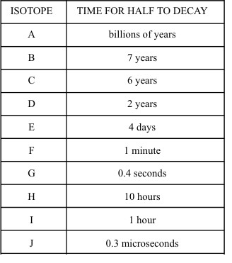
A rock sample contains:
    - many atoms of thorium-232
    - even more atoms of lead-208
    - hardly any atoms of any of the other isotopes shown on the diagramExplain this as fully as you can.
...................................................................................................................
...................................................................................................................
...................................................................................................................
...................................................................................................................
...................................................................................................................
(3) (Total 13 marks)
The figure below shows a simple model of the three states of matter.
17
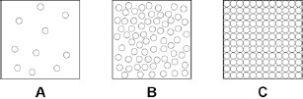
- What is the correct equation to work out the density of a material?
........................................................................................................................
(1)
- A student explains density to his teacher using the particle model in the figure above.
His teacher says there are limitations to the model.
Give two limitations of the particle model in the figure above.
  - .....................................................................................................................
........................................................................................................................
  - .....................................................................................................................
........................................................................................................................
(2)
- When the gas in a container with a fixed volume is heated, the pressure increases as the temperature increases.
Explain why the pressure increases.
Use the model in the figure above to help you.
........................................................................................................................
........................................................................................................................
........................................................................................................................
........................................................................................................................
........................................................................................................................
(4)
(Total 7 marks)
In this question you will be assessed on using good English, organising information
18
clearly and using specialist terms where appropriate.
The diagram shows the arrangement of particles in a solid, a liquid and a gas.
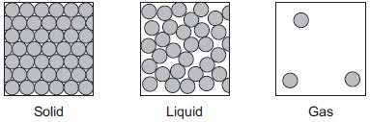
Use the diagram above and your own knowledge to compare solids, liquids and gases in terms of their particles.
You should include information about the arrangement, movement and energy of the particles.
.................................................................................................................................
.................................................................................................................................
.................................................................................................................................
.................................................................................................................................
.................................................................................................................................
.................................................................................................................................
.................................................................................................................................
(6 marks)

Some students measure the level of radiation from a radioactive source during the same lesson
19
each week over a period of six weeks.
Here are the results. (They have been corrected for background radiation.)

Time (weeks) | start | 1 | 2 | 3 | 4 | 5 | 6
Level of radiation  (average counts per minute) | 66 | 44 | 34 | 29 | 16 | 12 | 8
- Using the graph paper below, display these results in the most appropriate way.
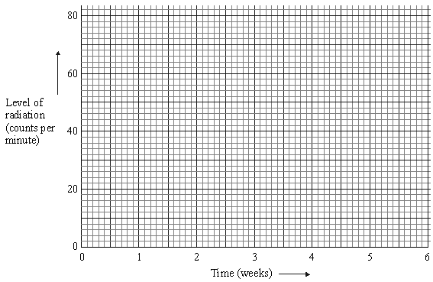
(5)
- What overall pattern is there in the students’ results?
.............................................................................................................................
.............................................................................................................................
.............................................................................................................................
(3)
(Total 8 marks)

The particle model can be used to explain the properties of gases.
20
- Describe the direction of motion of the particles in a gas.
........................................................................................................................
........................................................................................................................
(1)
- Explain why heating a gas increases the average speed of the gas particles.
........................................................................................................................
........................................................................................................................
........................................................................................................................
........................................................................................................................
........................................................................................................................
........................................................................................................................
(3)
- Water can exist as either a liquid or a gas at 100 °C.
Explain why a mass of gaseous water at 100 °C contains more energy than an equal mass of liquid water at 100 °C.
........................................................................................................................
........................................................................................................................
........................................................................................................................
........................................................................................................................
........................................................................................................................
........................................................................................................................
(2)
- Water vapour is a gas. Gases change state when they cool.
The figure below shows condensation on a cold bathroom mirror.
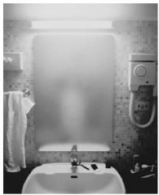
© Dwight Eschliman/Getty Images
A volume of 2.5 × 10^{–5} m³ of condensation forms on the mirror.
Density of water = 1000 kg / m³
Specific latent heat of vaporisation of water = 2.26 × 10⁶ J / kg.
Calculate the energy released when the condensation forms.
........................................................................................................................
........................................................................................................................
........................................................................................................................
........................................................................................................................
........................................................................................................................
........................................................................................................................
........................................................................................................................
Energy released = .............................................. J
(5)
(e) Central heating boilers burn gas and use the energy released to heat water.
Modern condensing central heating boilers take advantage of the energy that is released when water condenses.
Waste water vapour produced when the water is heated in the boiler is used to preheat the cold water entering the boiler.
Give some of the arguments in favour of condensing boilers compared to older non-condensing boilers.
........................................................................................................................
........................................................................................................................
........................................................................................................................
........................................................................................................................
........................................................................................................................
........................................................................................................................
........................................................................................................................
........................................................................................................................
........................................................................................................................
(4)
(Total 15 marks)

