St Bedes Catholic Voluntary Academy

Physics Paper 1 Foundation Revision Booklet

Name:…………………………………………………………….
Class:………………………………………………………………

The picture shows a solar-powered aircraft. The aircraft has no pilot.
1
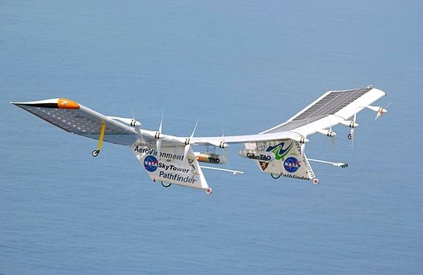
By NASA/Nick Galante [Public domain], via Wikimedia Commons
- Use words from the box to complete the following sentence.

electrical | heat | light | sound
Solar cells are designed to transform ............................................................. energy
into ............................................................. energy.
(2)
- On a summer day, 175 000 joules of energy are supplied to the aircraft’s solar cells everysecond. The useful energy transferred by the solar cells is 35 000 joules every second.
Use the equation in the box to calculate the efficiency of the solar cells.
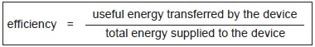
Show clearly how you work out your answer.
........................................................................................................................
........................................................................................................................
Efficiency = .............................................................
(2)
- The aircraft propellers are driven by electric motors.
Give one environmental advantage of using electric motors to drive the aircraft propellers rather than motors that burn a fuel.
........................................................................................................................
........................................................................................................................
(1)
(Total 5 marks)

Figure 1 shows a battery operated remote control car.
2
Figure 1
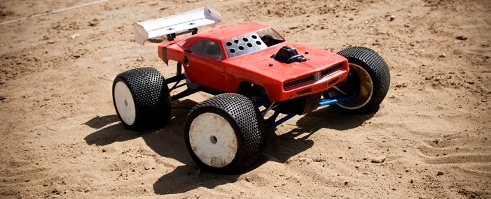
© Brandon Bolin/iStock/Thinkstock
- The car’s battery contains a store of energy.
As the car moves, energy from one store is transferred to another store.
Describe how different stores of energy change as the car moves.
........................................................................................................................
........................................................................................................................
........................................................................................................................
........................................................................................................................
(2)
- The car has a top speed of 12 m / s and a mass of 800 g.
Write down the equation that links kinetic energy, mass and speed.
Equation ........................................................................................................
(1)
- Calculate the maximum kinetic energy of the car.
........................................................................................................................
........................................................................................................................
........................................................................................................................
Maximum kinetic energy = .................................... J
(2)
- Explain why having a more efficient motor increases the top speed of the car.
........................................................................................................................
........................................................................................................................
........................................................................................................................
........................................................................................................................
(2)
- Figure 2 shows an electric car being charged. Figure 2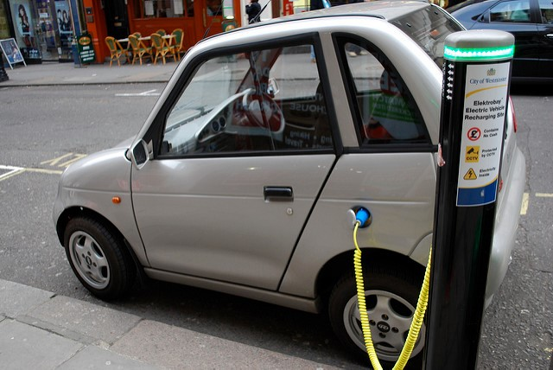 By Alan Trotter Electric Car Charging [CC-BY-2.0]via Flickr
A driver wishes to buy a new car.
The table below gives some data about an electric car and one with a petrol engine.

 | Electric car | Petrol engine car
Cost (£) | 27 000 | 15 000
Running cost per year (£) | 250 | 2 000
Average lifetime (years) | 12 | 12
Which car would be the most economic over its 12 year lifetime?
Use data from the table above to support your answer.
You should include the difference in cost in your answer.
........................................................................................................................
........................................................................................................................
........................................................................................................................
........................................................................................................................
........................................................................................................................
........................................................................................................................
........................................................................................................................
........................................................................................................................
........................................................................................................................
(4)
(Total 11 marks)

Diagram 1 shows the energy transferred per second from a badly insulated house on a cold day
3
in winter.
Diagram 1
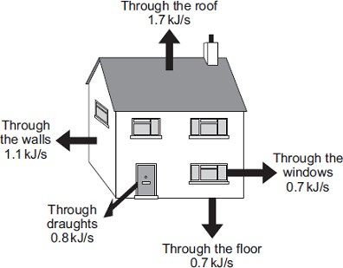
- (i) When the inside of the house is at a constant temperature, the energy transferredfrom the heating system to the inside of the house equals the energy transferred from the house to the outside.
Calculate, in kilowatts, the power of the heating system used to keep the inside of the house in Diagram 1 at a constant temperature.
1 kilowatt (kW) = 1 kilojoule per second (kJ/s)
...............................................................................................................
Power of the heating system = ...................................................... kW
(1)
  - In the winter, the heating system is switched on for a total of 7 hours each day.
Calculate, in kilowatt-hours, the energy transferred each day from the heating system to the inside of the house.
...............................................................................................................
...............................................................................................................
Energy transferred each day = ...................................................... kWh
(2)
  - Energy costs 15 p per kilowatt-hour.
Calculate the cost of heating the house for one day.
...............................................................................................................
Cost = ..............................
(1)
  - The heating system is switched off at midnight.
The graph shows how the temperature inside the house changes after the heating system has been switched off.
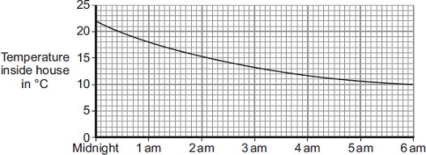
Time of day
Draw a ring around the correct answer in the box to complete the sentence.
Between midnight and 6 am the rate of energy transfer from

decreases.
decreases then stays constant. increases.

the house

Give the reason for your answer.
...............................................................................................................
...............................................................................................................
(2)
- Diagram 2 shows how the walls of the house are constructed.
Diagram 3 shows how the insulation of the house could be improved by filling the air gap between the two brick walls with plastic foam.

Diagram 2 Diagram 3

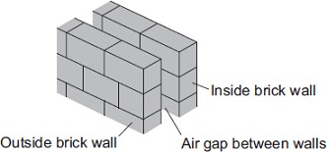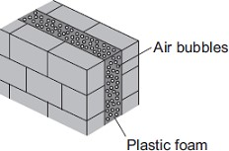
U-value of the wall = 0.7 U-value of the wall = 0.3
The plastic foam reduces energy transfer by convection.
Explain why.
........................................................................................................................
........................................................................................................................
........................................................................................................................
........................................................................................................................
(2)
(Total 8 marks)
Electrical appliances transfer energy in different ways. Figure 1 shows a television.
4
Figure 1
- Use the correct answer from the box to complete the sentence.

less than | more than | the same as
Energy is conserved by the television.
Energy is conserved, means that the energy input is .................... the total energy output.
(1)
- The power input to the television is 120 W.
Calculate the total energy transferred by the television when it is switched on for 300 seconds.
Use the correct equation from the Physics Equations Sheet.
........................................................................................................................
........................................................................................................................
........................................................................................................................
Energy = ........................................ J
(2)
- Figure 2 shows a torch that does not need batteries.
Figure 2
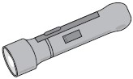
Shaking the torch up and down for 5 minutes generates enough electricity to light the torch bulb for 20 minutes.
Use the correct answer from the box to complete each sentence about the energy transfers.

elastic potential | kinetic | light | sound
When the torch is shaken up and down, the torch transfers ............................................. energy to electrical energy.
When the torch is turned on, the bulb usefully transfers electrical energy to
.................................... energy.
(2)
(Total 5 marks)

Wind and tides are energy sources that are used to generate electricity.
5
- Complete each sentence by putting a tick ( ) in the box next to the correct answer.
  - The wind is
    - non-renewable energy source.

a constant energy source.

an unreliable energy source.

(1)
  - The tides are
    - renewable energy source.

a constant energy source.

an unreliable energy source.

(1)
- If wood is to be used as a renewable energy source, what must be done each time a tree ischopped down?
........................................................................................................................
........................................................................................................................
(1)
- In the UK, electricity is generated using renewable and non-renewable energy sources.The graph shows the percentage of electricity generated using renewable energy sources between 1990 and 2005.
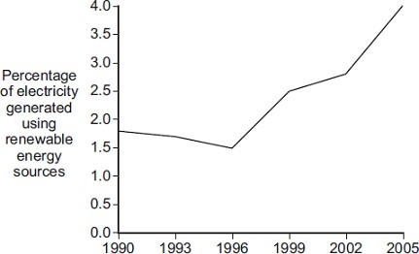
Year
Complete the following sentence by drawing a ring around the correct answer in the box.
In 2015, the percentage of electricity generated using renewable energy sources

greater than 4 %. equal to 4 %. less than 4 %.

is most likely to be

(1)

(Total 4 marks)

A student investigated the change in temperature when oils of different specific heat capacities
6
were heated.
She set up the apparatus shown in the figure below.
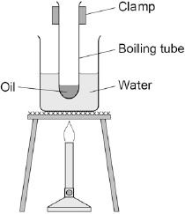
This is the method used.
- Put 25 g of oil into a boiling tube.
- Pour 100 ml of water into a beaker and heat it with a Bunsen burner.
- When the water is boiling, put the boiling tube into the beaker.
- When the temperature of the oil reaches 30 °C, heat for a further 30 seconds and recordthe rise in temperature.
- Repeat with different oils.
- Repeat the whole investigation.
- Name two pieces of apparatus the student used that are not shown in the figure above.
  - .....................................................................................................................
  - .....................................................................................................................
(2)
- What are the independent and dependent variables in the student’s investigation?
Independent ...................................................................................................
........................................................................................................................
Dependent .....................................................................................................
........................................................................................................................
(2)
- Give two safety precautions the student should have taken.
  - .....................................................................................................................
........................................................................................................................
  - .....................................................................................................................
........................................................................................................................
(2)
- Suggest one improvement to the student’s method.
........................................................................................................................
........................................................................................................................
........................................................................................................................
........................................................................................................................
(2)
- The table below shows the student’s results.

 |  | Temperature rise in °C
Type of oil | 1 | 2 | 3 | Mean
Castor oil | 20 | 19 | 21 | 20
Linseed oil | 19 | 18 | 19 | 19
Mineral oil | 21 | 21 | 21 | 21
Olive oil | 17 | 17 | 18
Sesame oil | 23 | 23 | 20 | 22
Calculate the mean temperature rise for olive oil.
Give your answer to two significant figures.
........................................................................................................................
........................................................................................................................
........................................................................................................................
........................................................................................................................
Mean temperature rise = ................................... °C
(2)
- The mean change in temperature of the castor oil is 20 °C
The specific heat capacity of castor oil is 1 800 J / kg °C
The mass of oil used is 0.025 kg
Calculate the change in thermal energy of the castor oil the student used.
Use the correct equation from the Physics Equations Sheet.
Select the correct unit from the box.

joule | newton | volt
........................................................................................................................
........................................................................................................................
........................................................................................................................
........................................................................................................................
........................................................................................................................
Change in thermal energy = ................................... °C
Unit = ................................... °C
(3)

(Total 13 marks)
Figure 1 shows the inside of a three-pin plug and a length of three-core cable.
7
The cable is to be connected to the plug.

Figure 1
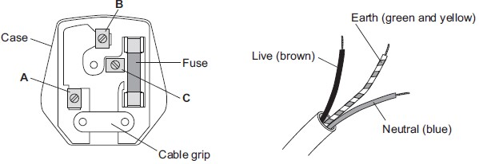
(i) Complete Table 1 to show which plug terminal, A, B or C, connects to each of the wires inside the cable.

Table 1

Wire | Plug terminal
Live
Neutral
Earth
(2)
(ii) Name a material that could be used to make the case of the plug.
...............................................................................................................
(1)
(b) Figure 2 shows an electric drill and an extension lead. The drill is used with the extension lead.

Figure 2
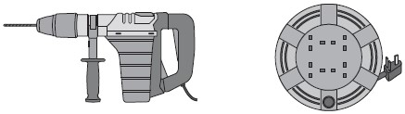
Electric drill Extension lead
- The drill is used for 50 seconds.
In this time, 30 000 joules of energy are transferred from the mains electricity supply to the drill.
Calculate the power of the drill.
...............................................................................................................
...............................................................................................................
...............................................................................................................
Power = .................................................. W
(2)
- A second drill is used with the extension lead. The power of this drill is 1200 W.
The instructions for using the extension lead include the following information.

When in use the lead may get hot:
DO NOT go over the maximum power
  - lead wound inside the case: 820 watts
  - lead fully unwound outside the case: 3100 watts
It would not be safe to use this drill with the extension lead if the lead was left wound inside the plastic case.
Explain why.
...............................................................................................................
...............................................................................................................
...............................................................................................................
(3)
(c) Table 2 gives information about three different electric drills.

Table 2

Drill | Power input in watts | Power output in watts
X | 640 | 500
Y | 710 | 500
Z | 800 | 500
A person is going to buy one of the drills, X, Y or Z. The drills cost the same to buy.
Use only the information in the table to decide which one of the drills, X, Y or Z, the person should buy.
Write your answer in the box.
Give a reason for your answer
..................................................................................................................................................................................................................................................................................................
(1)
(Total 9 marks)

A circuit was set up as shown in the diagram.
8
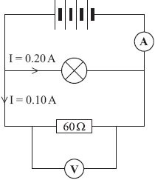
- Each cell provides a potential difference of 1.5 volts.
  - What is the total potential difference provided by the four cells in the circuit?
...................................................................................................................
Total potential difference = .............................. volts
(1)
  - What will be the reading on the voltmeter?
...................................................................................................................
(1)
- The current through the lamp is 0.20 amps.
The current through the resistor is 0.10 amps.
What is the reading on the ammeter?
...................................................................................................................
Reading on ammeter = .............................. amps
(1)
- Use a phrase from the box to complete the following sentence.

greater than equal to smaller than
The resistance of the lamp is ............................................................ 60 Ω.
Give a reason for your answer.
...................................................................................................................(2) (Total 5 marks)

- Complete the sentence below to name the instrument used to measure electrical current.
9
The instrument used to measure electrical current is called ...............................
(1)
- In the diagram below each box contains an electrical component or a circuit symbol.Draw straight lines to link each electrical component to its circuit symbol. The first one has been done for you.
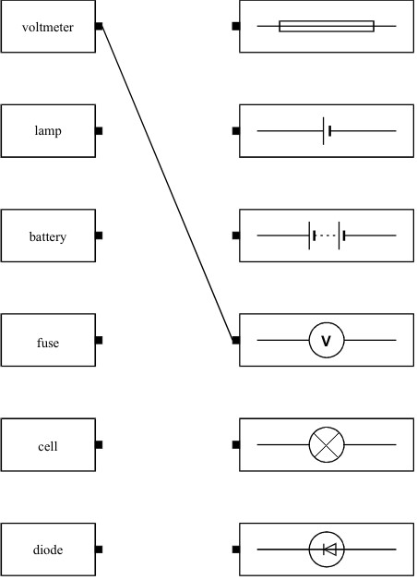
(4)
(Total 5 marks)

A circuit diagram is shown below.
10
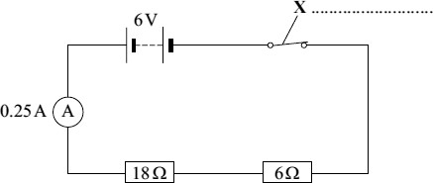
- Use a word from the box to label component X.

fuse | switch | thermistor
(1)
- Calculate the total resistance of the two resistors in the circuit.
........................................................................................................................
Total resistance = ........................................ Ω
(1)
- The reading on the ammeter is 0.25 A.
The current through the 6 Ω resistor will be:

bigger than 0.25 A equal to 0.25 A smaller than 0.25 A
Draw a ring around your answer
(1)
- The 6 V battery is made by correctly joining several 1.5 V cells in series.
Calculate the number of cells needed to make the battery.
........................................................................................................................
Number of cells = ...........................................
(1)
(Total 4 marks)

Most electrical appliances are connected to the mains electricity using three-core cables.
11
- What is the approximate value of the potential difference of the UK mains electricitysupply?
Tick one box.

230 V
300 V
350 V
23 V
(1)
- Figure 1 shows a three-core cable.
Figure 1
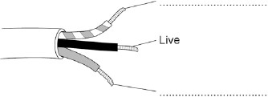
Use answers from the box to label the wires and complete Figure 1.

Earth | Negative | Neutral
(2)
- In the UK the three wires in a three-core cable are always the same colours.
Why are the wires always the same colours?
Tick one box.

Each wire is made by a different
company.
It is easy to identify each wire.

They are cheaper to manufacture.

(1)
- Touching the live wire is dangerous.
Use answers from the box to complete the sentences.

current | resistance | shock | force | voltage
Touching the live wire causes a large potential difference to exist across the body.
This causes a ......................................................... through the body, which
results in an electric .........................................................
(2)
- What is the approximate frequency of the UK mains electricity supply?
Tick one answer.

50 Hz

75 Hz

100 Hz

150 Hz

(1)
- Figure 2 shows how power stations transfer electrical power to consumers using the National Grid.
Figure 2
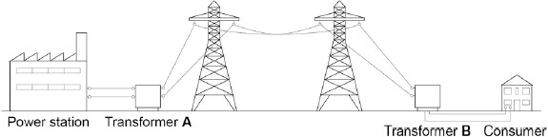
The power station generates electricity at a voltage of 25 kV.
Transformer A increases the voltage by a factor of 16.
What is the voltage output of transformer A?
........................................................................................................................
........................................................................................................................
........................................................................................................................
Output voltage = .......................................... kV
(2)
- Why is the voltage increased by transformer A?
Tick one box.

To reduce the energy lost due to

heating
To increase the power

To increase the current
(1)
- Why is it important that the voltage is decreased by transformer B?
Tick one box.

Less energy is used by consumers

It is safer for consumers

It reduces consumers’ electricity bills
(1)
(Total 11 marks)

- The graphs, A, B and C, show how the current through a component varies with the
12
potential difference (p.d.) across the component.
Draw a line to link each graph to the correct component. Draw only three lines.
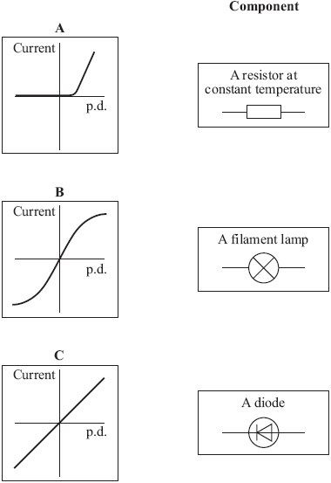
(2)
- Each of the circuits, J, K and L, include two diodes.
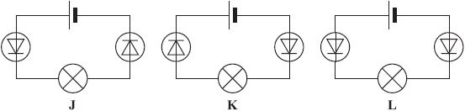
In which one of the circuits, J, K or L, would the filament lamp be on?
............................................................
(1)
(Total 3 marks)
(a) Draw one line from each circuit symbol to its correct name.
13

Circuit symbol |  | Name
Diode
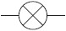
Lightdependent

resistor (LDR)
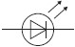
Lamp
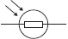
Light-
emitting
diode (LED)
(3)

(b) Figure 1 shows three circuits.
The resistors in the circuits are identical.
Each of the cells has a potential difference of 1.5 volts.
Figure 1

Circuit 1 Circuit 2 Circuit 3
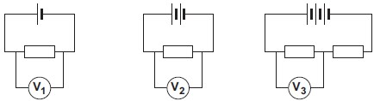
(i) Use the correct answer from the box to complete the sentence.

half twice the same as
The resistance of circuit 1 is ................................................ the resistance of circuit 3.
(1)
- Calculate the reading on voltmeter V₂.
...............................................................................................................
Voltmeter reading V₂ = .............................. V
(1)
- Which voltmeter, V₁, V₂ or V₃, will give the lowest reading?
Draw a ring around the correct answer.

V₁ V₂ V₃
(1)
(c) A student wanted to find out how the number of resistors affects the current in a series circuit.
Figure 2 shows the circuit used by the student.

Figure 2
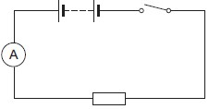
The student started with one resistor and then added more identical resistors to the circuit.
Each time a resistor was added, the student closed the switch and took the ammeter reading.
The student used a total of 4 resistors.
Figure 3 shows three of the results obtained by the student.

Figure 3
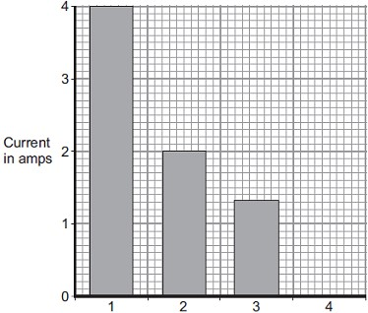
Number of resistors in series
- To get valid results, the student kept one variable the same throughout theexperiment.
Which variable did the student keep the same?
...............................................................................................................
(1)
- The bar chart in Figure 3 is not complete. The result using 4 resistors is not shown.
Complete the bar chart to show the current in the circuit when 4 resistors were used.
(2)
- What conclusion should the student make from the bar chart?
...............................................................................................................
...............................................................................................................
(1)
(Total 10 marks)
The diagram shows the structure of an atom.
13
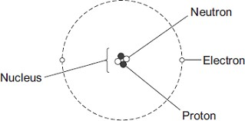 Not drawn to scale
- In 1931 scientists thought that atoms contained only protons and electrons.
Suggest what happened in 1932 to change the idea that atoms contained only protons and electrons.
........................................................................................................................
........................................................................................................................
(1)
- The table gives information about the particles in an atom.
Complete the table by adding the names of the particles.

Particle | Relative Mass | Relative Charge
 | 1 | 0
 | very small | –1
 | 1 | +1
(2)
(Total 3 marks)
The figure below is a diagram of an alpha particle and a helium atom.
14
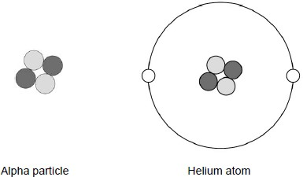
- What is the approximate size of a helium atom?
Tick one box.

1 × 10^{–5} m

1 × 10^{–10} m

1 × 10^{–15} m

1 × 10^{–20} m

(1)
- A helium atom is much larger than an alpha particle.
Give one other difference between a helium atom and an alpha particle.
........................................................................................................................
........................................................................................................................
(1)
- What is the atomic number of the helium atom in the figure above?
Tick one box.

2

4

6

8

(1)
- What is the charge on the helium atom in the figure above?
Explain your answer.
........................................................................................................................
........................................................................................................................
........................................................................................................................
........................................................................................................................
........................................................................................................................
(3)
- Helium is a gas that occurs naturally.
There is very little helium on Earth.
Helium has important uses in medicine and is also used to inflate party balloons.
Some scientists believe that helium should not be used to inflate party balloons.
Why?
........................................................................................................................
........................................................................................................................
........................................................................................................................
........................................................................................................................
(2)
(Total 8 marks)

- The diagrams show the arrangement of the particles in a solid and in a gas.
15
Each circle represents one particle.
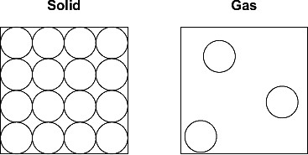
  - Complete the diagram below to show the arrangement of the particles in a liquid.
(2)
  - Explain, in terms of the particles, why gases are easy to compress.
........................................................................................................................
........................................................................................................................
........................................................................................................................
........................................................................................................................
(2)
- The diagram below shows the model that a science teacher used to show her students thatthere is a link between the temperature of a gas and the speed of the gas particles.
The ball-bearings represent the gas particles. Switching the motor on makes the ball-bearings move around in all directions.
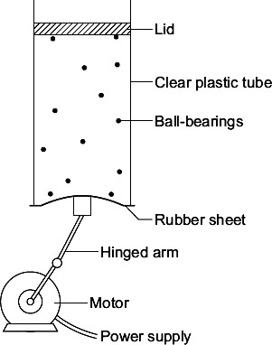
  - How is the motion of the ball-bearings similar to the motion of the gas particles?
........................................................................................................................
........................................................................................................................
(1)
  - The faster the motor runs, the faster the ball-bearings move. Increasing the speed ofthe motor is like increasing the temperature of a gas.
Use the model to predict what happens to the speed of the gas particles when the temperature of a gas is increased.
........................................................................................................................
........................................................................................................................
(1)
(Total 6 marks)

16
Figure 1
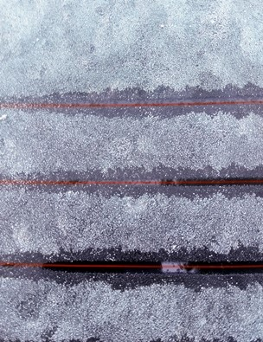
© Captive cookies/iStock/Thinkstock
The glass window contains an electrical heating element.
(a) Use the particle model in Figure 2 to describe how the heating element causes the arrangement of the ice particles to change as the ice melts.
Figure 2
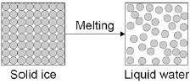
You should include a description of how the particles are arranged in the solid ice and in the water.
........................................................................................................................
........................................................................................................................
........................................................................................................................
........................................................................................................................
........................................................................................................................
........................................................................................................................
........................................................................................................................
........................................................................................................................
........................................................................................................................
(6)
- A car manufacturer tests different heating elements by measuring how long it takes ice tomelt.
During the test some variables must be controlled.
Identify two control variables in the car manufacturer’s test.
Tick two boxes.

The colour of the car

The current in the heating element

The mass of ice

The size of the car

The time taken for the ice to melt
(2)
- Some of the energy supplied by the heater causes the ice to melt without the temperatureof the ice increasing.
What is the name given to this energy supplied by the heater?
Tick one box.

Latent heat of freezing

Latent heat of fusion

Latent heat of vaporisation
(1)
- When the heater is supplied with 120 J of energy each second, the internal energy of theice increases by 45 J each second.
Use the following equation to calculate the efficiency of the heater.
Efficiency = 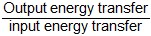
Give your answer to two decimal places.
........................................................................................................................
........................................................................................................................
........................................................................................................................
Efficiency = ........................................
(2)

(Total 11 marks)

- The diagram represents a helium atom.
17
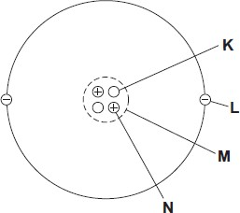
  - Which part of the atom, K, L, M or N, is an electron?
Part
(1)
  - Which part of the atom, K, L, M or N, is the same as an alpha particle?
Part
(1)
- A radioactive source emits alpha particles.
What might this source be used for?
Put a tick () in the box next to your answer.

to monitor the thickness of aluminium foil as it is made in a factory

to make a smoke detector work

to inject into a person as a medical tracer
(1)
- The graph shows how the count rate from a source of alpha radiation changes with time.
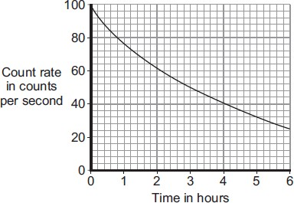
What is the count rate after 4 hours?
............................................. counts per second
(1)
(Total 4 marks)
- Radiation can cause cancer. The graph shows that the risk of cancer depends on the
18
radiation dose a person is exposed to.
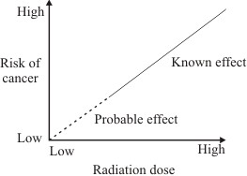
Complete the following sentence.
The ................................................ the dose of radiation a person gets, the greater the risk of cancer.
(1)
- A worker in a nuclear power station wears a special badge (diagram 1). Diagram 2 shows what is inside the badge. When the film inside the badge is developed, it will be dark in the places where it has absorbed radiation.
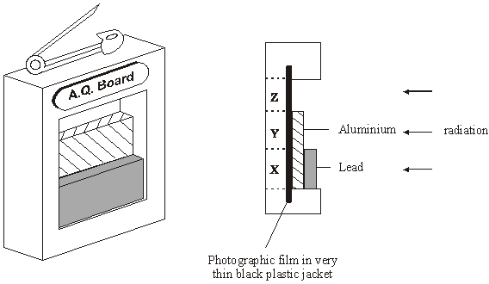
Diagram 1 Diagram 2
Which part of the film, X, Y or Z, would darken if the worker had received a dose of alpha radiation?
.............................................................................................................................
Give a reason for your answer.
.............................................................................................................................
.............................................................................................................................
(2)
(Total 3 marks)
(a) The names of the three types of nuclear radiation are given in List A.
18
Some properties of these types of radiation are given in List B.
Draw a straight line to link each type of radiation in List A to its correct property in List B.
Draw only three lines.

List A  Type of nuclear radiation |  | List B  Property of radiation

Has the same mass as an electron
Alpha

Very strongly ionising
Beta

Passes through 10 cm of aluminium
Gamma
Deflected by a magnetic field but
not deflected by an electric field
(3)
(b) The diagram shows a system used to control the thickness of cardboard as it is made.
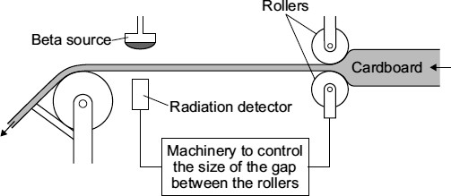
The cardboard passes through a narrow gap between a beta radiation source and a radiation detector.
The table gives the detector readings over 1 hour.

Time | Detector reading
08:00 | 150
08:15 | 148
08:30 | 151
08:45 | 101
09:00 | 149
- Between 08:00 and 08:30, the cardboard is produced at the usual, correct thickness.
Explain how you can tell from the detector readings that the cardboard produced at 08:45 is thicker than usual.
...............................................................................................................
...............................................................................................................
...............................................................................................................
...............................................................................................................
(2)
- Which would be the most suitable half-life for the beta source?
Draw a ring around your answer.

six days six months six years
(1)
- This control system would not work if the beta radiation source was replaced by an alpha radiation source.
Why not?
...............................................................................................................
...............................................................................................................
(1)
(Total 7 marks)

