- Changes of state and the particle model

- Why is it incorrect to say iron is heavier than wood?
________________________________________________________________________
________________________________________________________________________

- Water has a density of 1000 kg/m³. A piece of rubber has a density of 1024 kg/m³.
Explain what would happen if the rubber was put in a pool of water?
________________________________________________________________________
________________________________________________________________________

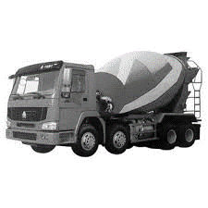
- This “ready-mix” concrete waggon contains 9600 kg of concrete.
If the density of the concrete is 2400 kg/m³, what volume of concrete
does the waggon contain?

Volume = _____________

- a. A sheet of insulating foam measures 3 m x 1 m x 0.08 m. It has a mass of 9.6 kg.
Calculate the density of the insulating foam.

Density = _____________
b. High density foam is made of the same material and can be used to give better
insulation for the same thickness of foam.
Describe how the arrangement of particles would differ in these two types of foam
(you may draw diagrams to help your answer).

_____________________________________________________________________
_____________________________________________________________________

5. When copper metal is heated to 1100 ⁰C it melts.
a. Is this a chemical or physical change? Explain your answer.

_____________________________________________________________________

b. What will happen to the mass of the sample of copper after it has melted?
Explain your answer.

_____________________________________________________________________
_____________________________________________________________________

- Explain the difference between a physical and a chemical change.
_____________________________________________________________________
_____________________________________________________________________

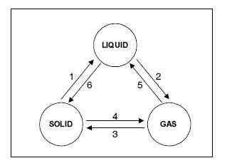
7. Name the changes in state given in
the diagram by the arrows 1 to 6.

- _______________________
- _______________________
- _______________________
- _______________________
- _______________________
- _______________________

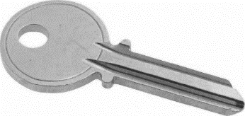
8. If you wanted to find the density of a brass key, you first need to
measure its volume. Describe how to determine the volume of a
brass key.

_____________________________________________________________________
_____________________________________________________________________
_____________________________________________________________________
_____________________________________________________________________
_____________________________________________________________________
_____________________________________________________________________

