Internal energy and energy transfers

- Define internal energy.
_______________________________________________________________________
_______________________________________________________________________

- Which of the following will change the internal energy of a stone? (circle the correct answer

- Lifting it to the top of a building

- Heating it

- Firing it from a catapult

- Water and the chemical isooctane both boil at 100⁰C. When the same mass of each substance is placed on a heater, the isooctane boils first. Explain why this happens.

_____________________________________________________________________
_____________________________________________________________________
_____________________________________________________________________
4. A hot stone is placed into a glass of water containing 200 g of cold water. The stone transfers 25 200 J of energy to the water. How much will the temperature of the water rise?
specific heat capacity of water = 4200 J/kg ºC ΔE = m c Δθ
_____________________________________________________________________
_____________________________________________________________________
_____________________________________________________________________

5. What is specific latent heat?
_____________________________________________________________________
_____________________________________________________________________

6. Explain the difference between latent heat of fusion and latent heat of vaporisation.
_____________________________________________________________________
_____________________________________________________________________

7. A boiler is being used to heat water. The graph shows the temperature of the water every
5 minutes.
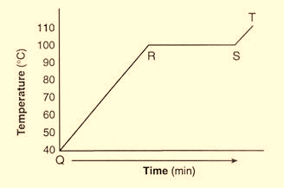
a. What state is the water in between points
Q and R?

_________________________________

b. At which point does the water begin
to evaporate?

_________________________________

c. What state is the water in at 110 ⁰C?

_________________________________

- Candle wax has a latent heat of fusion of 200 000 J/kg. If the candle is at its melting temperature, how much heat energy is needed to melt a 250 g candle?

E = m L_{f}

Heat energy = ______________

