

|  |  |  |  |
| --- | --- | --- | --- |
| **0** | **1** |  |  |

The pie chart in **Figure 1** shows the average radiation dose that a person in the UK receives each year from natural background radiation. The doses are measured in millisieverts.

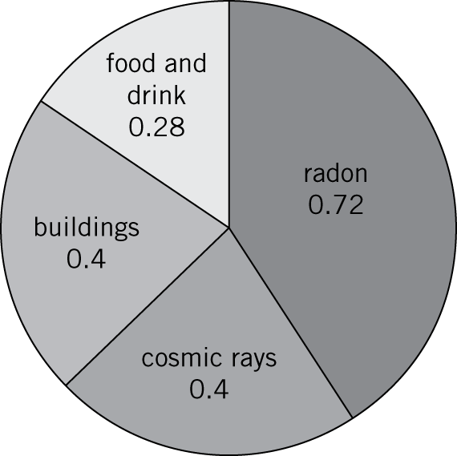

**Figure 1**

|  |  |  |  |
| --- | --- | --- | --- |
| **0** | **1** | **.** | **1** |

Calculate the percentage of natural background radiation that comes from radon.

Percentage: (*2 marks*)

|  |  |  |  |
| --- | --- | --- | --- |
| **0** | **1** | **.** | **2** |

Name **one** source of background radiation that is not from natural sources.

(*1 mark*)

|  |  |  |  |
| --- | --- | --- | --- |
| **0** | **1** | **.** | **3** |

The bar chart in **Figure 2** shows the average yearly dose from natural background radiation in different European countries in 2005.

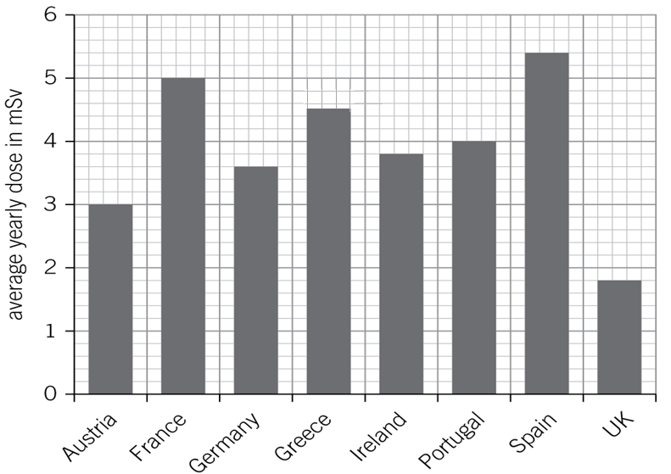

**Figure 2**

How many times bigger is the average annual background dose in Germany compared to the UK?

(*1 mark*)

|  |  |  |  |
| --- | --- | --- | --- |
| **0** | **1** | **.** | **4** |

**Table 1** gives the effects of different radiation doses on the human body.

**Table 1**

|  |  |
| --- | --- |
| Radiation dose in mSv | Effects |
| 10 000 | immediate illness; death within a few weeks |
| 1000 | radiation sickness; unlikely to cause death |
| 50 | lowest dose with evidence of causing cancer |

A family goes to Germany for a two-week holiday. Should they be concerned about the higher level of background radiation in Germany?

Circle your answer.

**Yes**

**No**

Explain your answer.

(*2 marks*)

|  |  |  |  |
| --- | --- | --- | --- |
| **0** | **1** | **.** | **5** |

A group of scientists investigate the background radiation in a mine shaft using a radiation monitor.. The results of three readings are shown.

**0.025**

**0.032**

**0.022**

Calculate the mean value of the background radiation.

(*1 mark*)

|  |  |  |  |
| --- | --- | --- | --- |
| **0** | **2** | **.** | **1** |

Label the plum pudding model of the atom in **Figure 3**. (*2 marks*)

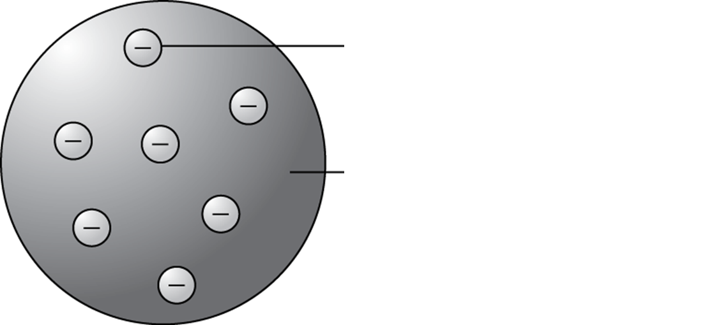

**Figure 3**

|  |  |  |  |
| --- | --- | --- | --- |
| **0** | **2** | **.** | **2** |

Many elements have radioactive isotopes.

Define the term isotope.

(*2 marks*)

|  |  |  |  |
| --- | --- | --- | --- |
| **0** | **2** | **.** | **3** |

A sample of gold atoms contains mostly gold-197, , and a few atoms of gold-195, .

Complete the table by calculating the number of particles present in gold-197 and gold-195. (*2 marks*)

|  |  |  |  |
| --- | --- | --- | --- |
| Gold atom | protons | electrons | neutrons |
| gold-197 |  |  |  |
| gold-195 |  |  |  |

|  |  |  |  |
| --- | --- | --- | --- |
| **0** | **3** |  |  |

A fragment of bone is discovered during an archaeological dig. The bone contains carbon-14 isotopes of the element carbon.

The bone is approximately 23 000 years old.

Calculate what proportion of the carbon-14 isotopes remains.

Give your answer to the nearest whole fraction.

The half-life of carbon-14 is 5730 years.

Proportion of carbon: (*2 marks*)

|  |  |  |  |
| --- | --- | --- | --- |
| **0** | **4** | **.** | **1** |

Complete the equation to show the radioactive decay of americium-243 to neptunium-239. (*2 marks*)



|  |  |  |  |
| --- | --- | --- | --- |
| **0** | **4** | **.** | **2** |

Complete equation to show the radioactive decay of carbon-14 to nitrogen-14. (*2 marks*)



|  |  |  |  |
| --- | --- | --- | --- |
| **0** | **5** | **.** | **1** |

A radioactive tracer is used in medicine to detect the flow of urine from the kidneys.

The tracer contains gamma radiation and has a half-life of 6 hours.

Explain why this tracer is suitable for the application.

(*2 marks*)

|  |  |  |  |
| --- | --- | --- | --- |
| **0** | **5** | **.** | **2** |

Using radioactive materials can cause radioactive contamination.

Describe what is meant by radioactive contamination.

(*2 marks*)

|  |  |  |  |
| --- | --- | --- | --- |
| **0** | **5** | **.** | **3** |

Some people object to the use of radioactive isotopes on animals.

Suggest **one** reason for and **one** reason against the use of tracers on animals.

Reason for:

Reason against:

(*2 marks*)

|  |  |  |  |
| --- | --- | --- | --- |
| **0** | **6** | **.** | **1** |

Describe the differences between nuclear fusion and nuclear fission.

(*4 marks*)

|  |  |  |  |
| --- | --- | --- | --- |
| **0** | **6** | **.** | **2** |

Scientists are working on developing a new type of fusion reactor to provide energy to make electricity. The fuel will be heavy hydrogen obtained from sea water. The reaction product will be helium.

Draw **two** conclusions based on the evidence in the above article to evaluate whether the development of the fusion reactor is a worthwhile project.

1.

2. (*2 marks*)