

|  |  |  |  |
| --- | --- | --- | --- |
| **0** | **1** | **.** | **1** |

Label the diagram of an atom of an element (**Figure 1**).The diagram is not drawn to scale. (*2 marks*)

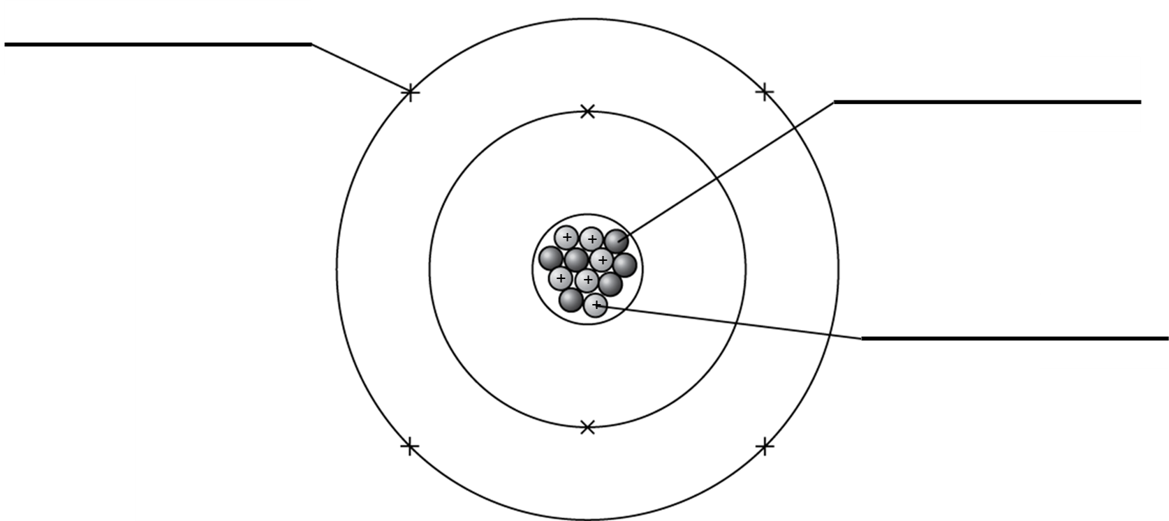

**Figure 1**

|  |  |  |  |
| --- | --- | --- | --- |
| **0** | **1** | **.** | **2** |

Give the mass number of the element.

(*1 mark*)

|  |  |  |  |
| --- | --- | --- | --- |
| **0** | **1** | **.** | **3** |

Give the atomic number of the element.

(*1 mark*)

|  |  |  |  |
| --- | --- | --- | --- |
| **0** | **1** | **.** | **4** |

Complete the sentence. Use **two** words from the box.

molecules protons electrons neutrons cells

An isotope of an element has the same number of …………………………… but a different number of ……………………………… . (*2 marks*)

|  |  |  |  |
| --- | --- | --- | --- |
| **0** | **2** |  |  |

A group of scientists investigated background radiation from some rocks in a mine shaft using a radiation monitor. The results of three readings are shown in the boxes.

**0.025**

**0.032**

**0.022**

|  |  |  |  |
| --- | --- | --- | --- |
| **0** | **2** | **.** | **1** |

Calculate the mean value of the background radiation.

Mean: (*1 mark*)

|  |  |  |  |
| --- | --- | --- | --- |
| **0** | **2** | **.** | **2** |

Give **two** sources of non-natural background radiation.

1.

2. (*2 marks*)

|  |  |  |  |
| --- | --- | --- | --- |
| **0** | **3** |  |  |

A teacher demonstrates some properties of a radioactive sample (**Figure 2**).

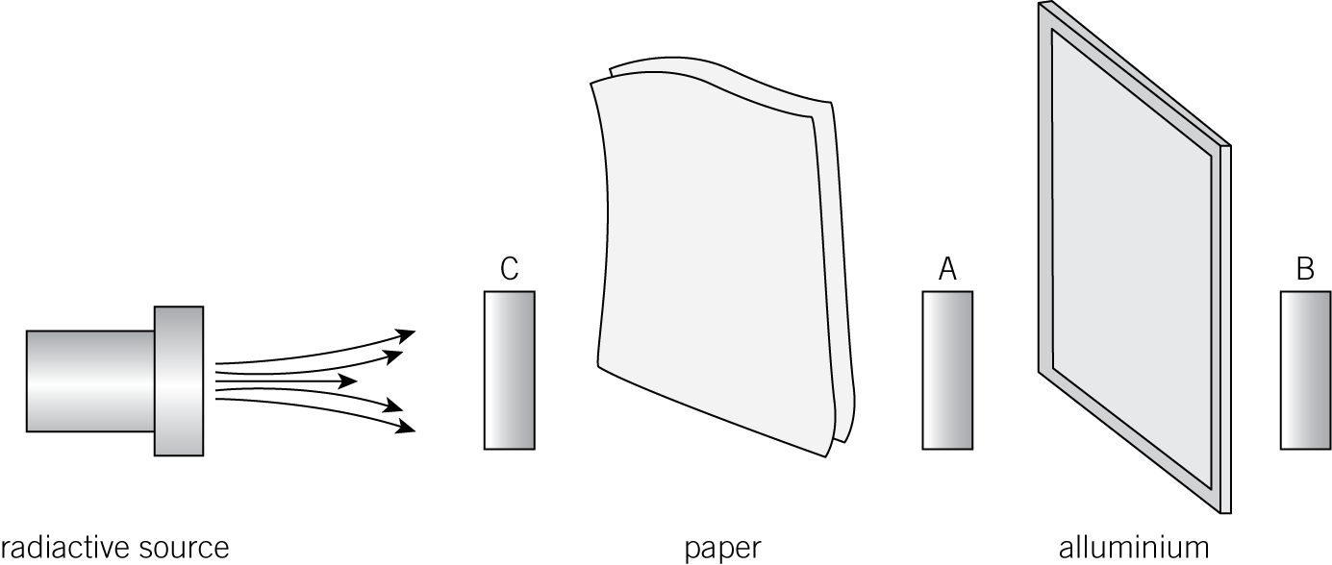

radioactive source paper aluminium

**Figure 2**

|  |  |  |  |
| --- | --- | --- | --- |
| **0** | **3** | **.** | **1** |

Identify the type of radiation you would detect at each point.

**A**

**B**

**C**: (*3 marks*)

|  |  |  |  |
| --- | --- | --- | --- |
| **0** | **3** | **.** | **2** |

Give **two** safety precautions the teacher should take.

1.

2. (*2 marks*)

|  |  |  |  |
| --- | --- | --- | --- |
| **0** | **3** | **.** | **3** |

A radioactive tracer is used in medicine to detect the flow of urine from the kidneys. The tracer contains gamma radiation and has a half-life of 3 days.

Explain why the radioactive tracer is suitable for this use.

(*3 marks*)

|  |  |  |  |
| --- | --- | --- | --- |
| **0** | **4** | **.** | **1** |

Some scientists found a fragment of bone during an archaeological dig. The bone contains isotopes of the carbon element carbon-14.

Only  of the carbon-14 is left not decayed in the bone.

Calculate the age of the bone.

The half-life of carbon-14 is 5730 years.

Age of the bone: years (*2 marks*)

|  |  |  |  |
| --- | --- | --- | --- |
| **0** | **4** | **.** | **2** |

The scientists reported their find in a scientific journal.

Explain why scientists use scientific journals to share their findings.

(*6 marks*)

|  |  |  |  |
| --- | --- | --- | --- |
| **0** | **5** | **.** | **1** |

Complete the equation to show the radioactive decay of americium-243 to neptunium-239.

(*2 marks*)

|  |  |  |  |
| --- | --- | --- | --- |
| **0** | **5** | **.** | **2** |

Complete the equation to show the radioactive decay of carbon-14 to nitrogen-14.

 (*2 marks*)

|  |  |  |  |
| --- | --- | --- | --- |
| **0** | **6** | **.** | **1** |

Name the process when the nucleus of an atom is struck by a neutron, causing the nucleus to split into two smaller fragments.

(*1 mark*)

|  |  |  |  |
| --- | --- | --- | --- |
| **0** | **6** | **.** | **2** |

Name the process when two small nuclei are fused together to form a single larger nucleus.

(*1 mark*)