Specific Latent Heat Summary questions
These are to be answered on the sheet, either typed in or printed out and hand written in and then screen shot the answers to Ms Rumbles

- Explain the changes of state for
  - Evaporation

  - Condensation

  - Melting

Include the energy changes and how the particles change how they are arranged.

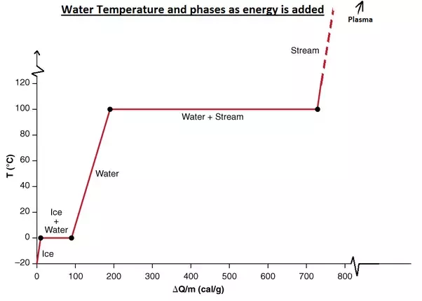

Explain why the graph is horizontal for ‘ice+water’ and ‘water+steam’.

What is happening at those 2 points?
- A 0.01kg hot stone was placed in water at 15^{oc} in an insulated plastic beaker. The mass of the water was 0.120kg. The temperature of the water increased by 9^{oc}. The specific heat capacity of the water is 4200J/Kg/oc.

  - Calculate the energy of the liquid:
Energy = mass x specific heat capacity x temperature change.

  - Use your answer from ‘a’ to calculate the specific latent heat of water.

Specific latent heat = energy
Mass

- Give the definition of latent heat.

