Home study – Review of some of the work covered

Tissue – a group of similar cells working together to perform the same function.
Organ – a group of tissues working together to perform the same function.
Organ system – a group of organs working together to perform the same function.

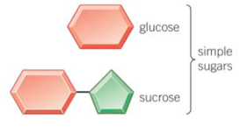
Carbohydrates
- Glucose
Test: Heat with benedict’s, will turn from blue to orange.

- Starch
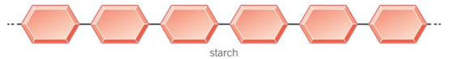
Starch is made of glucose.
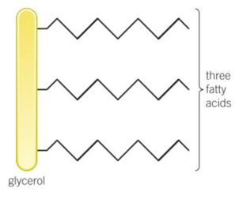
Broken down by the enzyme amylase (salivary glands and pancreas)
Test: add iodine, will turn from brown to blue/black.

Lipids (fats)
Made of x1 glycerol and x3 fatty acid chains.
Broken down by the enzyme lipase (pancreas, stomach and small intestine)
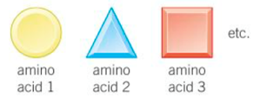
Test: Shake with ethanol, will turn from clear to cloudy white.

Protein
Made of a chain of amino acids.
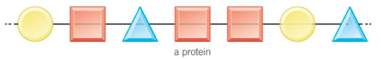
Broken down by the enzyme protease (pancreas and small intestine)
Test: Add biuret solution, will turn from blue to purple.

Enzymes
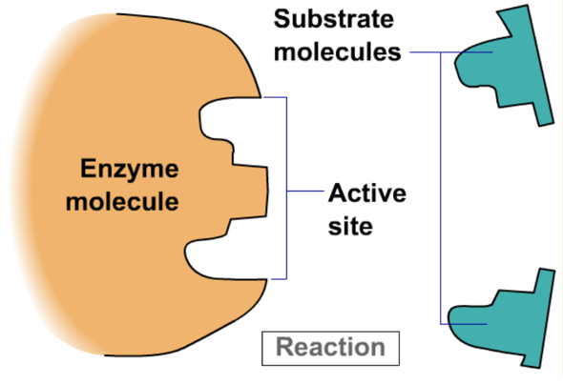
An enzyme is a protein which acts as a biological catalyst which increases the rate of reaction without being used up or changed in the process.

Each enzyme will only speed up one reaction as the shape of the enzyme molecule needs to match the shape of the substrate molecule (it must have a complimentary fit). This is called the ‘lock and key hypothesis’.
The part of the enzyme molecule which matches to a substrate is called the active site.

The rate at which an enzyme works depends on many factors, including the temperature and the pH.
If conditions stray too far from the enzymes optimum conditions the protein strands which make up the enzyme will denature, the active site will change shape and the enzyme and substrate will no longer have a complimentary fit.
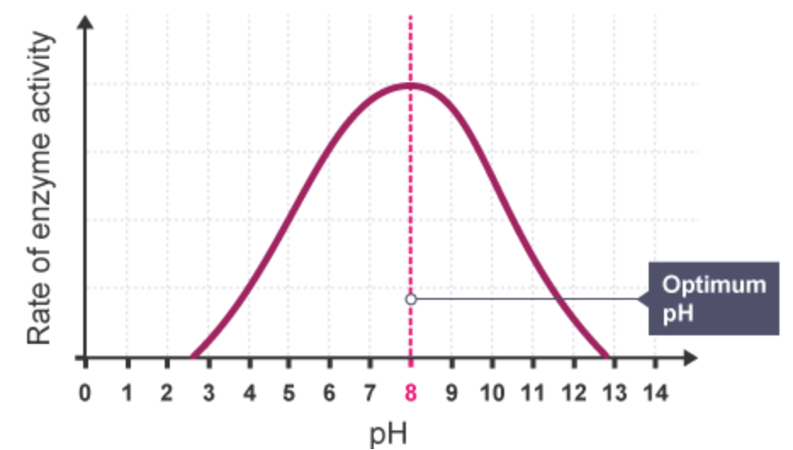
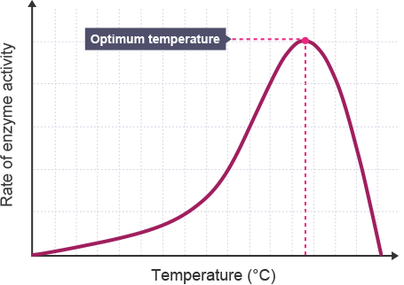

Quick-Fire Questions
To check your understanding, answer these simple questions in your exercise book or on paper.

1 | Define the term ‘tissue’
2 | State how to test for glucose.
3 | Describe the structure of a lipid.
4 | In which organ are all enzymes made?
5 | Which part of an enzyme has a specific shape?
6 | State what occurs to an enzyme if the pH changes.
7 | State the colour change for a protein food test.
8 | Enzymes and substrates have a __________ fit.
9 | The optimum temp. of enzymes in the human body is:
10 | Where does digestion of starch begin?

Exam Questions
Q1. The diagram below shows the human digestive system.
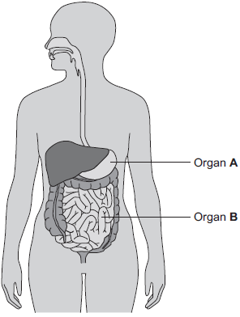
(a) (i) What is Organ A?
Draw a ring around the correct answer.
gall bladder liver stomach
(1)
(ii) What is Organ B?
Draw a ring around the correct answer.
large intestine pancreas small intestine
(1)
(b) Digestive enzymes are made by different organs in the digestive system.
Complete the table below putting a tick (✓) or cross (✕) in the boxes.
The first row has been done for you.

 |  | Organ producing enzyme
 |  | salivary glands | stomach | pancreas | small intestine
Enzyme | amylase | ✓ | ✕ | ✓ | ✓
 | lipase
 | protease
(2)
(c) The stomach also makes hydrochloric acid.
How does the acid help digestion?
__________________________________________________________
__________________________________________________________
(1)
(d) Draw one line from each digestive enzyme to the correct breakdown product.

Digestive enzyme |  | Breakdown products
 |  | amino acids.
Amylase breaks down starch into……
 |  | bases.
Lipase breaks down fats into…
 |  | fatty acids and glycerol.
Protease breaks down proteins into…
 |  | sugars.
(3)
(Total 8 marks)

Q2. Bread contains starch, protein and fat.
(a) Complete each sentence by choosing the correct words from the box.

amino acids | protein
fat | starch
fatty acids | sugar
Amylase speeds up the digestion of _________________ . The product of this digestion is _____________ . Protease speeds up the digestion of _____________ . The product of this digestion is __________________ .
(4)
(b) Why do molecules of starch, protein and fat need to be digested?
______________________________________________________
_______________________________________________________
(2)
(c) In which part of the digestive system does the digestion of starch begin?
Draw a ring around your answer.
large intestine mouth small intestine stomach
(1)
(d) What do we call substances like amylase and protease which speed up chemical reactions?
___________________________________________________________
(1)
(Total 8 marks)

