Review of home learning from w/c 23rd November
- Explain the difference between temperature and thermal energy store
____________________________________________________________________________________________________________________________________________________________________________________________________________________________________________________________________

- State the definition of internal energy
________________________________________________________________________________________________________

- What is the definition of specific heat capacity (SHC)? Give the equation as well
____________________________________________________________________________________________________________________________________________________________________________________________________________________________________________________________________

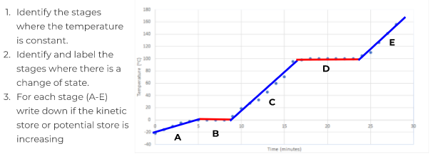
- Complete the questions about the heating curve below.

