- Energy changes and energy stores part 1 – Energy systems and energy changes

- What sort of energy store do the following examples have?
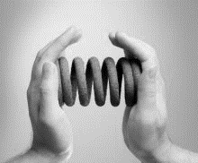
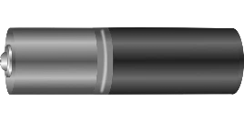
a. b. c.

a._________________ b. _____________________ c. _________________________
2. 2. Write down the correct answer to complete the statement.
Energy can not…
be transferred from one source to another.
be created or destroyed.
travel along a pathway to another store.

3. A basketball player throws the ball into the hoop. Describe the
energy store change which has taken place.

_________________________ ________________________
4. Complete the energy store and pathway diagrams for the objects described.

- A moving car braking to a stop.

CAR i ii iii

- Bringing water to the boil on a gas hob.

i GAS HOB ii iii

5. Describes the main change in energy stores for a coal fired power station.
a. Name the energy sources for:
i Input energy
ii Useful output energy
iii Wasted output energy.

b. In one hour, coal supplies 500 000 J of energy. The wasted energy
amounts to 380 000 J.
Calculate how much useful energy is produced in one hour.

6. When a football is kicked it gains kinetic energy.

- What is the formula used to calculate kinetic energy?

b. The football has a mass of 0.4 kg. When the football is kicked, it has a velocity of 15 m/s.
Calculate the kinetic energy of the moving football?

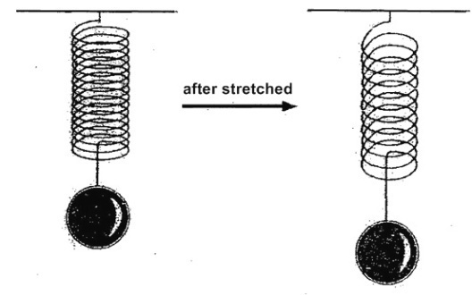
7. The un-stretched spring opposite has a length of 0.5 m but after
a mass is added it is 0.6 m long.
If the spring constant is 800 N/m.
Calculate the stored elastic potential energy.

E_{e} = ½ k e²

8. A pole vaulter just clears a bar which is 5.1 m high. His mass is 62 kg.

(g = 10 N/kg)

- Work out how much stored energy the pole vaulter has due to his
position above the ground.

- Work out how much stored energy the pole vaulter has due to his position above the ground.

- As he falls back to the ground, this energy store will be transferred into a new energy store.
Name this new energy store.

- When he lands, what happens to the energy stores described above?

C. Conservation and dissipation of energy
1.In a “closed” system …..........
A. energy can be transferred but there is no net energy loss.
B. energy and mass are transferred in and out of the system.
C. energy cannot be transferred between different energy stores.

2. The energy transfer diagram for a mobile phone shows that 100 J of electrical energy produces 45 J of light energy and 36 J of sound energy.
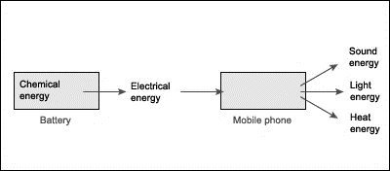
How much thermal energy will be dissipated by the phone?

3. Explain how the thermal energy produced by a bus driving along a road is dissipated.

4. a. The diagram shows the main energy transfers for an electric fan. Complete boxes A to
D showing the energy stores involved. Use the size of the arrows to help you.
B

A
C

D

b. State why the total energy supplied an electric fan must always equal the total energy
transferred by the electric fan.

5. The diagrams show two different types of loft insulation.

Fiberglass insulation Wool insulation
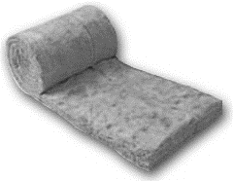
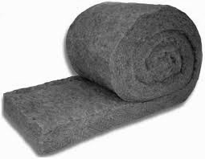

- The wool needs to be thicker to have the same insulating properties. Explain which material has the highest thermal conductivity?

- Explain how trapped air reduces the rate of heat loss, in terms of thermal conductivity.

6. The diagram represents the energy store transfers when a motor is lifting a weight.

Electrical energy 340J
gravitational potential energy 100J

Thermal
Sound 80J

- How much electrical energy is transferred to a thermal energy store?
- What is the total amount of dissipated energy?
- Calculate the efficiency fraction of the useful energy transfer.

