- Changes of state and the particle model

- Why is it incorrect to say iron is heavier than wood?
________________________________________________________________________
________________________________________________________________________

- Water has a density of 1000 kg/m³. A piece of rubber has a density of 1024 kg/m³.
Explain what would happen if the rubber was put in a pool of water?
________________________________________________________________________
________________________________________________________________________

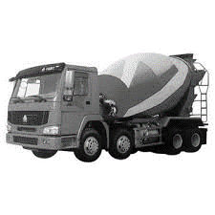
- This “ready-mix” concrete waggon contains 9600 kg of concrete.
If the density of the concrete is 2400 kg/m³, what volume of concrete
does the waggon contain?

Volume = _____________

- a. A sheet of insulating foam measures 3 m x 1 m x 0.08 m. It has a mass of 9.6 kg.
Calculate the density of the insulating foam.

Density = _____________
b. High density foam is made of the same material and can be used to give better
insulation for the same thickness of foam.
Describe how the arrangement of particles would differ in these two types of foam
(you may draw diagrams to help your answer).

_____________________________________________________________________
_____________________________________________________________________

5. When copper metal is heated to 1100 ⁰C it melts.
a. Is this a chemical or physical change? Explain your answer.

_____________________________________________________________________

b. What will happen to the mass of the sample of copper after it has melted?
Explain your answer.

_____________________________________________________________________
_____________________________________________________________________

- Explain the difference between a physical and a chemical change.
_____________________________________________________________________
_____________________________________________________________________

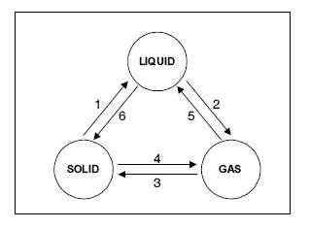
7. Name the changes in state given in
the diagram by the arrows 1 to 6.

- _______________________
- _______________________
- _______________________
- _______________________
- _______________________
- _______________________

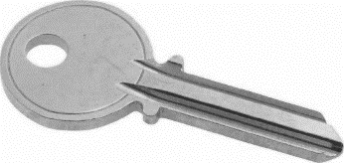
8. If you wanted to find the density of a brass key, you first need to
measure its volume. Describe how to determine the volume of a
brass key.

_____________________________________________________________________
_____________________________________________________________________
_____________________________________________________________________
_____________________________________________________________________
_____________________________________________________________________
_____________________________________________________________________

B. Internal energy and energy transfers

- Define internal energy.
_______________________________________________________________________
_______________________________________________________________________

- Which of the following will change the internal energy of a stone? (circle the correct answer

- Lifting it to the top of a building

- Heating it

- Firing it from a catapult

- Water and the chemical isooctane both boil at 100⁰C. When the same mass of each substance is placed on a heater, the isooctane boils first. Explain why this happens.

_____________________________________________________________________
_____________________________________________________________________
_____________________________________________________________________
4. A hot stone is placed into a glass of water containing 200 g of cold water. The stone transfers 25 200 J of energy to the water. How much will the temperature of the water rise?
specific heat capacity of water = 4200 J/kg ºC ΔE = m c Δθ
_____________________________________________________________________
_____________________________________________________________________
_____________________________________________________________________

5. What is specific latent heat?
_____________________________________________________________________
_____________________________________________________________________

6. Explain the difference between latent heat of fusion and latent heat of vaporisation.
_____________________________________________________________________
_____________________________________________________________________

7. A boiler is being used to heat water. The graph shows the temperature of the water every
5 minutes.
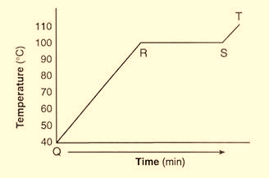
a. What state is the water in between points
Q and R?

_________________________________

b. At which point does the water begin
to evaporate?

_________________________________

c. What state is the water in at 110 ⁰C?

_________________________________

- Candle wax has a latent heat of fusion of 200 000 J/kg. If the candle is at its melting temperature, how much heat energy is needed to melt a 250 g candle?

E = m L_{f}

Heat energy = ______________

