St Bedes Catholic Voluntary Academy

Chemistry Paper 1 Higher Revision Booklet

Name:…………………………………………………………….
Class:………………………………………………………………

- The table gives information about two isotopes of hydrogen, hydrogen-1 and hydrogen-2.
1

 | Hydrogen-1 | Hydrogen-2
Atomic number | 1 | 1
Mass number | 1 | 2
An atom of hydrogen-1 is represented as: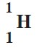

Show how an atom of hydrogen-2 is represented.

(1)
- (i) Calculate the relative formula mass (M_{r}) of water, H₂O
Relative atomic masses: H = 1; O = 16.
...............................................................................................................
...............................................................................................................
Relative formula mass (M_{r} ) = ...........................................
(1)
(ii) Simple molecules like water have low boiling points.
Explain why, in terms of molecules.
...............................................................................................................
...............................................................................................................
...............................................................................................................
...............................................................................................................
(2)
- Molecules of heavy water contain two atoms of hydrogen-2 instead of two atoms ofhydrogen-1.
Explain why a molecule of heavy water has more mass than a normal water molecule. You should refer to the particles in the nucleus of the two different hydrogen atoms in your answer.
........................................................................................................................
........................................................................................................................
........................................................................................................................
........................................................................................................................
........................................................................................................................
(2) (Total 6 marks)

- The electronic structure of a sodium atom can be written 2,8,1.
2
Write the electronic structure of a potassium atom in the same way.
.............................................................................................................................
(1)
- The electronic structure of a sodium atom can also be represented as in thediagram below.
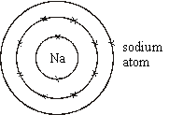
  - Draw a similar diagram for a fluorine atom.

  - Draw similar diagrams to show the electronic structure of the particles insodium fluoride.

(4)
(Total 5 marks)

The elements in Mendeleev’s periodic table were arranged in order of increasing atomic mass.
3
Part of the modem Periodic Table is shown.
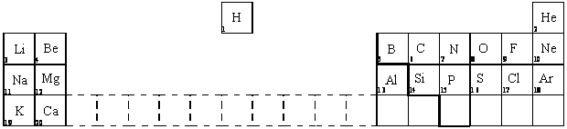
- Complete the sentence by writing in the missing words.
The modem Periodic Table is arranged in order of increasing
......................................... ......................................... .
(1)
- (i) Name a metal in the same group as lithium.
...................................................................................................................
(1)
(ii) Name a non-metal in the same period as magnesium.
...................................................................................................................
(1)
(Total 3 marks)

The diagram shows some of the elements in Groups I and 7 of the Periodic Table.
4
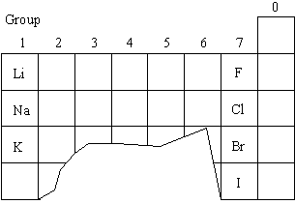
- The elements in Group 1 have similar chemical properties.
Describe one chemical reaction which shows that lithium, sodium and potassium react in the same sort of way.
You should say what you would react them with and what substances would be produced. • What you would react them with
.............................................................................................................................
• Substances produced
.............................................................................................................................
.............................................................................................................................
(3)
- All the elements in Group 7 react with hydrogen.
Fluorine reacts in the dark, explosively, at very low temperatures.
Chlorine reacts explosively in sunlight, at room temperature. Bromine, in light, only reacts if heated to about 200°C.
Suggest the conditions needed for hydrogen and iodine to react. Give reasons for your answer.
.............................................................................................................................
.............................................................................................................................(2)
- Hydrogen and chlorine react to produce hydrogen chloride. Balance the symbol equation for the reaction.
H₂ + Cl₂ → HCl
(1)
- Use your understanding of atomic structure to explain the trend in reactivity in the Group 7 elements.
.............................................................................................................................
.............................................................................................................................
.............................................................................................................................
.............................................................................................................................
(2) (Total 8 marks)

Three elements in Group 2 of the periodic table are beryllium (Be), magnesium (Mg) and calcium
5
(Ca). Their mass numbers and proton numbers are shown below. The electronic structure is shown for beryllium and calcium.
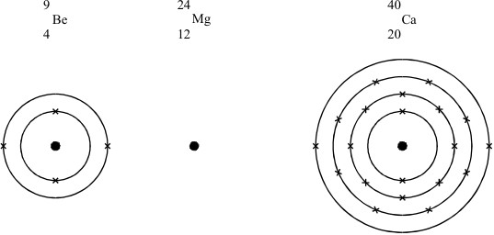
- In a similar way, draw the electronic structure for magnesium.
(3)
- • The three elements have similar chemical properties
- • The reactivity of these elements with non-metals, increases from beryllium to magnesium to calcium.
Explain these two statements in terms of atomic structure.
.............................................................................................................................
.............................................................................................................................
.............................................................................................................................
.............................................................................................................................
.............................................................................................................................
.............................................................................................................................
(6)
(Total 9 marks)

The table shows the properties of four elements from Group VII of the Periodic Table.
6
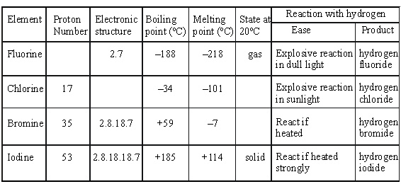
- Complete the spaces in the table.
(4)
- Comment briefly on the trend in melting points for these four elements.
.............................................................................................................................
(1)
- Explain, in as much detail as you can:
  - why the reactions of these elements with hydrogen are similar.
...................................................................................................................
...................................................................................................................
...................................................................................................................
  - why their reactivity with hydrogen decreases from fluorine to iodine.
...................................................................................................................
...................................................................................................................
...................................................................................................................
...................................................................................................................
(4)
(Total 9 marks)
- The table gives the melting points of some of the elements of Group 7.
7

Element | Atomic number | Melting point in ºC
Fluorine | 9 | –220
Chlorine | 17 | –101
Bromine | 35 | –7
Iodine | 53 | 114
Astatine | 85 | ?
  - Plot a graph of the melting point against atomic number.
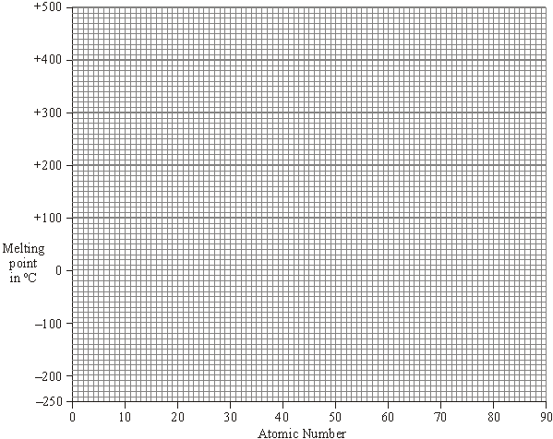
Draw a line of best fit.
Extend your line to estimate a value for the melting point of astatine.
(2)
  - Estimate the melting point of astatine. ........................................................ °C
(1)
  - Which of the Group 7 elements are solids at 20 °C?
...................................................................................................................
(1)
- (i) Draw a diagram to show the arrangement of electrons in an atom of fluorine.

(1)
(ii) The elements of Group 7 have similar chemical properties.
Explain, in terms of electrons, why they have similar chemical properties.
...................................................................................................................
...................................................................................................................
(1)
- Xenon is a very unreactive element.
  - Explain, in terms of electrons, why xenon is so unreactive.
...................................................................................................................
...................................................................................................................
...................................................................................................................
...................................................................................................................
(2)
  - Fluorine reacts with xenon but iodine does not.
Explain, in terms of atomic structure, why fluorine is more reactive than iodine.
...................................................................................................................
...................................................................................................................
...................................................................................................................
...................................................................................................................
...................................................................................................................
...................................................................................................................
(3)
(Total 11 marks)

Sodium is a reactive element.
8
- Complete the diagram to show the electronic structure of a sodium atom.
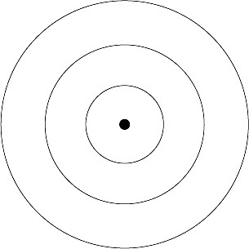
(2)
- Sodium reacts with chlorine to form sodium chloride.
Explain how in terms of electrons, atoms and ions.
........................................................................................................................
........................................................................................................................
........................................................................................................................
........................................................................................................................
........................................................................................................................
........................................................................................................................
........................................................................................................................
........................................................................................................................
(4)
(Total 6 marks)

Figure 1 shows the plum pudding model of the atom.
9
This model was used by some scientists after the discovery of electrons in 1897.
Figure 1

Plum-pudding model
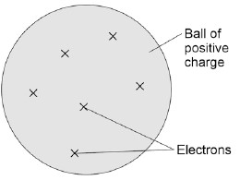
In 1911 the scientists Geiger and Marsden investigated the effect of firing alpha particles at very thin sheets of gold foil.
Their experiment is shown in Figure 2. The arrows show the paths taken by alpha particles in the experiment.

Figure 2
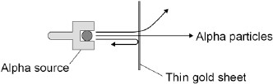
- Explain why scientists replaced the plum pudding model of the atom with the nuclear modelof the atom as a result of the experiment.
........................................................................................................................
........................................................................................................................
........................................................................................................................
........................................................................................................................
........................................................................................................................
........................................................................................................................
........................................................................................................................
........................................................................................................................
(4)
- According to modern measurements:
  - the radius of an atom is about 1 × 10^{–10}m
  - the radius of an atomic nucleus is about 1 × 10^{–14}m
Show that these values fit with the nuclear model of the atom.
........................................................................................................................
........................................................................................................................
........................................................................................................................
........................................................................................................................
(2)
- In 1931 a scientist discovered that there are hydrogen atoms with mass number 2 as wellas hydrogen atoms with mass number 1.
A year later, another scientist discovered neutrons.
Explain why the discovery of neutrons could explain the presence of hydrogen atoms with different mass numbers.
........................................................................................................................
........................................................................................................................
........................................................................................................................
........................................................................................................................
(3)
- How would the results of the experiment shown in Figure 2 change if neutrons were used instead of alpha particles to bombard a thin sheet of gold?
........................................................................................................................
........................................................................................................................
........................................................................................................................
........................................................................................................................
........................................................................................................................
........................................................................................................................
(2)
(Total 11 marks)

Here is the word equation for a chemical reaction.
10
methane + oxygen → water + carbon dioxide
Write down everything that the word equation tells you about the reaction.
...............................................................................................................................................
...............................................................................................................................................
...............................................................................................................................................
...............................................................................................................................................
...............................................................................................................................................
...............................................................................................................................................
(Total 4 marks)
Iron is used (as steel) to make the body panels for cars.
11
The iron panels have to be bendable so that they can be pressed into the shape required, but must also be strong. The panels must also be able to conduct electricity because they form part of the electrical circuits of the car.
- Iron is a typical metal. Describe the structure and bonding in a metal such as iron. You mayuse a diagram if you wish.
.............................................................................................................................
.............................................................................................................................
.............................................................................................................................
.............................................................................................................................
.............................................................................................................................
(4)
- Explain how the structure and bonding of iron:
(i) allows the body panels to conduct electricity;
...................................................................................................................
(2) (ii) allows the body panels to be bent into shape;
...................................................................................................................
(1)
(iii) gives the body panels strength....................................................................................................................
- (Total 8 marks)
12. The hydrogen halides (hydrogen fluoride, hydrogen chloride, hydrogen bromide and hydrogen iodide) are important chemicals.
The diagram below represents a molecule of hydrogen chloride.
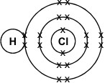
- What type of particles are represented by the crosses (X)?
.............................................................................................................................
(1)
- What type of chemical bond holds the atoms in this molecule together?
.............................................................................................................................
(1)
- Would you expect hydrogen chloride to be a gas, a liquid or a solid, at room temperature and pressure? Explain your answer.
.............................................................................................................................
.............................................................................................................................
.............................................................................................................................
(3)
Millions of years ago the Earth formed as a giant ball of molten rock. The outer surface cool
forming a thin, solid outer crust. Volcanic activity on the surface produced an atmosphere containing the compounds carbon dioxide, ammonia, methane and water vapour.
Describe the bonding in any one of these compounds. You must include electronic structures in your explanation...................................................................................................................................
...............................................................................................................................................
...............................................................................................................................................
...............................................................................................................................................
...............................................................................................................................................
...............................................................................................................................................
...............................................................................................................................................
............................................................................................................................................... (4)

(Total 9 marks)

(a) By reference to their structure, explain how the particles in a piece of metal are held
13
together and how the shape of the metal can be changed without it breaking.
(You may use a diagram in your answer.)
.............................................................................................................................
.............................................................................................................................
.............................................................................................................................
.............................................................................................................................
.............................................................................................................................
............................................................................................................................. .............................................................................................................................(5)
(b) Explain why metals are good conductors of electricity and suggest why this conductivity increases across the periodic table from sodium to magnesium to aluminium.
.............................................................................................................................
.............................................................................................................................
.............................................................................................................................
.............................................................................................................................
.............................................................................................................................
.............................................................................................................................
.............................................................................................................................
(4)
(Total 9 marks)

Silicon dioxide is used as a lining for furnaces.
14
Furnaces can be used to melt iron for recycling.
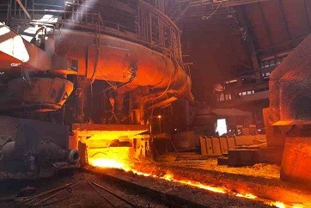
© Oleksiy Mark/iStock
The diagram shows a small part of the structure of silicon dioxide.
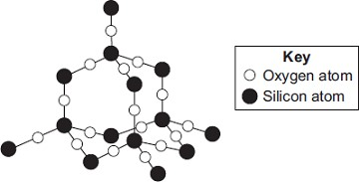
Explain why silicon dioxide is a suitable material for lining furnaces.
.................................................................................................................................
.................................................................................................................................
.................................................................................................................................
.................................................................................................................................
.................................................................................................................................
(Total 4 marks)
Aqamed is a medicine for children.
15
- The medicine is a formulation.
What is meant by a formulation?
........................................................................................................................
........................................................................................................................
(1)
- Children often do not like taking medicine.
Suggest a substance that could be added to Aqamed to increase the desire for children to take it.
Give a reason for your suggestion.
Substance ..................................................................................................
Reason ...................................................................................................
........................................................................................................................
(2)
- The main ingredient in Aqamed is a painkiller called paracetamol.
The figure below represents a molecule of paracetamol.
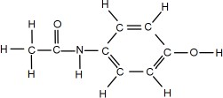
Give the molecular formula of paracetamol.
Calculate its relative formula mass (M_{r}).
Relative atomic masses (A_{r}): H = 1; C = 12; N = 14; O = 16
Molecular formula ................................................................................
Relative formula mass ................................................................................
........................................................................................................................
M_{r} = .........................................................
(2)
- Aspirin is a medicine for use by adults.
An aspirin tablet contains 300 mg of acetylsalicylic acid.
Calculate the number of moles of acetylsalicylic acid in one aspirin tablet.
Give your answer in standard form to three significant figures.
Relative formula mass (M_{r}) of aspirin = 180
........................................................................................................................
........................................................................................................................
........................................................................................................................
........................................................................................................................
........................................................................................................................
........................................................................................................................
Number of moles = ............................................
(4) (Total 9 marks)
Scientists found that a compound contained:
16
22.8% sodium; 21.8% boron; and 55.4% oxygen.
Use the percentages to calculate the empirical formula of the compound.
Relative atomic masses (A _{r}): B = 11; O = 16; Na = 23
To gain full marks you must show all your working.
.................................................................................................................................
.................................................................................................................................
.................................................................................................................................
.................................................................................................................................
.................................................................................................................................
.................................................................................................................................
.................................................................................................................................
.................................................................................................................................
.................................................................................................................................
.................................................................................................................................
.................................................................................................................................
.................................................................................................................................
Empirical formula = ............................................................
(Total 5 marks)
Some students investigated magnesium oxide.
17
- Magnesium oxide has the formula MgO.
    - Calculate the relative formula mass (M_{r}) of magnesium oxide.
Relative atomic masses: O = 16; Mg = 24.
...............................................................................................................
...............................................................................................................
Relative formula mass = .....................................
(2)
    - Calculate the percentage by mass of magnesium in magnesium oxide.
...............................................................................................................
...............................................................................................................
Percentage by mass of magnesium in magnesium oxide = .............%
(2)
    - Calculate the mass of magnesium needed to make 25 g of magnesium oxide.
...............................................................................................................
Mass of magnesium = ..................................... g
(1)
- The students calculated that if they used 0.12 g of magnesium they should make 0.20 g ofmagnesium oxide.
They did this experiment to find out if this was correct.
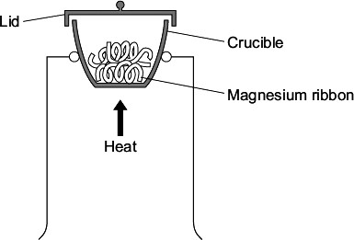
    - The students weighed 0.12 g of magnesium ribbon into a crucible.
    - They heated the magnesium ribbon.
    - They lifted the lid of the crucible slightly from time to time to allow air into the crucible.
    - The students tried to avoid lifting the lid too much in case some of the magnesiumoxide escaped.
    - When all of the magnesium appeared to have reacted, the students weighed themagnesium oxide produced.
The results of the experiment are shown below.

Mass of magnesium used in grams | 0.12
Mass of magnesium oxide produced in grams | 0.18
  - The mass of magnesium oxide produced was lower than the students had calculated.They thought that this was caused by experimental error.
Suggest two experimental errors that the students had made.
...............................................................................................................
............................................................................................................... (2)
  - The students only did the experiment once.
Give two reasons why they should have repeated the experiment.
...............................................................................................................
...............................................................................................................
...............................................................................................................
...............................................................................................................
(2) (Total 9 marks)

Titanium is a transition metal used as pins and plates to support badly broken bones. Titanium is
19
extracted from an ore that contains the mineral titanium oxide. This oxide is converted into titanium chloride. Titanium chloride is heated with sodium to form titanium metal. This reaction takes place in an atmosphere of a noble gas, such as argon.
4Na(s) + TiCl₄(l) → Ti(s) + 4NaCl(s)
Calculate the mass of titanium that can be extracted from 570 kg of titanium chloride.
Relative atomic masses: Cl 35.5; Ti 48.
...............................................................................................................................................
...............................................................................................................................................
...............................................................................................................................................
...............................................................................................................................................
Mass of titanium = ............................ kg

(Total 3 marks)
This question is about compounds.
20
(a) The table gives information about the solubility of some compounds.

Soluble compounds
All potassium and sodium salts
All nitrates
Chlorides, bromides and iodides, except those of silver and lead
Use information from the table to answer these questions.
(i) Name a soluble compound that contains silver ions.
...............................................................................................................(1)
(ii) Name a soluble compound that contains carbonate ions.
...............................................................................................................

(1)
(b) Metal oxides react with acids to make salts.
What type of compound is a metal oxide?
........................................................................................................................

(1)
(c) Lead nitrate solution is produced by reacting lead oxide with nitric acid.
(i) State how solid lead nitrate can be obtained from lead nitrate solution.
...............................................................................................................
...............................................................................................................

(1)
(ii) Balance the equation for the reaction.
PbO + HNO₃ Pb(NO₃)₂ + H₂O

(1)
(iii) Give the total number of atoms in the formula Pb(NO₃)₂
...............................................................................................................

(1)
(d) An oxide of lead that does not have the formula PbO contains 6.21 g of lead and 0.72 g of oxygen.
Calculate the empirical formula of this lead oxide.
Relative atomic masses (A_{r}): O = 16; Pb = 207
You must show your working to gain full marks.
........................................................................................................................
........................................................................................................................
Empirical formula = ........................................
(4) (Total 10 marks)
This question is about potassium.
21
- Humphrey Davy was a professor of chemistry.
In 1807 Davy did an electrolysis experiment to produce potassium.
      - Davy first tried to electrolyse a solid potassium salt to produce potassium.
Explain why this electrolysis did not work.
...............................................................................................................
...............................................................................................................
...............................................................................................................
(2)
      - Humphrey Davy was the first person to produce potassium.
Humphrey Davy’s experiment to produce this new element was quickly accepted by other scientists.
Suggest why.
...............................................................................................................(1)
- A student dissolved some potassium chloride in water. The student tried to electrolyse thepotassium chloride solution to produce potassium.
The apparatus the student used is shown in the diagram.
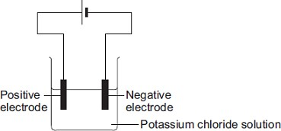
The student expected to see potassium metal at the negative electrode, but instead saw bubbles of a gas.
    - Name the gas produced at the negative electrode.
    - Explain why this gas was produced at the negative electrode and why potassium was not produced.
The reactivity series of metals on the Chemistry Data Sheet may help you to answer this question.
........................................................................................................................
........................................................................................................................
........................................................................................................................
(3)
- The student tried to electrolyse molten potassium chloride to produce potassium.
  - Potassium metal was produced at the negative electrode.
Describe how potassium atoms are formed from potassium ions.
...............................................................................................................
............................................................................................................... (2)
  - Complete and balance the equation for the reaction at the positive electrode.
...........Cl⁻ Cl₂ + ...................
(1)
  - Complete the diagram to show the electronic structure of a chloride ion (Cl⁻).
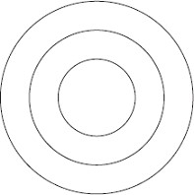
(1) (Total 10 marks)
Where copper ore has been mined there are areas of land that contain very low percentages of
22
copper compounds.
One way to extract the copper is to grow plants on the land.
The plants absorb copper compounds through their roots.
The plants are burned to produce copper oxide.
The copper oxide produced from plants can be reacted to produce copper or copper sulfate solution, as shown in Figure 1.
Figure 1
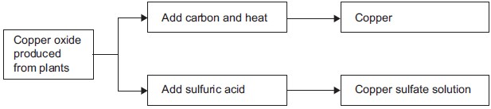
- Draw a ring around the correct answer to complete each sentence.

carbon neutral. economical. reversible.
Copper ores contain enough copper to make extraction of the
(i)
metal
(1)

photosynthesis. phytomining. polymerisation.
    - Using plants to extract metals is called
(1)

carbon dioxide.
oxygen.
sulfur dioxide.
    - Copper oxide reacts with carbon to produce copper and
(1)
- Copper is produced from copper sulfate solution by displacement using iron or byelectrolysis.
  - Complete the word equation.
copper sulfate + iron ...................... + ......................
(2)
  - Figure 2 shows the electrolysis of copper sulfate solution.
Figure 2
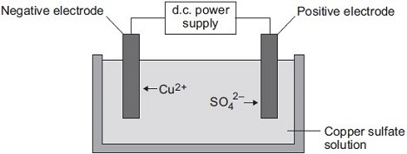
Why do copper ions go to the negative electrode?
...............................................................................................................
...............................................................................................................
(1)
- Suggest two reasons why copper should not be disposed of in landfill sites.
........................................................................................................................
........................................................................................................................
........................................................................................................................
........................................................................................................................
(2) (Total 8 marks)
The symbol equation shows the decomposition of water.
23
2H₂O → 2H₂ + O₂
An energy level diagram for this reaction is shown below.
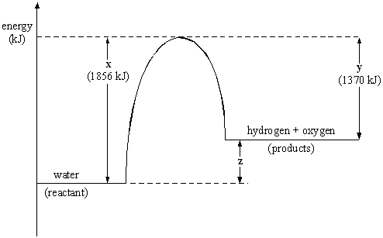
Explain the significance of x, y and z on the energy level diagram in terms of energy transfers that occur in the reaction. You should make specific reference to the bonds broken and formed and to the nett energy transfer (energy transferred to or from the surroundings).
...............................................................................................................................................
...............................................................................................................................................
...............................................................................................................................................
...............................................................................................................................................
...............................................................................................................................................
...............................................................................................................................................
...............................................................................................................................................
...............................................................................................................................................
(Total 6 marks)
Exothermic reactions transfer energy to the surroundings.
24
- Draw a reaction profile for an exothermic reaction using the axes in Figure 1.
Show the:
• relative energies of the reactants and products • activation energy and overall energy change.
Figure 1
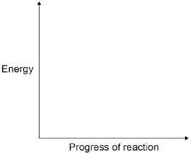
(2)
- Combustion is an exothermic reaction.
Calculate the overall energy change for the complete combustion of one mole of methane in oxygen.
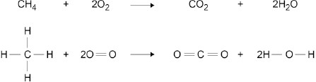

Bond | Bond energy in kJ / mol
 | 413
 | 498
 | 805
 | 464
........................................................................................................................
........................................................................................................................
........................................................................................................................
........................................................................................................................
........................................................................................................................
........................................................................................................................
Overall energy change = ................................... kJ / mol
(3)
- Figure 2 shows the chemicals given to a student.
Figure 2
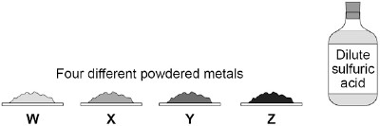
The student wants to investigate the reactivity of the four metals.
Outline a plan the student could use to investigate the relative reactivity of the four metals, W, X, Y and Z.
The plan should use the fact that all four metals react exothermically with dilute sulfuric acid.
You should name the apparatus used and comment on the safe use of the chemicals.
........................................................................................................................
........................................................................................................................
........................................................................................................................
........................................................................................................................
........................................................................................................................
........................................................................................................................
........................................................................................................................
........................................................................................................................
........................................................................................................................
........................................................................................................................
(6)
- Another student used displacement reactions to investigate the relative reactivity of the fourmetals, W, X, Y and Z.
The table below shows the student’s results.

 |  | Observations
Solution | Metal W | Metal X | Metal Y | Metal Z
Copper nitrate | Brown layer formed on metal | Brown layer formed on metal | Brown layer formed on metal | No change
Magnesium sulfate | No change | No change | No change | No change
Sulfuric acid | Gas bubbles produced | Few gas bubbles produced | Gas bubbles produced | No change
Zinc chloride | Grey layer formed on metal | No change | No change | No change
Give the order of reactivity of metals, W, X, Y and Z.
Use the results in the table above to justify your answer.
........................................................................................................................
........................................................................................................................
........................................................................................................................
........................................................................................................................
(3)
- The student concluded that these results could also be used to justify the order of reactivityof copper, magnesium, hydrogen and zinc.
The student is not completely correct. Use the results in the table above to explain why.
Suggest one further experiment that would provide evidence for the student’s conclusion.
........................................................................................................................
........................................................................................................................
........................................................................................................................
........................................................................................................................
........................................................................................................................
........................................................................................................................
........................................................................................................................
........................................................................................................................
........................................................................................................................
........................................................................................................................
(4)
(Total 18 marks)

