0 | 1
This question is about factors affecting the rate of a chemical reaction.
Draw one line connecting each factor that increases the rate of a reaction with the fullest explanation. (3 marks)
Factor |  | Explanation
 |  | smaller surface area
increasing solution temperature
 |  | more collisions every second and more collisions with enough energy to break bonds
adding a catalyst
 |  | particles have less energy
increasing gas pressure |  | more collisions every second
 |  | more collisions with enough energy to break bonds

0 | 2
This question is about the effect of concentration on the rate of a reaction.
When hydrochloric acid is added to sodium thiosulfate solution, it slowly becomes cloudy. The time taken for a cross under the solution to disappear can be used to monitor the rate of the reaction.
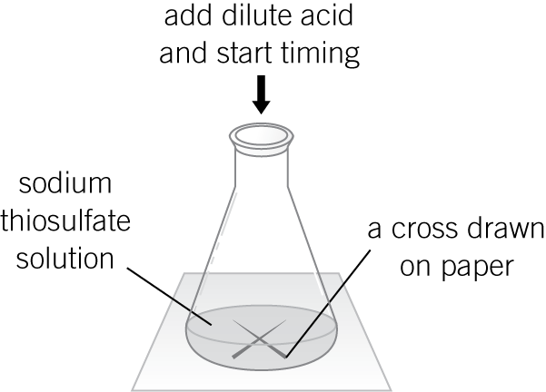
Figure 1

A student:
- measured 50 cm3 of sodium thiosulfate into a flask
- added 10 cm3 of dilute hydrochloric acid and started a stopwatch
- stopped the clock when the cross disappeared and recorded the time taken
- repeated the experiment using different concentrations of sodium thiosulfate.
The results are shown in Table 1.
Table 1
Concentration of sodium thiosulfate solution in g/dm³ | Time taken for cross to disappear in s
5 | 85
10 | 45
15 | 29
20 | 21
25 | 13
30 | 15
35 | 14

0 | 2 | . | 1
Plot these results on the grid below. Draw a line of best fit. (3 marks)
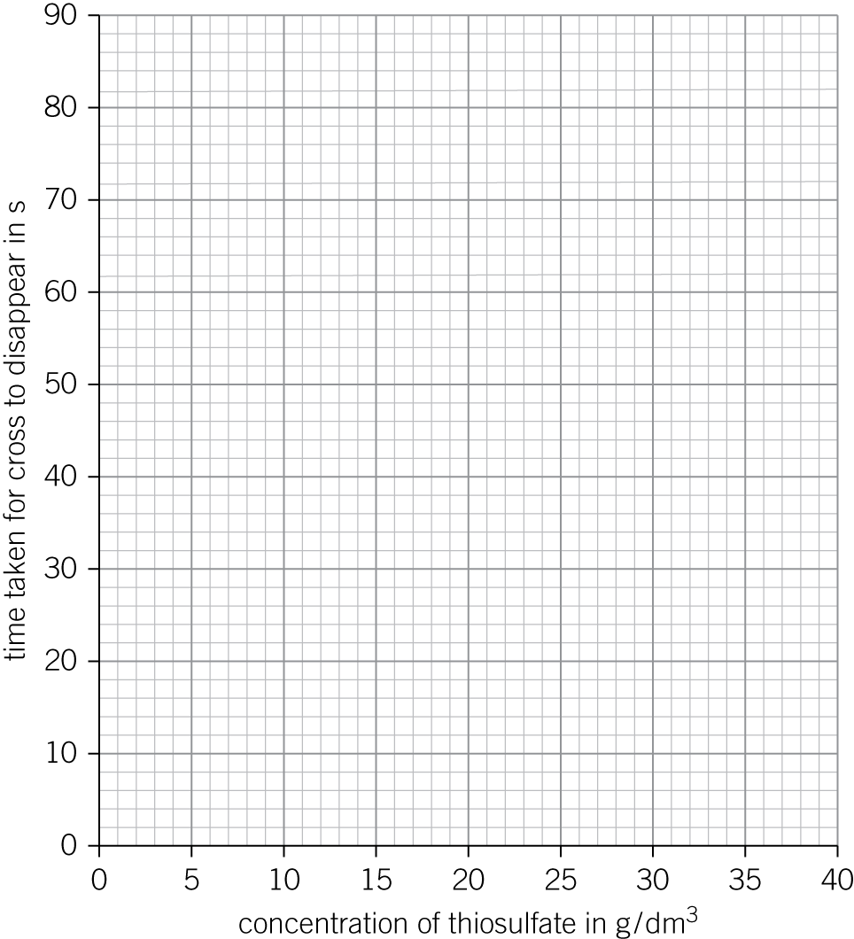
0 | 2 | . | 2
One of the points is anomalous. Describe an error in the experiment which could have produced it.

(1 mark)

0 | 2 | . | 3
Describe and explain, in terms of particles, the pattern in the results she obtained.

(3 marks)

0 | 3
Hydrated copper(II) sulfate is a blue solid. When it is heated, water is given off as steam and the crystals turn white. The reaction is reversible.
Describe an experiment to investigate this chemical change. You should outline the method you would use, name any apparatus required, and describe two pieces of evidence that the reaction is reversible.

(6 marks)

0 | 4
A student investigates the rate of reaction between marble chips (calcium carbonate) and dilute hydrochloric acid.
The equation for the reaction is:
CaCO3(s) + 2 HCl(aq) → CaCl2(aq) + H2O(l) + CO2(g)
His results are shown in Table 2.
Table 2
Time in s | Volume of carbon dioxide in cm³
0 | 0.0
20 | 45.0
40 | 62.0
60 | 70.5
80 | 75.0
100 | 78.0
120 | 79.5
140 | 80.0
160 | 80.0
180 | 80.0

0 | 4 | . | 1
Complete the diagram to show how the carbon dioxide is collected. Label the apparatus the gas is collected in with its name. (2 marks)

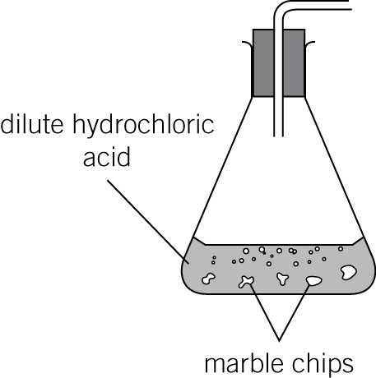

0 | 4 | . | 2
The results were plotted as a line graph in Figure 2.
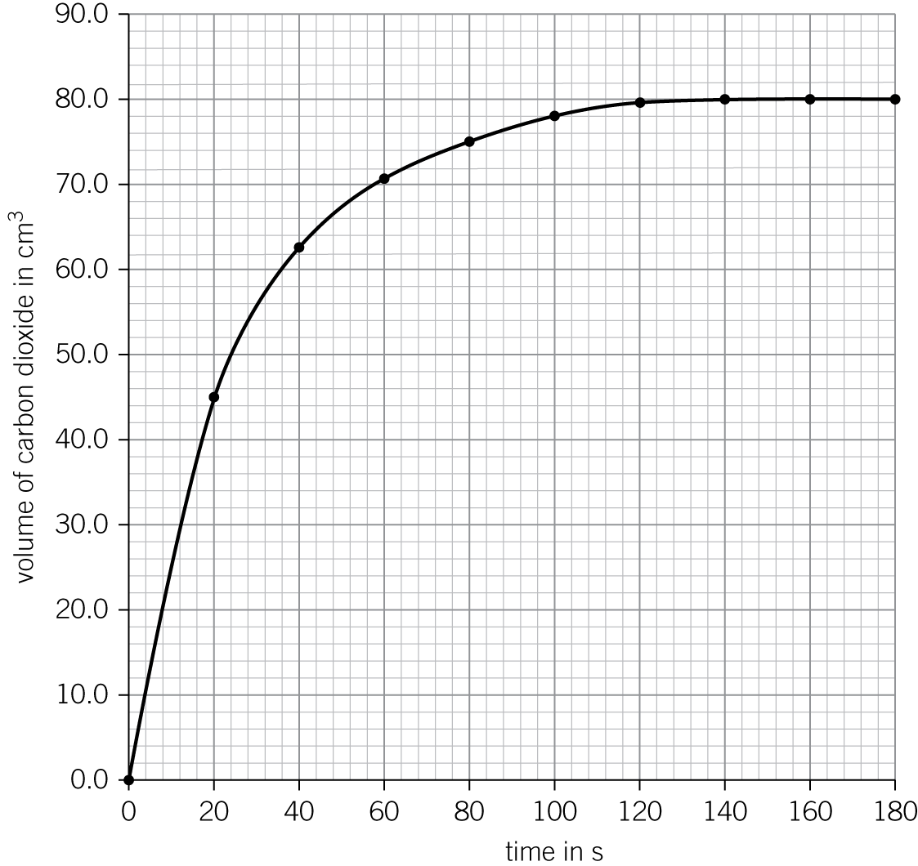
Figure 2
Use Figure 2 to identify at what time the experiment has the fastest rate of reaction. Explain your answer.

(2 marks)

0 | 4 | . | 3
On Figure 2, sketch the results the student would obtain if he used the same mass of powdered marble instead of marble chips. (2 marks)

0 | 4 | . | 4
Explain the shape of the graph after 140 seconds.

(1 mark)

0 | 5
The Contact process is an industrial method for making sulfuric acid from sulfur, oxygen, and water.
One important reaction in the Contact process is:
2SO2(g) + O2(g) ⇌ 2SO3(g)
sulfur dioxide oxygen sulfur trioxide
The reaction is exothermic in the forwards direction.

0 | 5 | . | 1
State the meaning of the symbol ⇌.
(1 mark)

0 | 5 | . | 2
Describe and explain the effect of increasing pressure on the amount of sulfur trioxide at equilibrium.

(2 marks)

0 | 5 | . | 3
The reaction is carried out at a temperature of 450 °C.
Describe and explain the effect of raising the temperature above 450 °C on the amount of sulfur trioxide at equilibrium.

(2 marks)

0 | 5 | . | 4
A vanadium pentoxide catalyst is used.
Explain how the use of a catalyst increases the rate of the reaction.

(2 marks)

