GCSE Physics
Boyle’s Law Questions
- Gases under pressure exert pressure due to collisions between the particles of the gas and the walls of the container
- Compressing a gas increases the rate of collisions (they happen more often) so the pressure is increased
- For a fixed mass of gas at a constant temperature, the pressure is inversely proportional to the volume. This is known as Boyle’s law and can be written as:
$$p_{1}V_{1}= p_{2}V_{2}$$

- The pressure of a sample of gas in a sealed container is changed with the temperature remaining the same. Which statement is correct?
A. If pressure is doubled, the volume also doubles
B. If pressure is halved, the volume also doubles
C. If pressure is halved, the volume is also halved
D. If pressure is doubled, the volume reduces to a quarter

- The diagram represents the particles in a sample of air inside a sealed syringe.
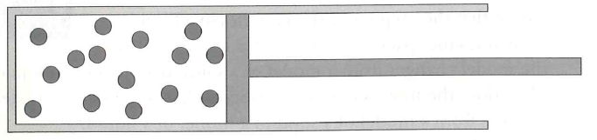

- Add arrows to show how the particles could be moving.
The piston is now pulled out so that the gas occupies double the original volume.
- Draw a second diagram to show the effect this has on the particles or describe any changes to the particle arrangement or movement.

c. What effect does this have on the pressure of the air?
- A sample of gas is at atmospheric pressure (100 000 Pa) and has volume 50cm³ (Leave in cm³)
- Determine the new pressure if the volume is halved.

- Determine the new pressure if the volume is doubled.

- Determine the new pressure if the volume is decreased to 35cm³. (Leave in cm³)

- Determine the new volume if the pressure is reduced to 78 000 Pa.

- Circle the two graphs below that could represent the relationship between pressure and volume (for a fixed mass of gas at constant temperature).
$$P$$
$$V$$
$$P$$
$$\frac{1}{V}$$

$$P$$
$$\frac{1}{V}$$
$$P$$

$$V$$
- Fill in the blanks:

For a fixed ____________________of gas at constant ____________________, the pressure of a gas increases as the ____________________ of its container ____________________.

- Fill in the blanks: Leave in the current units.
P₁ | V₁ | P₂ | V₂
100 000 Pa | 5 m³ | 50 000 Pa
100 000 Pa | 2 m³ | 400 000 Pa
250 000 Pa |  | 450 000 | 1 m³
1.2 x 10⁵Pa | 10 m³ | 6.0 x 10⁵ Pa
100 kPa | 240 cm³ |  | 150 cm³

Extension
- A carbon dioxide gas cylinder contains 180cm³ of gas at a pressure of 6.3 x 10⁶ Pa.
- Calculate the volume of the gas at atmospheric pressure, 1.0 x 10⁵ Pa.

The cylinder valve is opened and the gas is collected at atmospheric pressure.
- Explain why less gas would be collected than the answer to a.?

Carbon dioxide does not liquefy when put under pressure. Butane gas (used in camping gas cylinders) does liquefy.
- Explain how the cylinders used to store carbon dioxide would be different from those used to store butane (camping gas).

