St Bedes Catholic Voluntary Academy

Biology Paper 1 Higher Revision Booklet

Name:…………………………………………………………….
Class:………………………………………………………………

The image below shows an epithelial cell from the lining of the small intestine.
1
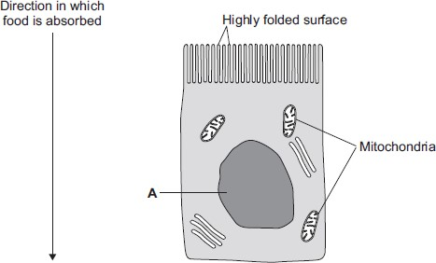
(a) (i) In the image above, the part of the cell labelled A contains chromosomes.
What is the name of part A?
...............................................................................................................

(1)
(ii) How are most soluble food molecules absorbed into the epithelial cells of the small intestine?
Draw a ring around the correct answer.

diffusion osmosis respiration

(1)
(b) Suggest how the highly folded cell surface helps the epithelial cell to absorb soluble food.
........................................................................................................................
........................................................................................................................

(1)
(c) Epithelial cells also carry out active transport.
(i) Name one food molecule absorbed into epithelial cells by active transport.
...............................................................................................................

(1)
(ii) Why is it necessary to absorb some food molecules by active transport?
...............................................................................................................
...............................................................................................................

(1)
(ii) Suggest why epithelial cells have many mitochondria.
...............................................................................................................
...............................................................................................................
...............................................................................................................
...............................................................................................................
(2)
(d) Some plants also carry out active transport.
Give one substance that plants absorb by active transport.
........................................................................................................................

(1) (Total 8 marks)
The figure below shows four different types of cell.
2
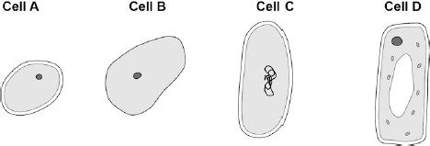
- Which cell is a plant cell?
Give one reason for your answer.
Cell ..................
Reason ..........................................................................................................
(2)
- Which cell is an animal cell?
Give one reason for your answer.
Cell ..................
Reason ..........................................................................................................
(2)
- Which cell is a prokaryotic cell?
Give one reason for your answer.
Cell ..................
Reason ..........................................................................................................
(2)
- A scientist observed a cell using an electron microscope.
The size of the image was 25 mm.
The magnification was × 100 000
Calculate the real size of the cell.
Use the equation:
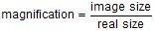
Give your answer in micrometres.
........................................................................................................................
........................................................................................................................
........................................................................................................................
Real size = .................................... micrometres

(3) (Total 9 marks)

The drawing shows part of a root hair cell.
3
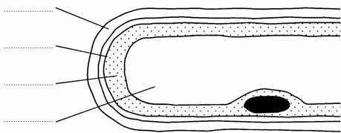
- Use words from the list to label the parts of the root hair cell.
cell membrane cell wall cytoplasm nucleus vacuole
(4)
- The diagram shows four ways in which molecules may move into and out of a cell. Thedots show the concentration of molecules.
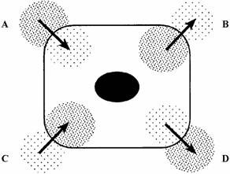
The cell is respiring aerobically.
Which arrow, A, B, C or D represents:
    - movement of oxygen molecules; ....................
    - movement of carbon dioxide molecules? ....................
(2)
- Name the process by which these gases move into and out of the cell.
.....................................................................................................................................
(1)

(Total 7 marks)

- How many pairs of chromosomes are there in a body cell of a human baby?
4
.....................................................................................................................................
(1)
- Place the following in order of size, starting with the smallest, by writing numbers 1 – 4 in the boxes underneath the words.
(1)
- For a baby to grow, its cells must develop in a number of ways.
Explain how each of the following is part of the growth process of a baby. (i) Cell enlargement
..........................................................................................................................

(1) (ii) The process of cell division by mitosis
..........................................................................................................................
..........................................................................................................................
..........................................................................................................................
..........................................................................................................................
..........................................................................................................................
..........................................................................................................................
(3)
- Why is cell specialisation (differentiation) important for the development and growth of ahealthy baby from a fertilised egg?
.....................................................................................................................................
.....................................................................................................................................
(2)

(Total 8 marks)

- The diagrams show what happens to the shape of a plant cell placed in distilled water.
5
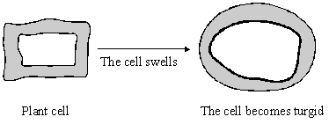
  - Explain why the cell swells and becomes turgid. Name the process involved.
..........................................................................................................................
..........................................................................................................................
..........................................................................................................................
(2)
  - Give one feature of the cell wall which allows the cell to become turgid.
..........................................................................................................................
(1)

- Describe the change which will occur if a piece of peeled potato is placed in a concentratedsugar solution and explain why this change occurs.
.....................................................................................................................................
.....................................................................................................................................
.....................................................................................................................................
.....................................................................................................................................
.....................................................................................................................................
.....................................................................................................................................
(3)
(Total 6 marks)
Diagrams A, B and C show cells from different parts of the human body, all drawn to the same scale
6
A B C
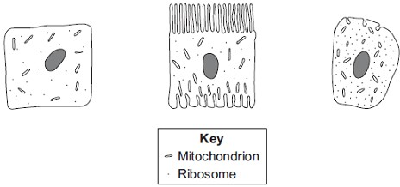
- Which cell, A, B or C, appears to be best adapted to increase diffusion into or
out of the cell?
Give one reason for your choice.
........................................................................................................................
........................................................................................................................
(1)
- (i) Cell C is found in the salivary glands.
Name the enzyme produced by the salivary glands.
...............................................................................................................
(1)
(ii) Use information from the diagram to explain how cell C is adapted for producing this enzyme.
...............................................................................................................
...............................................................................................................
...............................................................................................................
...............................................................................................................
(2)
(Total 4 marks)
Oxygen is transported round the body by the blood.
7
Blood leaving the human lung can carry about 250 milligrams of oxygen per litre.
However, only 7 milligrams of oxygen will dissolve in one litre of water at body temperature.
- Suggest an explanation for the difference.
........................................................................................................................
........................................................................................................................
........................................................................................................................
(2)
- Blood leaving the skeletal muscles during exercise may contain only 30 milligrams ofoxygen per litre.
Explain what causes the difference in oxygen concentration between the blood leaving the lungs and the blood leaving the skeletal muscles.
........................................................................................................................
........................................................................................................................
........................................................................................................................
........................................................................................................................
........................................................................................................................
........................................................................................................................
........................................................................................................................
(4)
(Total 6 marks)
The drawings show the structure of three types of blood vessel, A, B and C. They are drawn to
8the scales indicated.
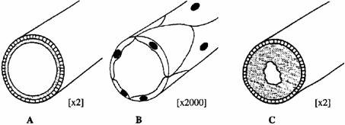
- Name the three types of blood vessel.
  - ..............................................................
  - ..............................................................
  - ..............................................................
(3)
- Describe the job of blood vessel B.
.....................................................................................................................................
.....................................................................................................................................
.....................................................................................................................................
.....................................................................................................................................
(2)
(Total 5 marks)

The graph shows the effect of increasing the carbon dioxide content of the inhaled air on:
9
- the number of breaths per minute;
- the total volume of air breathed per minute.
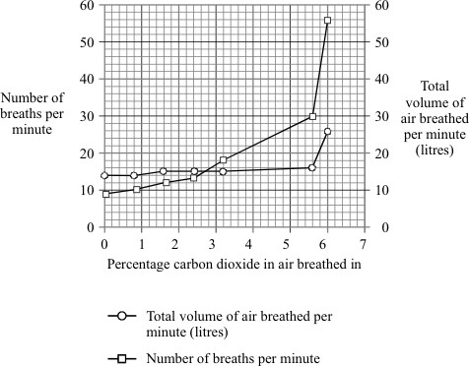
- Describe the effect of increasing the percentage of carbon dioxide in the inhaled air on thetotal volume of air breathed.
.....................................................................................................................................
.....................................................................................................................................
.....................................................................................................................................
.....................................................................................................................................
(2)
- Suggest why the total volume of inhaled air is not directly proportional to the number of breaths per minute.
.....................................................................................................................................
.....................................................................................................................................
.....................................................................................................................................
.....................................................................................................................................
(2)
(Total 4 marks)

The diagram shows part of the human digestive system.
10
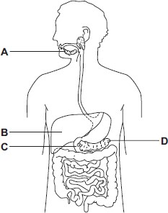
- Name the parts of the digestive system labelled A, B, C and D.
    - ................................................................................
    - ................................................................................
    - ................................................................................
    - ................................................................................
(4)
- A student has eaten a steak for dinner. The steak contains protein and fat.
    - Describe how the protein is digested.
...............................................................................................................
...............................................................................................................
...............................................................................................................
...............................................................................................................
...............................................................................................................
...............................................................................................................
(3)
    - Explain two ways in which bile helps the body to digest fat.
...............................................................................................................
...............................................................................................................
...............................................................................................................
...............................................................................................................
...............................................................................................................
...............................................................................................................
(4)
- A group of students investigated the action of salivary amylase.The students:
    - collected a sample of salivary amylase
    - put a different pH solution and 5 cm³ of a food substance in each of 6 test tubes
    - added 1 cm³ of salivary amylase to each of the 6 test tubes
    - recorded the amylase activity after 10 minutes.
The results are shown in the table.

pH | 7 | 6 | 5 | 4 | 3 | 2
Amylase activity in arbitrary units | 12 | 10 | 3 | 0 | 0 | 0
  - Name the food substance that amylase breaks down.
...............................................................................................................
(1)
  - Suggest what happens to the breakdown of this substance when food reaches the stomach.
Use information from the table to help you to answer this question.
...............................................................................................................
...............................................................................................................
...............................................................................................................
...............................................................................................................
...............................................................................................................(3)
(Total 15 marks)

There are enzymes in biological washing powders. Biological washing powder has to be used at
11
temperatures below 45 °C.
- The enzymes in biological washing powders do not work on the stains on clothes at temperatures above 45 °C.
Explain why.
........................................................................................................................
........................................................................................................................
........................................................................................................................
........................................................................................................................
(2)
- Some bacteria, called thermophilic bacteria live in hot springs at temperatures of 80 °C.
Scientists have extracted enzymes from these thermophilic bacteria. These enzymes are being trialled in industrial laundries.
The laundries expect to increase the amount of clothes they can clean by using enzymes from thermophilic bacteria instead of using the biological washing powders the laundries use now.
  - The laundries expect to be able to increase the amount of clothes that they can cleaneach day.
Suggest why.
...............................................................................................................
...............................................................................................................
...............................................................................................................
(2)
  - Using washing powders with enzymes from thermophilic bacteria may be more harmful to the environment than using the biological washing powders that laundries use now.
Suggest why.
...............................................................................................................
...............................................................................................................
...............................................................................................................
(2)
(Total 6 marks)

The parts of the blood can be separated from each other by spinning the blood in a centrifuge.
12
The image below below shows the separated parts of a 10 cm³ blood sample.
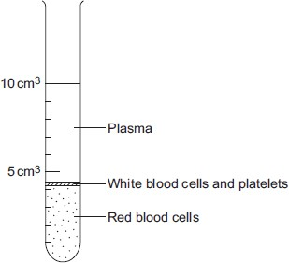
- Calculate the percentage of the blood that is made up of plasma.
........................................................................................................................
........................................................................................................................
Answer = .............................. %
(2)
- Name three chemical substances transported by the plasma.
1........................................................................................................................
2........................................................................................................................
3........................................................................................................................
(3)
- In this question you will be assessed on using good English, organising information clearly and using specialist terms where appropriate.
White blood cells are part of the immune system. White blood cells help the body to defend itself against pathogens.
Describe how pathogens cause infections and describe how the immune system defends the body against these pathogens.
........................................................................................................................
........................................................................................................................
........................................................................................................................
........................................................................................................................
........................................................................................................................
........................................................................................................................
........................................................................................................................
........................................................................................................................
........................................................................................................................
(6)
(Total 11 marks)

(a) Respiration is a process which takes place in living cells. What is the purpose of
13 respiration?
.....................................................................................................................................
.....................................................................................................................................

(1)
(b) (i) Balance the equation for the process of respiration when oxygen is available.
C₆H₁₂O₆ + O₂ → CO₂ + H₂O

(1)
(ii) What is the name of the substance in the equation with the formula C₆H₁₂O₆?
..........................................................................................................................

(1)
(c) Oxygen is absorbed through the alveoli in the lungs.
(i) How are the alveoli adapted for this function?
..........................................................................................................................
..........................................................................................................................
..........................................................................................................................

(2)
(ii) Name the gas which is excreted through the alveoli.
..........................................................................................................................

(1)
(d) (i) What is the name of the process of respiration when oxygen is not available?
..........................................................................................................................

(1)
(ii) Describe the process of respiration which takes place in human beings when oxygen is not available and give an effect.
..........................................................................................................................
..........................................................................................................................
..........................................................................................................................
..........................................................................................................................
..........................................................................................................................
..........................................................................................................................
(3)
(Total 10 marks)

- The table shows the effect of exercise on the action of one person’s heart.
14
 | At rest | During exercise
Heart rate in beats per minute | 72 | 165
Volume of blood leaving the heart in each beat in cm³ | 75 | 120
Heart output in cm³ per minute | 5400
  - Calculate the heart output for this person during exercise.
Show clearly how you work out your answer.
...........................................................................................................................
...........................................................................................................................
...........................................................................................................................
...........................................................................................................................
Answer = .............................. cm³ per minute
(2)

  - During exercise, more oxygen is carried to the working muscles.
Explain why this is helpful during exercise.
...........................................................................................................................
...........................................................................................................................
...........................................................................................................................
...........................................................................................................................
...........................................................................................................................
(2)
- Give two other changes in the body that help to increase the amount of oxygen delivered to the working muscles during exercise.
  - ..................................................................................................................................
.....................................................................................................................................
  - ..................................................................................................................................
.....................................................................................................................................
(2)
(Total 6 marks)

The diagram shows some plants growing in a greenhouse on a hot summer’s day.
15
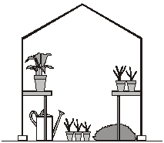
Which one of the following factors is most likely to limit the rate of photosynthesis at this time?
- carbon dioxide concentration
- light intensity
- temperature
Factor ............................................................................................
Explain the reason for your answer.
...............................................................................................................................................
...............................................................................................................................................
...............................................................................................................................................
...............................................................................................................................................
...............................................................................................................................................
...............................................................................................................................................
(Total 4 marks)
One factor that may affect body mass is metabolic rate.
16
- (i) What is meant by metabolic rate?
...............................................................................................................
...............................................................................................................
(1)

(ii) Metabolic rate is affected by the amount of activity a person does.
Give two other factors that may affect a person’s metabolic rate.
1............................................................................................................. ...............................................................................................................
2.............................................................................................................
...............................................................................................................
(2)
- Predicted early death is the number of years that a person will die before the mean age of death for the whole population. The predicted early death of a person is affected by their body mass.
Scientists have calculated the effect of body mass on predicted early death.
The graph shows the results of the scientists’ calculations.
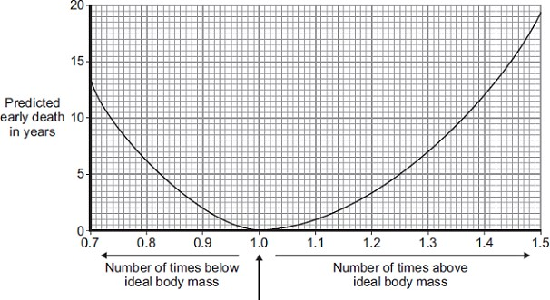
Ideal body mass
The number of times above or below ideal body mass is given by the equation:
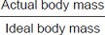
In the UK the mean age of death for women is 82.
A woman has a body mass of 70 kg. The woman’s ideal body mass is 56 kg.
  - Use the information from the graph to predict the age of this woman when she dies.
Age at death = ......................... years
(2)
  - The woman could live longer by changing her lifestyle.
Give two changes she should make.
1...............................................................................................................
...............................................................................................................
2...............................................................................................................
………………….….................................................................................... (2)
(Total 7 marks)

A student investigated the effect of light intensity on the rate of photosynthesis in pondweed.
17
- The formula for glucose is C₆H₁₂O₆
Use the formula for glucose to write the balanced symbol equation for photosynthesis.
........................................................................................................................
(2)
- Figure 1 shows the apparatus the student used.
Figure 1
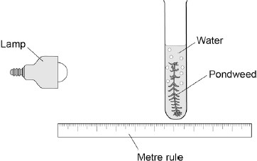
The student altered the distance of the lamp from the pondweed and counted the number of bubbles produced in 30 seconds for each distance.

The table below shows the student’s results.

Distance in cm | Number of bubbles produced in 30 seconds
10 | 27
20 | 23
30 | 16
40 | 7
50 | 2
Use the data in the table above to complete the graph on Figure 2.
Figure 2
(3)
- The student concluded that the rate of photosynthesis is inversely proportional to thedistance of the lamp from the pondweed.
Does the student’s data support this conclusion?
Use data from Figure 2 to justify your answer.
........................................................................................................................
........................................................................................................................
........................................................................................................................
........................................................................................................................
........................................................................................................................
(3)
- The volume of one bubble can be calculated using the equation:
V = 4 / 3 π r³
The radius of one bubble is 0.1 cm.
The value for π is 3.14
Use data from the table above and the information above to calculate the rate of gas production at a distance of 40 cm.
Give your answer in standard form to three significant figures.
........................................................................................................................
........................................................................................................................
........................................................................................................................
........................................................................................................................
........................................................................................................................
........................................................................................................................
........................................................................................................................
Rate of reaction = .................................... cm³ per minute
(5)
(Total 13 marks)

