St Bedes Catholic Voluntary Academy

Biology Paper 1 Foundation Revision Booklet

Name:…………………………………………………………….
Class:………………………………………………………………

The image below shows an epithelial cell from the lining of the small intestine.
1
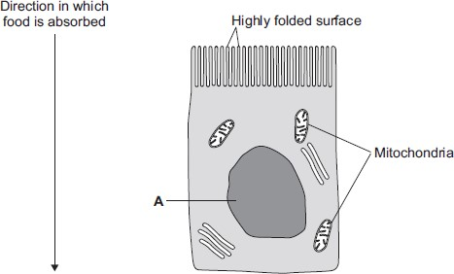
(a) (i) In the image above, the part of the cell labelled A contains chromosomes.
What is the name of part A?
...............................................................................................................

(1)
(ii) How are most soluble food molecules absorbed into the epithelial cells of the small intestine?
Draw a ring around the correct answer.

diffusion osmosis respiration

(1)
(b) Suggest how the highly folded cell surface helps the epithelial cell to absorb soluble food.
........................................................................................................................
........................................................................................................................

(1)
(c) Epithelial cells also carry out active transport.
(i) Name one food molecule absorbed into epithelial cells by active transport.
...............................................................................................................

(1)
(ii) Why is it necessary to absorb some food molecules by active transport?
...............................................................................................................
...............................................................................................................

(1)
(ii) Suggest why epithelial cells have many mitochondria.
...............................................................................................................
...............................................................................................................
...............................................................................................................
...............................................................................................................
(2)
(d) Some plants also carry out active transport.
Give one substance that plants absorb by active transport.
........................................................................................................................

(1) (Total 8 marks)

The diagrams show four types of cell, A, B, C and D.
2
Two of the cells are plant cells and two are animal cells.
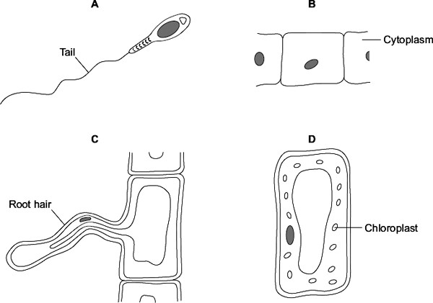
- (i) Which two of the cells are plant cells?
Tick () one box.

A and B

A and D

C and D
(1)
  - Which part is found only in plant cells?
Draw a ring around one answer.

cell membrane cell wall nucleus
(1)

- (i) Which cell, A, B, C or D, is adapted for swimming?
(1)

  - Which cell, A, B, C or D, can produce glucose by photosynthesis?
(1)
(c) Cells A, B, C and D all use oxygen.
For what process do cells use oxygen?
Draw a ring around one answer.

osmosis photosynthesis | respiration
(1)
(Total 5 marks)

The diagrams show an animal cell and a bacterial cell.
3
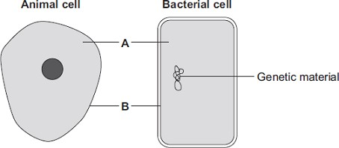
- (i) Structures A and B are found in both the animal cell and the bacterial cell.
Use words from the box to name structures A and B.

cell membrane | chloroplast | cytoplasm | vacuole
  - ............................................................
  - ............................................................
(2)
(ii) Both cells contain genetic material.
Name the structure in the animal cell that contains genetic material.
............................................................

(1)

- List A gives three structures found in animal cells.
List B gives four functions of cell structures.
Draw one line from each structure in List A to its correct function in List B.

List A – Structure List B – Function
Controls what enters the cell
Cell membrane
Photosynthesis
Mitochondrion
Protein synthesis
Ribosome
Respiration
(3)
(6 marks)
- The diagram shows the structure of a bacterial cell.
4
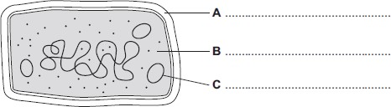
  - On the diagram use words from the box to label structures A, B and C.

cell membrane | cell wall | chloroplast | cytoplasm | plasmid
(3)
  - Give one difference between the structure of the bacterial cell and an animal cell.
...............................................................................................................
(1)
  - Name one structure that is found in a plant cell but is not found in a bacterial or an animal cell.
...............................................................................................................
(1)
- Cells can be specialised for a particular job.
The diagram shows the structure of a human sperm cell.
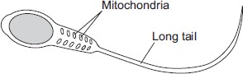
Describe how the long tail and the mitochondria help the sperm to do its job.
Long tail..........................................................................................................
........................................................................................................................
........................................................................................................................
Mitochondria...................................................................................................
........................................................................................................................
........................................................................................................................
(4)
(Total 9 marks)
The diagram shows a cell.
5
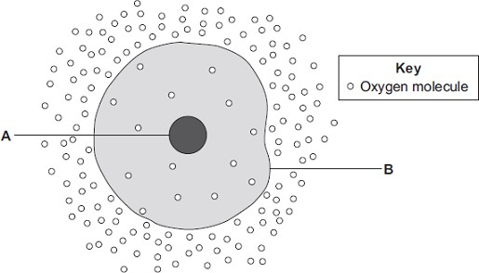
- (i) Use words from the box to name the structures labelled A and B .

cell membrane | chloroplast | cytoplasm | nucleus
  - .......................................................
  - .......................................................
(2)
(ii) The cell in the diagram is an animal cell.
How can you tell it is an animal cell and not a plant cell?
Give two reasons.
  - ............................................................................................................
...............................................................................................................
  - ............................................................................................................
...............................................................................................................
(2)
- Oxygen will diffuse into the cell in the diagram.
Why?
Use information from the diagram.
........................................................................................................................
........................................................................................................................
(1)
- The cell shown in the diagram is usually found with similar cells.
Draw a ring around the correct answer to complete the sentence.

an organ. a system. a tissue.

Scientists call a group of similar cells

(1)
(Total 6 marks)

The image below shows some muscle cells from the wall of the stomach, as seen through a light
6
microscope.
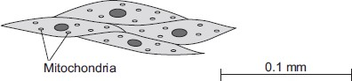
- Describe the function of muscle cells in the wall of the stomach.
........................................................................................................................
........................................................................................................................
........................................................................................................................
........................................................................................................................
(2)
- Figure above is highly magnified.
The scale bar in Figure above represents 0.1 mm.
Use a ruler to measure the length of the scale bar and then calculate the magnification of Figure above.
........................................................................................................................
........................................................................................................................
........................................................................................................................
........................................................................................................................
Magnification = ............................. times
(2)
- The muscle cells in Figure above contain many mitochondria.
What is the function of mitochondria?
........................................................................................................................
........................................................................................................................
........................................................................................................................
........................................................................................................................
(2)
- The muscle cells also contain many ribosomes. The ribosomes cannot be seen in Figure above.
- What is the function of a ribosome?
...............................................................................................................
...............................................................................................................
(1)
- Suggest why the ribosomes cannot be seen through a light microscope.
...............................................................................................................
...............................................................................................................
(1)
(Total 8 marks)
Diagram 1 shows the nucleus of a body cell as it begins to divide by mitosis.
7
Diagram 1
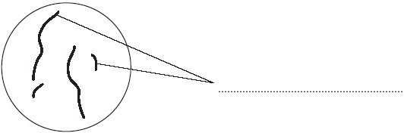
- Use a word from the box to label Diagram 1.

alleles chromosomes gametes
(1)
- Complete Diagram 2 to show what the nucleus of one of the cells produced by this mitosis would look like.
Diagram 2
(1)
- Stem cells from a recently dead embryo can be grown in special solutions.
Some facts about stem cells are given below.
  - Stem cells from an embryo can grow into any type of tissue.
  - Stem cells may grow out of control, to form cancers.
  - Large numbers of stem cells can be grown in the laboratory.
  - Stem cells may be used in medical research or to treat some human diseases.
  - Patients treated with stem cells need to take drugs for the rest of their life to prevent rejection.
  - Collecting and growing stem cells is expensive.
Use only the information above to answer these questions.
(i) Give two advantages of using stem cells.
    - ........................................................................................................................
...........................................................................................................................
    - ........................................................................................................................
...........................................................................................................................
(2)
(ii) Give two disadvantages of using stem cells.
    - ........................................................................................................................
...........................................................................................................................
    - ........................................................................................................................
...........................................................................................................................
(2)
(Total 6 marks)

Cells contain a solution of salts and sugars.
8
A student is investigating how cells change when they are put into water.
- The student:
  - looks at a plant cell using a microscope
  - adds water to the cell.
The plant cell swells up.
Explain why, as fully as you can.
........................................................................................................................
........................................................................................................................
........................................................................................................................
........................................................................................................................
........................................................................................................................
........................................................................................................................
(3)
- When animal cells are put in water, they swell up, and then burst. When plant cells are put in water, they swell up, but do not burst.
How does the structure of plant cells prevent them from bursting?
........................................................................................................................
........................................................................................................................
(1)
(Total 4 marks)

The diagram shows a cell from a plant leaf.
9
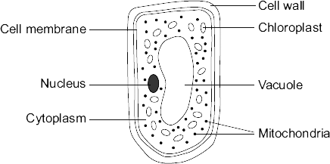
- Name the part of this cell that:
  - controls the passage of substances in and out of the cell
...............................................................................................................
(1)
  - is filled with cell sap.
...............................................................................................................
(1)
- Give the names of two parts of the leaf cell that would not be found in a human liver cell.
.................................................. and ..................................................
(2)
- The chloroplasts produce oxygen.
Draw a ring around the correct answer to complete the sentence.

diffusion. digestion. respiration.

The oxygen produced by the chloroplasts passes out of the cell by

(1)
(Total 5 marks)

The diagrams show four types of cell, A, B, C and D.
10
Two of the cells are plant cells and two are animal cells.
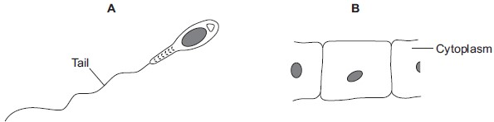
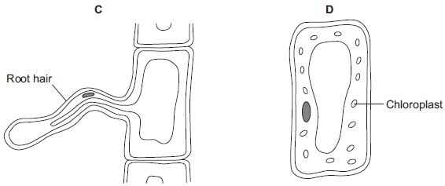
- (i) Which two of the cells are plant cells?
Tick () one box.
A and B
A and D
C and D
(1)
(ii) Give one reason for your answer.  ...............................................................................................................  ............................................................................................................... | (1)
- (i) Which cell, A, B, C or D, is adapted for swimming?
(1)
(ii) Which cell, A, B, C or D, can produce glucose by photosynthesis?
(1)
(c) Cells A, B, C and D all use oxygen.
For what process do cells use oxygen?
Draw a ring around one answer.

osmosis photosynthesis | respiration
(1)
(Total 5 marks)

Complete the table to show which part of the blood carries out each function.
11
Choose your answers from the list.
plasma platelet red blood cell white blood cell
The first answer has been done for you.

Function | Part of the blood
Transports most of the carbon dioxide | plasma
Transports most of the oxygen
Helps blood to clot at a wound
Defends the body against microorganisms
Transports the products of digestion

(Total 4 marks)

- Draw a ring around one word to answer each of the following questions.
12
  - Which type of blood vessel carries blood out of the heart?
artery capillary vein
(1)
  - Which type of blood vessel allows substances to enter and leave the blood?
artery capillary vein
(1)
- Use words from the box to complete the sentences.
alveoli cell membrane nucleus
plasma red blood cells villi
Oxygen enters the blood through the walls of the .................................................... . Most of the oxygen transported by the blood is carried in the
................................................................................................................................... .
A red blood cell is different from other body cells because it does not have a
.................................................................. .
(3)
(Total 5 marks)
Our lungs help us to breathe.
13The image below shows the human breathing system.
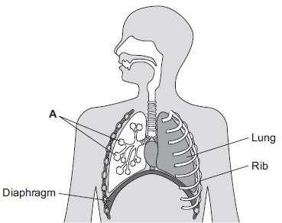
- (i) Name part A.
...............................................................................................................
(1)
(ii) Give one function of the ribs.
...............................................................................................................
(1)
- (i) Use the correct answer from the box to complete the sentence.

active transport | diffusion | osmosis
Oxygen moves from the air inside the lungs into the blood by the
process of .................................................... .
(1)
  - Use the correct answer from the box to complete the sentence.

arteries | capillaries | veins
Oxygen moves from the lungs into the blood through the walls
of the .................................................... .
(1)
  - Inside the lungs, oxygen is absorbed from the air into the blood.
Give two adaptations of the lungs that help the rapid absorption of oxygen into the blood.
- ...........................................................................................................
..............................................................................................................
- ...........................................................................................................
..............................................................................................................
(2) (Total 6 marks)
Bread contains starch, protein and fat.
14
- Complete each sentence by choosing the correct words from the box.
amino acids protein
fat starch
fatty acids sugar

Amylase speeds up the digestion of .................................... . The product of this digestion is ............................. . Protease speeds up the digestion of ............................. .
The product of this digestion is .............................................. .
(4)
- Why do molecules of starch, protein and fat need to be digested?
.....................................................................................................................................
.....................................................................................................................................
(2)
- In which part of the digestive system does the digestion of starch begin?Draw a ring around your answer.
large intestine mouth small intestine stomach
(1)
- What do we call substances like amylase and protease which speed up chemicalreactions?
.....................................................................................................................................
(1)
(Total 8 marks)

The table shows the mass of carbon dioxide passed into the atmosphere in one year.

15
 | Mass of carbon dioxide passed into the atmosphere in billions of tonnes per year
Animals | 45
Plants | 15
Microorganisms | 60
Human activity | 9
- (i) Calculate the total mass of carbon dioxide passed into the atmosphere in one year.
...............................................................................................................
...............................................................................................................
Answer = .................................................. billion tonnes
(1)
(ii) Plants take 120 billion tonnes of carbon dioxide out of the atmosphere per year.
Use your answer to part (a)(i) to calculate the change in the mass of carbon dioxide in the atmosphere in one year.
...............................................................................................................
...............................................................................................................
Answer = .................................................. billion tonnes
(1)
- The drawing shows part of a campaign to encourage householders to reduce thetemperature of the water used to wash clothes.
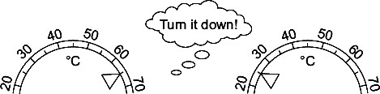
Give two advantages to the environment of reducing the temperature of the water used to wash clothes.
  - .....................................................................................................................
........................................................................................................................
  - .....................................................................................................................
........................................................................................................................
(2)
- A householder reduces the temperature of the water he uses to wash clothes.
He finds that some stains are not removed at the new temperature.
He decides to use a biological washing powder. Biological washing powders contain enzymes.
    - Draw a line from each enzyme in List 1 to the type of stain the enzyme will remove, in List 2.
List 1 List 2
Enzyme Type of Stain
Starch
Protease
Fat
Lipase
Protein
(2)
    - The biological washing powder would not have removed the stains from clothes if the water had been at 65 °C.
Use one word from the box to complete the sentence.
killed | denatured | diffused
At 65 °C the enzymes would be ..............................................................................
(1)

(Total 7 marks)
The human body is organised to carry out many different functions.
16
- Use words from the box to complete Figure 1 by putting the parts of the body in order of size from smallest to largest.
The smallest one has been done for you.
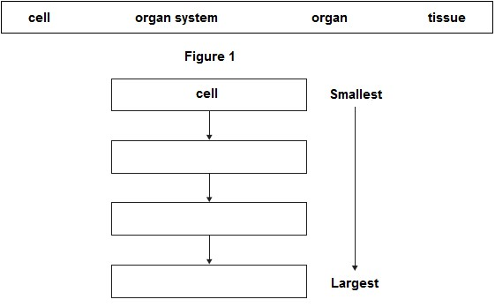
(2)
- The stomach is made of different types of tissue.
Draw one line from each type of stomach tissue to the correct description.
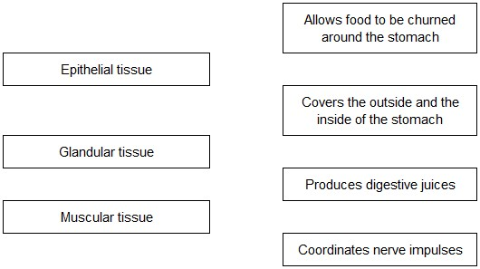
(3)
- Animals can react to their surroundings because they have nervous systems.
A student investigated the behaviour of small animals called woodlice.
The student set up the investigation as shown in Figure 2.
- The student covered one half of a Petri dish with black paper to make that side of thePetri dish dark.
- The other side had no cover.
- The student put five woodlice into each side of the dish and then put the clear Petridish lid back on the dish.
Figure 2
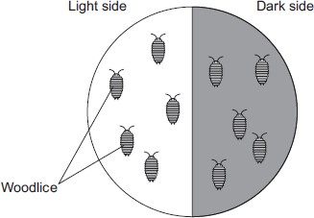
After 30 minutes, all the woodlice had moved to the dark side of the Petri dish.
- In this investigation, what is the stimulus that the woodlice responded to?
...............................................................................................................
(1)
- In this investigation, what is the response that the woodlice made?
...............................................................................................................
(1)
- The student concluded that woodlice prefer dark conditions.
Give two ways in which the student could improve the investigation to be sure that his conclusion was correct.
1............................................................................................................. ...............................................................................................................
2.............................................................................................................
...............................................................................................................
(2)
(Total 9 marks)

Pathogens cause infectious diseases in animals and plants.
17
- Draw one line from each disease to the type of pathogen that causes the disease.

Disease Type of pathogen

Bacterium
Gonorrhoea
Fungus
Malaria
Protist
Measles
Virus
(3)
- Some parts of the human body have adaptations to reduce the entry of live pathogens.
Look at Figure 1.

Figure 1
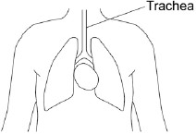
Explain how the trachea is adapted to reduce the entry of live pathogens.
........................................................................................................................
........................................................................................................................
........................................................................................................................
........................................................................................................................
........................................................................................................................
........................................................................................................................ (4)
(c) Malaria is a serious disease that can be fatal.
Malaria is spread to humans by infected mosquitoes.
Scientists investigated the behaviour of mosquitoes to understand how the spread of malaria could be controlled.
Figure 2 shows the equipment the scientists used.

Figure 2
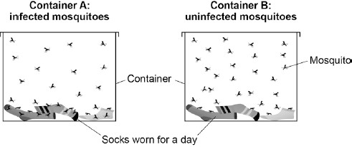
This is the method used.
- 30 mosquitoes infected with malaria were placed in Container A.
- 30 uninfected mosquitoes were placed in Container B.
- The total number of times the mosquitoes landed on the socks was recorded.
Name the dependent variable and suggest one control variable in this investigation.
Dependent variable ........................................................................................
........................................................................................................................
Control variable ..............................................................................................
........................................................................................................................
(2)
- Infected mosquitoes landed on the socks three times more often than uninfectedmosquitoes.
Explain how this information can be used to reduce the spread of malaria.
........................................................................................................................
........................................................................................................................
........................................................................................................................
........................................................................................................................
(2)
- Tobacco mosaic virus (TMV) affects many species of plant.
Figure 3 shows a leaf infected with TMV.

Figure 3
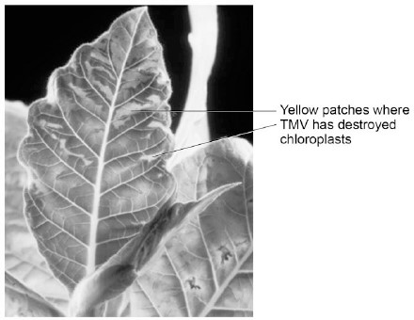
© Nigel Cattlin/Getty Images
TMV destroys chloroplasts in the leaf.
Explain how this could affect the growth of the plant.
........................................................................................................................
........................................................................................................................
........................................................................................................................
........................................................................................................................
........................................................................................................................
........................................................................................................................
(3)
(Total 14 marks)
- (i) Complete the word equation for the process of aerobic respiration.
18
Glucose + ........................... → carbon dioxide + water
(1)
(ii) Which organ removes carbon dioxide from your body?
.................................................................................................................
(1)

- Use names from the box to complete the two spaces in the passage.
carbon dioxide lactic acid nitrogen oxygen water
Anaerobic respiration can occur when an athlete does vigorous exercise.
This is because there is not enough ....................................................... in the body.
The product of anaerobic respiration is ................................................................. .
(2)
(Total 4 marks)
An athlete did a 6-month training programme.
19
The graph shows the effect of the same amount of exercise on his heart rate before and after the training programme.
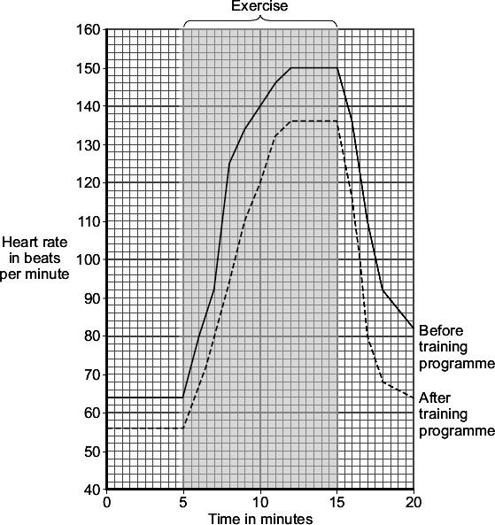
- (i) What was the maximum heart rate of the athlete during exercise before the trainingprogramme?
.................................................. beats per minute
(1)
(ii) Give two differences between the heart rate of the athlete before and after the training programme.
After the training programme
Difference 1 ..........................................................................................
...............................................................................................................
Difference 2 ..........................................................................................
...............................................................................................................
(2)
- Which two substances need to be supplied to the muscles in larger amounts during exercise?
Tick () two boxes.

Carbon dioxide

Glucose

Lactic acid

Oxygen

Urea
(2)
(Total 5 marks)

Photosynthesis uses carbon dioxide to make glucose.
20
(a) (i) Complete the equation for photosynthesis.
carbon dioxide + ..........................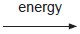 glucose + ....................

(2)
(ii) What type of energy does a plant use in photosynthesis?
...............................................................................................................

(1)
(iii) Which part of a plant cell absorbs the energy needed for photosynthesis?
...............................................................................................................

(1)
(b) The graph shows the effect of the concentration of carbon dioxide on the rate of photosynthesis in tomato plants at 20 °C.
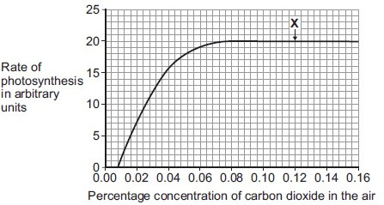
(i) What is the maximum rate of photosynthesis of the tomato plants shown in the graph?
.......................... arbitrary units

(1)
(ii) At point X, carbon dioxide is not a limiting factor of photosynthesis.
Suggest one factor that is limiting the rate of photosynthesis at point X.
...............................................................................................................

(1)
(c) A farmer plans to grow tomatoes in a large greenhouse.
The concentration of carbon dioxide in the atmosphere is 0.04%.
The farmer adds carbon dioxide to the greenhouse so that its concentration is 0.08%.
- Why does the farmer use 0.08% carbon dioxide?
Tick () one box.

To increase the rate of growth of the tomato plants
To increase the rate of respiration of the tomato

plants
To increase water uptake by the tomato plants
(1)
- Why does the farmer not use a concentration of carbon dioxide higher than 0.08%?
Tick () two boxes.

Because it would cost more money than using 0.08%
Because it would decrease the temperature of the greenhouse
Because it would not increase the rate of photosynthesis of the

tomato plants any further
Because it would increase water loss from the tomato plants
(2)
(Total 9 marks)
(a) Complete the word equation for photosynthesis.
21

energy
carbon dioxide + water glucose + .....................................

(1)
(b) Draw a ring around the correct answer to complete each sentence.

light.
osmosis. respiration.
(i) The energy needed for photosynthesis comes from

(1)

chloride. chloroplast. chlorophyll.
(ii) Energy is absorbed by a green pigment called

(1)

decrease. increase. stay the same.
(iii) If the temperature is decreased the rate of photosynthesis will

(1)
(c) Give three ways in which plants use the glucose made in photosynthesis.
- .....................................................................................................................
........................................................................................................................
- .....................................................................................................................
........................................................................................................................
- .....................................................................................................................
........................................................................................................................

(3)
(Total 7 marks)

