0 | 1
This question is about specialised cells.
Figure 1 shows a nerve cell and a root hair cell.
Figure 1
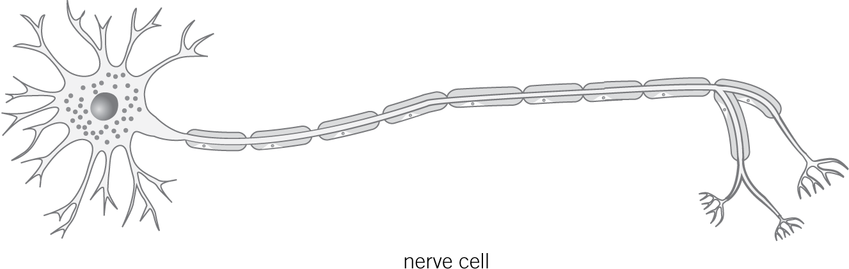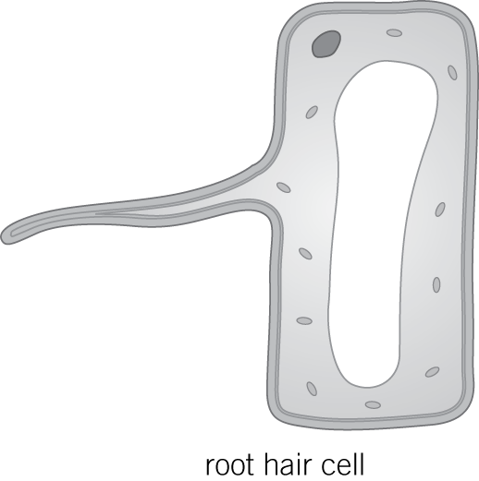

0 | 1 | . | 1
What is the function of a nerve cell?
(1 mark)

0 | 1 | . | 2
How is a nerve cell adapted for this function?
(1 mark)

0 | 1 | . | 3
There are thousands of root hair cells on a plant root.
Explain how these help the plant.

(2 marks)

0 | 2
Figure 2 shows a sperm cell.
Figure 2
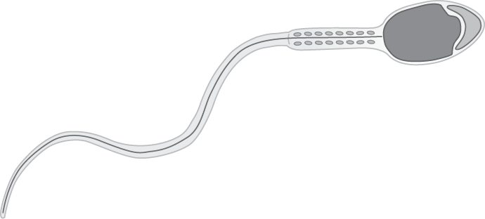

0 | 2 | . | 1
Describe how a sperm cell is adapted for its function.

(2 marks)

0 | 2 | . | 2
A student observed a sperm cell using a microscope.
The sperm cell image measured 22 mm long.
The real length of the sperm cell is 0.055 mm.
Use the equation to calculate the magnification the student used to see the sperm cell.

(2 marks)

0 | 2 | . | 3
How can you tell that the sperm cell is an animal cell and not a plant cell?
Give one reason.

(1 mark)

0 | 3
Substances can move into and out of cells.
0 | 3 | . | 1
Use the correct answer from the box to complete each sentence.
active transport diffusion higher lower osmosis the same
Oxygen enters cells by the process of
It moves from an area of concentration to an area of concentration. (3 marks)
0 | 3 | . | 2
Give one factor that affects the rate of movement of oxygen into and out of cells.
(1 mark)

0 | 4
A student investigated the effect of different concentrations of salt solution on the mass of chips.
The student:
- cut five chips from one potato
- weighed each chip
- placed each chip into a different concentration of salt solution
- left the chips for one hour
- then removed the chips from the salt solutions and reweighed them.
The student’s results are shown Table 1.
Table 1
Concentration of salt solution in M | 0.0 | 0.5 | 1.0 | 2.0 | 3.0
Mass of chip at start in grams | 2.5 | 2.8 | 2.8 | 2.5 | 2.6
Mass of chip after one hour in grams | 2.7 | 2.8 | 2.7 | 2.3 | 2.1

0 | 4 | . | 1
Draw one line from each variable to its description.
Variable |  | Description
Concentration of salt solution |  | Control variable
Length of time left in solution |  | Dependent variable
Change in mass |  | Independent variable
(2 marks)

0 | 4 | . | 2
The 0 M salt solution did not contain any salt. It was just water.
Calculate the change in mass of the chip placed in the 0 M solution.

grams (1 mark)

0 | 4 | . | 3
What caused this change in the mass of the chip placed in the 0 M solution?
Tick () one box.
A The chip absorbed salt
B The chip absorbed water
C The chip lost water
D The chip lost salt (1 mark)

0 | 4 | . | 4
In which concentration of salt solution was there no change in the mass of the chip?

M (1 mark)

0 | 4 | . | 5
What does your answer to 04.4 suggest about the concentration of salt solution inside the chip?

(1 mark)

0 | 4 | . | 6
Suggest one way the student could have made his investigation more valid?

(1 mark)

0 | 5
Figure 3 shows a plant cell.
Figure 3
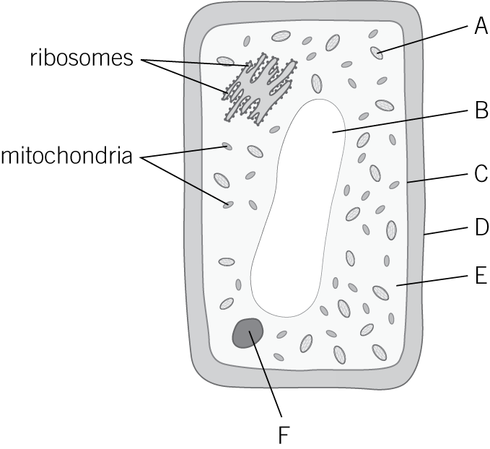

0 | 5 | . | 1
Which part of the cell shown in Figure 3 is the cell wall?
(1 mark)

0 | 5 | . | 2
Name the chemical that the cell wall is made of.
(1 mark)

0 | 5 | . | 3
Which part of the cell shown in Figure 3 controls what enters and leaves the cell?
What is this structure called?
(2 marks)

0 | 5 | . | 4
In which part of the cell shown in Figure 3 does photosynthesis take place?
What is the name of this structure?
(2 marks)

0 | 5 | . | 5
What is the function of ribosomes?

(1 mark)

0 | 5 | . | 6
In which type of animal cell would you find a lot of mitochondria?
Give a reason for your answer.

(2 marks)

0 | 5 | . | 7
Name one part of a plant cell that is also found in bacterial cells.
(1 mark)

0 | 6
A student prepared a slide of onion epidermis to observe under a microscope.
Two of the slides she prepared are shown in Figure 3.
Figure 3
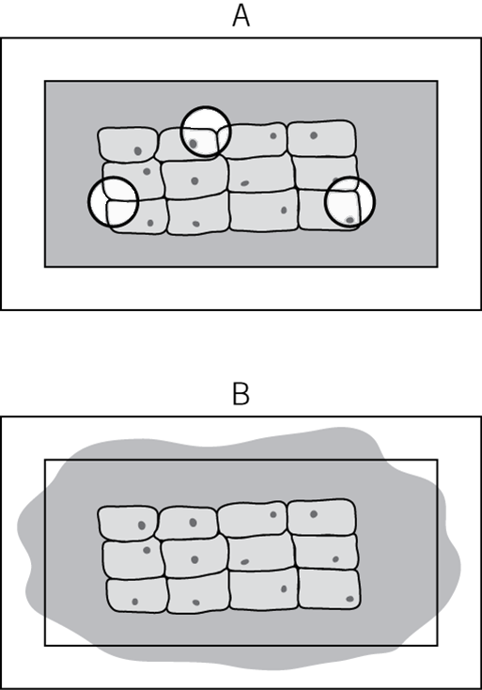

0 | 6 | . | 1
Describe what is wrong with slide A.
Suggest how this problem can be avoided.

(2 marks)

0 | 6 | . | 2
Describe what is wrong with slide B.
Suggest how this problem could be corrected.

(2 marks)

0 | 6 | . | 3
When observing a slide under the microscope you must first use the lowest power objective lens.
Explain why this is important.

(2 marks)
0 | 7 | . | 1
Figure 5 shows a root hair cell.
Figure 5
Root hair cells are adapted for the efficient absorption of water and mineral ions from the soil.
Describe the processes by which root hair cells absorb water and mineral ions from the soil.

(6 marks)

