A. Atoms and isotopes

- The diameter of an atom is about 0.000 000 000 2m. Give the diameter in standard form?

- What is the nucleus of an atom composed of?

- Describe what happens when an electron drops to a lower energy level in an atom.

- An atom of sodium is represented by:

Use this information to determine the number of protons, neutrons and electrons in an atom of sodium.

- What is the electrical charge attached to:

    - a neutron

    - an electron

    - a proton

- What is the mass number and atomic number for Fluorine?

9 | Be
4
- Beryllium has the chemical symbol.
Use this information to draw a representation of an atom of beryllium.

- A different isotope of beryllium has an extra neutron.
Write the chemical symbol of this new isotope of beryllium.

- The radioactive element Uranium has two common isotopes.

236 | U
92
238 | U
92

and

Complete the table to show the number of protons, neutrons and electrons in each isotope.
Isotope | Protons | Neutrons | Electrons
236 | U
92

238 | U
92

- Sodium can lose its outer electron to have a full outer energy level.
What will the atom now become?

- Which scientific discovery resulted in the solid atom theory being adapted into the “plum pudding” model of the atom?

- Rutherford carried out an experiment to show alpha particles either passing through gold leaf, being scattered by it. Summarise the conclusions he made from this experiment.

- What contribution did Niels Bohr make to the arrangement of electrons in the atomic model?

B. Atoms and nuclear radiation

- Which part of an atom is involved with radioactive decay?

- Explain the meaning of the term activity, as applied to radioactive materials, and state the units of activity.

- What is meant by the term “count rate”?

- Complete the table to show the nature of alpha, beta and gamma radiations.

Radiation | Symbol | Composition | Electrical charge
Beta | β
Gamma |  | Electromagnetic wave
Alpha |  |  | +2

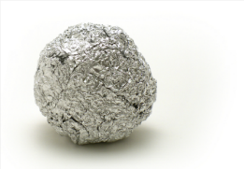
- A piece of radioactive rock shows a reading of 350 counts/min.
When covered in aluminium foil, this drops down to 4 counts/min.
Explain what type of radioactivity this rock could be emitting.

- Radioactive emissions are often described as ionising radiations. What does this mean?

- Smoke detectors use americium-241, which is an alpha emitter. Explain why an alpha
source is used in these detectors.

- Why is an alpha particle often described as a helium nuclei not helium atom?

9. Complete the nuclear equation for the beta decay of Carbon.

10. Uranium-235 undergoes an alpha decay to produce thorium-231. (Atomic number of
uranium is 92). Write the nuclear decay equation for this process.

11. When iodine-131 decays, there is no mass change in the nucleus and no new element is
formed. What type of radioactive emission is this?

12. Explain what is meant by the term “half-life”.

13. A radioactive sample reduces its count rate from 240 counts/min to 30 counts/min over
a period of 60 hours. What is its half-life?

14. Use the decay curve below to work out the half-life of the isotope.
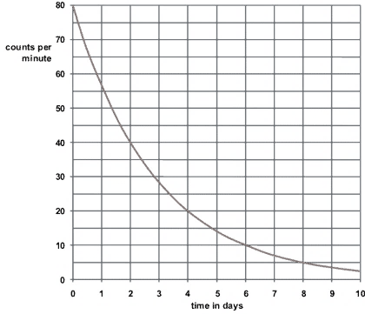

15. (Physics only) Calculate the net decline of the above isotope, expressed as a
ratio, during radioactive emission after 3 half- lives.

16. Explain the difference between radioactive irradiation and radioactive contamination.

17. Complete the table below to suggest one way of preventing exposure to
irradiation and contamination by radioactive materials.

Type of exposure | Method of preventing exposure
Irradiation
Contamination

