A. Photosynthesis
1. Write down the word equation for photosynthesis.
2. Copy and complete this table.
Name of molecule | Chemical Symbol
Water
Oxygen
Carbon dioxide
Glucose

3. Photosynthesis is affected by limiting factors.
What is meant by the term ‘limiting factor’?
4. Name the raw materials needed by a plant for photosynthesis?
5. Name the green pigment present in plant cells.
6. What is the role of this green pigment?
7. For the graphs below - identify what the limiting factor(s) might be in the experiments.
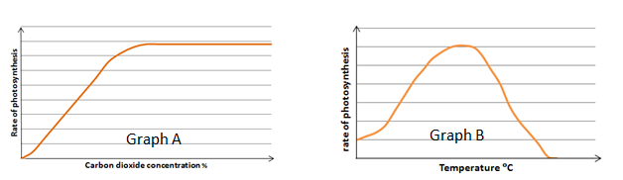
8. Sketch out Graph A and draw a line onto it showing what might occur if the experiment was repeated at a lower light intensity.
9. List three ways commercial farmers improve the environmental conditions to maximise photosynthesis and ensure they make a profit.
10. How is the glucose produced by photosynthesis used in plants?
Higher Tier Questions
HT 11. Calculate the light intensity for the following student data. Use the formula:
Distance (d) of lamp from pond weed (m) | 0.3 | 0.5
Light Intensity 1/d²

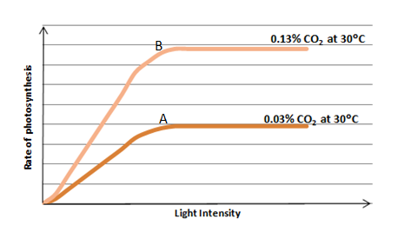
HT 12. a) What is the limiting factor at A?
b) What might the limiting factor(s) be at point B?

B. Respiration
- When does respiration occur in cells?
- Copy and complete the table below:
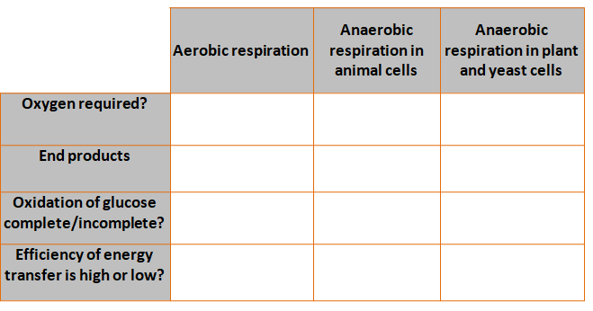

3. Name three processes that organisms require energy for.
4. What does the chemical formula C₆H₁₂O₆ represent?
5. Write down the word equation for aerobic respiration in a plant cell.
6. Write down the word equation for anaerobic respiration in a yeast cell.
7. Why is fermentation of economic importance?
8. Describe three ways in which the body responds to vigorous exercise in order to ensure sufficient oxygen reaches the muscle cells.
9. If exercise carries on for a long time, what happens to the muscles?
10. Why is respiration described as an endothermic reaction?

11. Copy and complete the table below:
Name of large molecule | Made from subunits of:
Carbohydrate
Lipid
Protein

12. What is the definition of metabolism?
Higher tier questions
HT 13. Describe the process for removing lactic acid from the body.
HT 14. What is meant by the term ‘oxygen debt’?

