W = m g |  | W = weight (N)  m = mass (kg)  g = gravitational field strength (N/kg)
m
g
W

weight = mass x gravitational field strength
W = F s |  | W = work done (J)  F = force (N)  s = distance (m)
F
s
W

Work done = force x distance (along the line of action of the force)
F = k e |  | F = force (N)  k = constant (N/m)  e = extension (m)
k
e
F

Force applied to a spring = spring constant x extension
s = v t |  | s = distance travelled (m)  v = speed (m/s)  t = time (s)
v
t
s

Distance travelled = speed x time
a =  ∆v  t |  | a = acceleration (m/s²)  ∆v = change in velocity (m/s)  t = time taken (s)
a
t
∆v

Acceleration = change in velocity
Time taken
F = m a |  | F = force (N)  m = mass (kg)  a = acceleration (m/s²)
m
a
F

Resultant force = mass x acceleration
p = m v |  | p = momentum (kg m/s)  m = mass (kg)  v = velocity (m/s)
m
v
p

Momentum = mass x velocity
Ek = ½ m v² |  | Ek = kinetic energy (J)  m = mass (kg)  v² = (speed) ² (m/s)
Ek

v²
m
½

Kinetic energy = 0.5 x mass x speed
Ep = m g h |  | Ep = gravitational potential energy (J)  m = mass (kg)  g = gravitational field strength (N/kg)  h = height (m)
h
g
m
Ep

Gravitational potential energy = mass x gravitational field strength x height
P = $\frac{E}{t}$ |  | P = power (kWh)  E = energy transferred (kw)  t = time (h)
P
t
E

Power = energy transferred
time
P = $\frac{W}{t}$ |  | P = power (W)  W = work done (J)  t = time (s)
P
t
E

Power = work done
time
Efficiency (%)
Total output energy transfer (J)
Total input energy transfer (J)

Efficiency = total output energy transfer
total input energy transfer
Efficiency (%)
Useful power output (J)
total power output (J)

Efficiency = useful power output
total power output
v = f  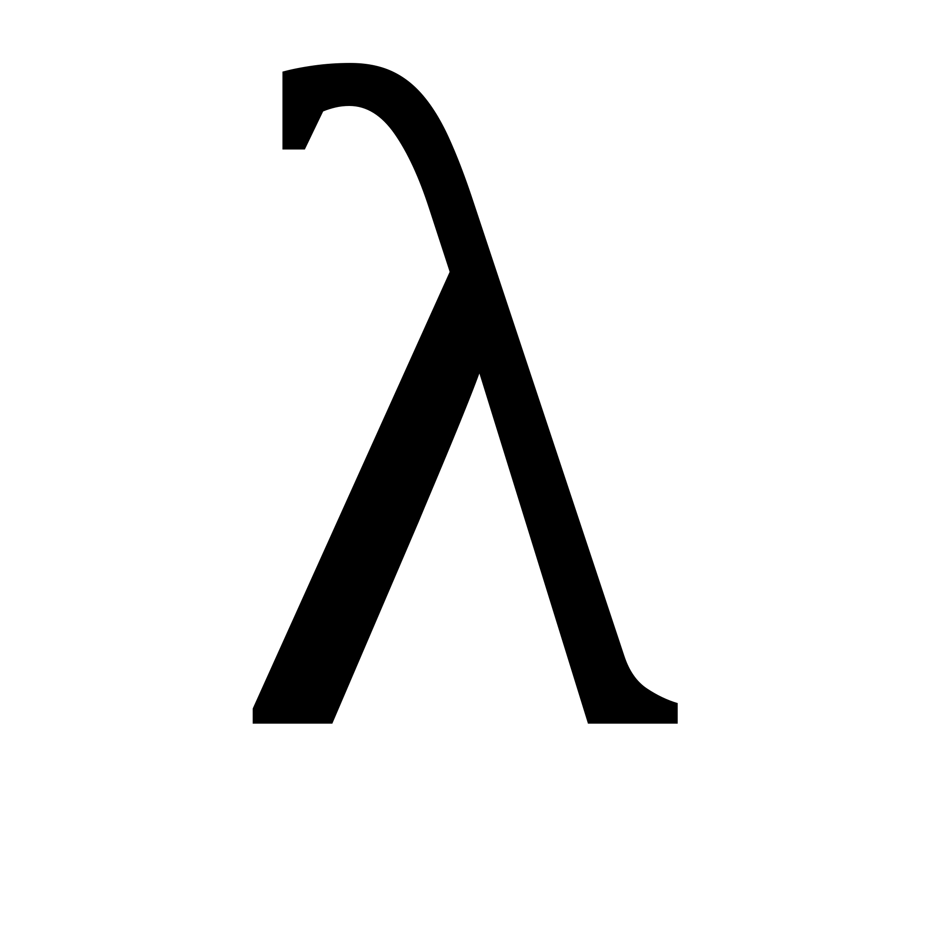 |  | v = wave speed (m/s)  f = frequency (hz)  = wavelength (m)
f
v

Wave speed = frequency x wavelength
Q = I t |  | Q = charge flow (C)  I = current (A)  t = time (s)
I
t
Q

Charge flow = current x time
V = I R |  | V = potential difference (v)  I = current (A)  R = resistance (Ω)
I
R
V

Potential difference = current x resistance
P = V I |  | P = power (W)  V = potential difference (V)  I = resistance (A)
V
I
P

Power = potential difference x current
P = I² R |  | P = power (W)  I² = potential difference (V)  R = resistance (A)
m
g
W

Power = (current)² x resistance
E = P t |  | E = energy transferred (kWh)  P = power (W)  t = time (h)
P
t
E

Energy transferred = power x time
E = Q V |  | E = energy transferred (J)  Q = charge flow (C)  V = potential difference (V)
m
g
W

Energy transferred = charge flow x potential difference
p = $\frac{m}{V}$ |  | p = density (kg/m³)  m = mass (kg)  V = volume (m³)
m
g
W

Density = mass
volume

