8.7.13f A question of colour

Name _____________________________ Class ____________

1 Write down the colour which is made when these lights overlap. Some colours are listed below to help you.

cyan magenta white yellow

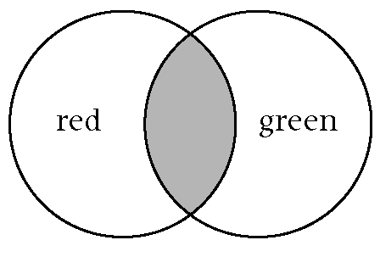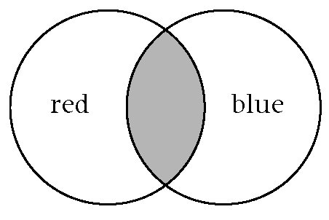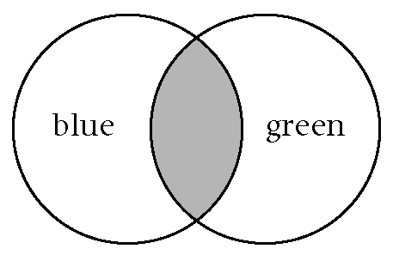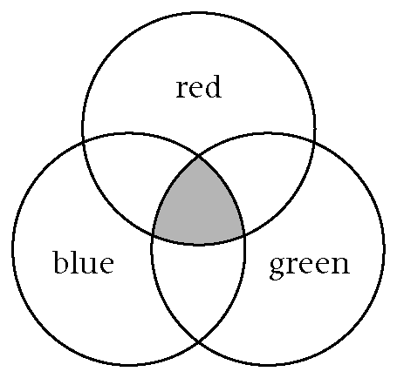

2 Fill in the gaps in these sentences and on the diagram. Use words from the box below.

The colours of the spectrum are red, _______________ , _______________ ,

_______________ , _______________ , _______________ and _______________ .

The colours of the rainbow are called a _______________ . Three of the colours in the

spectrum are primary colours. The primary colours are _______________ ,

_______________ and _______________ .

Two primary colours mixed together can make other colours which are called

_______________colours.
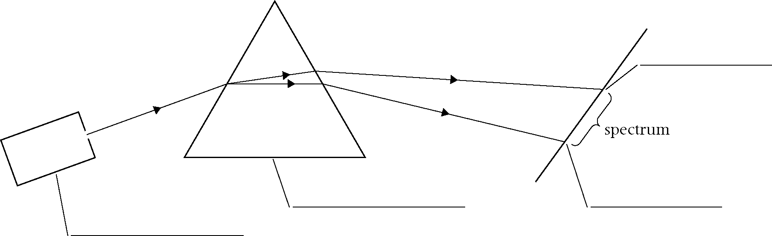

blue green indigo orange prism ray box red
secondary spectrum violet yellow

3 The colour of light which is refracted the most is _______________ .

