- Name the unit used to measure strength of nuclear radiation.
…………………………………………………………………………………………………………… 1 mark)

- Name the 3 types of nuclear radiation.
………………………………………………………………………………………………………… (3 marks)

- Inside a radiation badge there are sections with small sheets of copper, aluminium and lead, why is this?
…………………………………………………………………………………………………………………………….
…………………………………………………………………………………………………………………………………………………………………………………………………………………………………………. (1 mark)

- Explain why ionising radiation is dangerous.
…………………………………………………………………………………………………………………………………………………………………………………………………………………………………………………………………………………………………………………………………………………….. (2 marks)

- Explain what happens to gamma radiation in magnetic or electric field – draw if it helps.
…………………………………………………………………………………………………………………………………………………………………………………………………………………………………………………………………………………………………………………………………………………… (2 marks)

- What is meant by an isotope and what happens to unstable isotopes when they decay?
…………………………………………………………………………………………………………………………………………………………………………………………………………………………………………………………………………………………………………………………………………………………………………………………………………………………………………………………………………………………………………………………………………… (3 marks)
- What is meant by the ‘half-life’ of a radioactive sample?
…………………………………………………………………………………………………………………………………………………………………………………………………………………………………………………………………………………………………………………………………………………………………………………………………………………………………………………………………………………………………………………………………………… (2 marks)
- A radioactive sample of iodine-131 gives a count rate of 1200 counts per second. The Half-life of iodine-131 is 8 days. How many days will it take for the sample count rate to fall to 75 counts per second?
…………………………………………………………………………………………………………………………………………………………………………………………………………………………………………………………………………………………………………………………………………………………………………………………………………………………………………………………………………………………………………………………………………… (4 marks)

- What is the half-life of the radioactive sample shown in the graph below?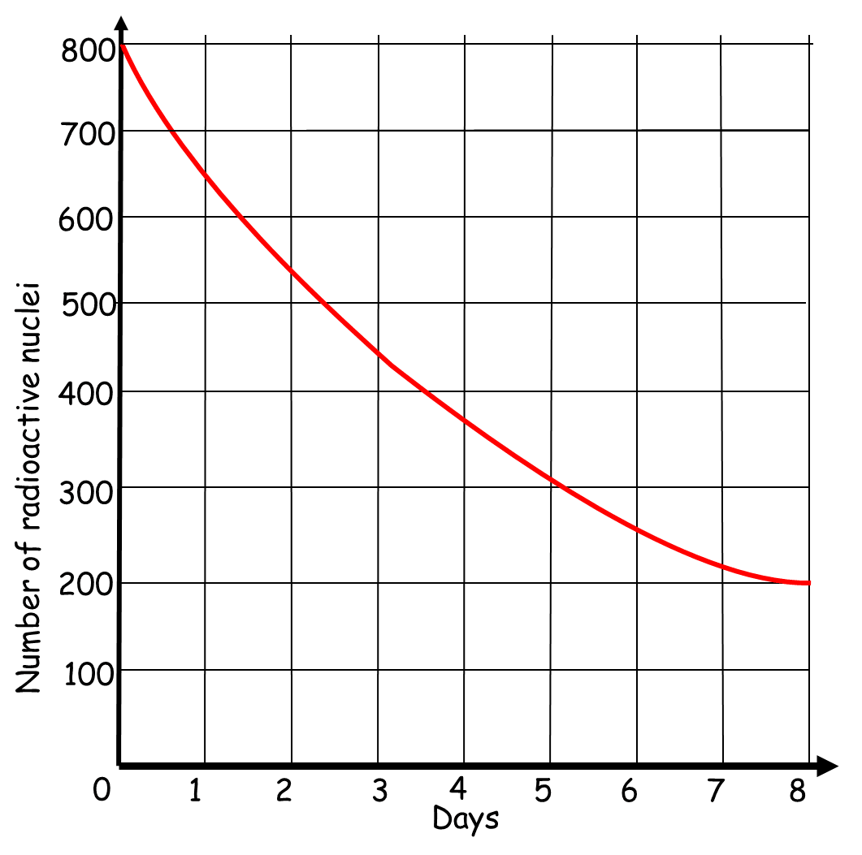 Half-life = ……………………………………………….. (2 marks)

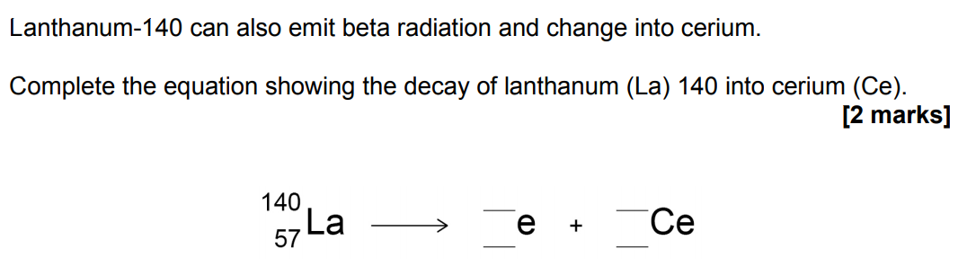

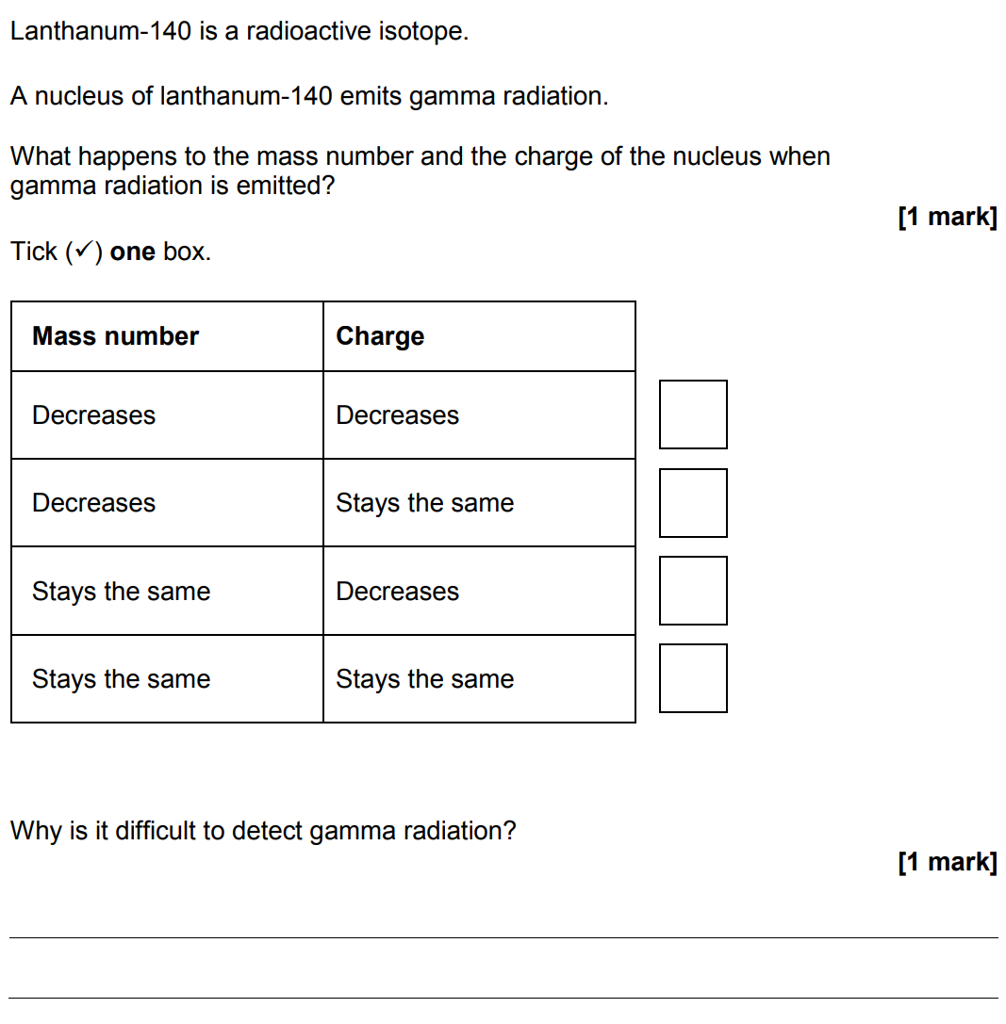

- Scientists sometimes replace one scientific model with a different model.
For example, in the early 20th Century the plum pudding model of the atom was replaced by the nuclear model of the atom.
Explain what led to the plum pudding model of the atom being replaced by the nuclear model of the atom.
……………………………………………………………………………………………………………
……………………………………………………………………………………………………………
……………………………………………………………………………………………………………
……………………………………………………………………………………………………………
……………………………………………………………………………………………………………
……………………………………………………………………………………………………………..
……………………………………………………………………………………………………………..
…………………………………………………………………………………………….. (6 marks)

