PiXL Independence:

GCSE Biology – Student Booklet

KS4

Topic: Cell biology

Contents:
- Level 1- Multiple Choice Quiz – 20 credits
- Level 2 - 5 questions, 5 sentences, 5 words – 10 credits each
- Level 3 - Science in The News – 100 credits
- Level 4 - Scientific Poster – 100 credits
- Level 5 - Video summaries – 50 credits each

PiXL Independence – Level 1
Multiple Choice Questions
GCSE Biology – Cell biology

INSTRUCTIONS Score: /20

- Read the question carefully.
- Circle the correct letter.
- Answer all questions.

1. | Which cell group does not possess a true nucleus?
 | a. | Prokaryotes
 | b. | Eukaryotes
 | c. | Plants
 | d. | Animals
2. | Which of the following is a eukaryote?
 | a. | Bacteria
 | b. | Virus
 | c. | Archaea
 | d. | Sperm
3. | Which of the following is found in all prokaryotic cells but only some eukaryotic cells?
 | a. | Cell membrane
 | b. | Cell wall
 | c. | Mitochondria
 | d. | Ribosome
4. | Where in the cell are proteins synthesised?
 | a. | Mitochondria
 | b. | Vacuole
 | c. | Ribosomes
 | d. | Nucleus
5. | Where do the majority of metabolic reactions take place?
 | a. | Cytoplasm
 | b. | Nucleus
 | c. | Cell membrane
 | d. | Ribosomes
6. | How do you calculate the magnification of a magnified object?
 | a. | Image size x actual size
 | b. | Image size ÷ actual size
 | c. | Actual size x image size
 | d. | Actual size ÷ image size

7. | Which of these cells contain spirals of lignin?
 | a. | Palisade cells
 | b. | Bacterial cells
 | c. | Yeast cells
 | d. | Xylem cells
8. | What are cells called if they are adapted to perform a certain job?
 | a. | Specific
 | b. | Functional
 | c. | Unique
 | d. | Specialised
9. | What are cells produced by mitosis called?
 | a. | Sister cells
 | b. | Daughter cells
 | c. | Haploid cells
 | d. | Zygotes
10. | How many cell divisions occur in mitosis?
 | a. | None
 | b. | 1
 | c. | 2
 | d. | 3
11. | A cell that has half the usual number of chromosomes is called what?
 | a. | Haploid
 | b. | Diploid
 | c. | Homozygous
 | d. | Heterozygous
12. | What is the name of the first stage of mitosis?
 | a. | Prophase
 | b. | Metaphase
 | c. | Anaphase
 | d. | Telophase
13. | What is the term for when a cell divides?
 | a. | Cytolysis
 | b. | Cytocrenation
 | c. | Cytodivision
 | d. | Cytokinesis
14. | Diffusion is the movement of particles from…
 | a. | a higher concentration to a lower concentration.
 | b. | a lower concentration to a higher concentration.
 | c. | a higher water potential to a lower water potential through a partially permeable membrane.
 | d. | a lower concentration to a higher concentration using ATP.

15. | Small circular pieces of DNA in a bacterial cell are called:
 | a. | Plasmids
 | b. | Loose DNA
 | c. | Ribosomes
 | d. | Enzymes
16. | Root hair cells are adapted to absorb water and mineral ions by…
 | a. | having no chloroplasts.
 | b. | being transparent.
 | c. | having a thick cell wall.
 | d. | having a large surface area.
17. | Respiration in the mitochondria requires which two chemicals?
 | a. | Glucose
 | b. | Carbon dioxide
 | c. | Water
 | d. | Oxygen
18. | Electron microscopes are able to distinguish between two points just a few nanometers apart. This is called…
 | a. | magnification
 | b. | resolution
 | c. | resolving power
 | d. | image size
19. | The food producer within the plant cell uses energy from the sun and converts carbon dioxide and water into sugars. This sub-cellular structure is called the…
 | a. | vacuole.
 | b. | mitochondria.
 | c. | chloroplast.
 | d. | nucleus.
20. | The thick rigid layer that surrounds plant cells and provides support and structure is called the…
 | a. | nucleus.
 | b. | mitochondria.
 | c. | cell wall.
 | d. | chloroplast.

PiXL Independence – Level 2
5 questions, 5 sentences, 5 words
GCSE Biology – Cell biology
INSTRUCTIONS

- For each statement, use either the suggested website or your own text book to write a 5-point summary. In examinations, answers frequently require more than 1 key word for the mark, so aim to include a few key words.
- It is important to stick to 5 sentences. It is the process of selecting the most relevant information and summarising it that will help you remember it.
- Write concisely and do not elaborate unnecessarily, it is harder to remember and revise facts from a long paragraph.
- Finally, identify 5 key words that you may have difficulty remembering and include a brief definition. You might like to include a clip art style picture to help you remember it.

Example:
QUESTION: | Describe the differences between prokaryotes and eukaryotes.
Sources: | Website – http://www.ivyroses.com/Biology/Cells/Prokaryotic-and-Eukaryotic-Cells.php  Interactive - https://www.my-gcsescience.com/aqa/biology/eukaryotic-and-prokaryotic-cells/
- All animal and plant cells are eukaryotic, which makes all plants and animals eukaryotes.
- Many eukaryotic cells belong to more complex organisms so often such organisms are made from more than one cell and so we call them multicellular.
- Plant and animal cells are eukaryotic. They can be unicellular or belong to multicellular organisms
- All bacterial cells are prokaryotic, which means that all bacteria are prokaryotes.
- Prokaryotes are single celled, do not have a nucleus containing their genetic material (DNA) and are smaller than eukaryotic cells.

Prokaryotic cells  Cells that do not contain a nucleus (bacterial cells). |  | Prokaryote  A prokaryotic organism (a bacterial cell). | Eukaryotic cells  Cells that contain a nucleus. | Eukaryote  An organism that is made of eukaryotic cells (those that contain a nucleus). | Multicellular  An organism made of many cells.

QUESTION 1: | Explain how the main sub-cellular structures, including the nucleus, cell membranes, mitochondria and chloroplasts in plant cells as well as plasmids in bacterial cells, are related to their functions.
Sources: | Website – https://www.khanacademy.org/test-prep/mcat/cells/eukaryotic-cells/a/organelles-article  Video - https://www.youtube.com/watch?v=JL19uv7NT7s

QUESTION 2: | Describe and explain how a sperm cell is adapted for its function.
Sources: | Website – http://slideplayer.com/slide/6031489/  Video - https://www.youtube.com/watch?v=7z6W2xv4upc

QUESTION 3: | Explain the importance of cell differentiation.
Sources: | Website – http://www.bbc.co.uk/schools/gcsebitesize/science/add_ocr_gateway/living_growing/growthdevrev5.shtml  Interactive - https://www.youtube.com/watch?v=9db44fBrWrE

QUESTION 4: | Compare and contrast an electron microscope with a light microscope.
Sources: | Website – http://www.biologyexams4u.com/2012/10/difference-between-light-microscope-and.html#.WeOLXGhSzIU  Video - https://www.youtube.com/watch?v=b4WOsYktdn4

QUESTION 5: | Describe the cell cycle including the stages of mitosis.
Sources: | Website – http://www.biology.arizona.edu/cell_bio/tutorials/cell_cycle/cells3.html  Interactive - http://www.sumanasinc.com/webcontent/animations/content/mitosis.html

PiXL Independence – Level 3
Science in the News
GCSE Biology – Cell biology
Fake news
Sensationalised news stories have been around for some time, but with the mass growth of social media, the problem seems to have grown in recent years. At the very least, the US Presidential election has certainly highlighted the impact that misleading information can have. www.tiny.cc/fakenews2

At home, the Brexit vote also suffered from the circulation of misleading news stories. www.tiny.cc/fakenews3

Therefore, the ability to identify real information, track it back to the source article and make your own judgement is a very important skill. This activity will help you develop that skill.

Can we drink too much water?
News article: http://news.bbc.co.uk/1/hi/england/bradford/7779079.stm
NHS article: http://www.nhs.uk/conditions/dehydration/pages/introduction.aspx
Discussion article: http://www.nbcnews.com/id/16614865/ns/us_news-life/t/woman-dies-after-water-drinking-contest/#.WeNOd2hSzIU
Real article: http://purchon.com/biology/?page_id=173
Task 1:
You need to produce a 1 page essay on water and the effects of drinking too much or too little.

Essay section | Activity
Introduction | Discuss why water is essential to our body and where we get water from.
Describe | Describe what osmosis is and the factors that can affect how your cells absorb water.
Explore | Explain the effects of drinking too much water. Discuss the implications of water intoxication.  Explain the effects of not drinking enough water. Discuss the implications of dehydration.
Evaluate | “Everyone should drink two litres of water a day.”  Evaluate this statement.

Sports drinks- vital for hydration or just a waste of money?
News article: https://www.theguardian.com/lifeandstyle/2009/jul/27/sports-drinks
NHS article: https://www.nhs.uk/news/food-and-diet/sugar-and-water-as-good-as-a-sports-drink-says-study/
Discussion article: http://www.mensfitness.com/nutrition/what-to-drink/sports-drinks-vs-water
Real article: https://www.webmd.com/fitness-exercise/features/drink-up-sports-fitness#1

Task 2:
You need to produce a 1 page essay on the advantages and disadvantages of drinking sports drinks.

Essay section | Activity
Introduction | Describe what sports drinks are and why people drink them.
Describe | Describe the advantages of drinking sports drinks during or after exercise and explain why people drink them in these situations.
Explore | Describe the disadvantages of drinking sports drinks.
Evaluate | Explain your opinion of sports drinks and justify your reasons.

PiXL Independence – Level 4
Scientific Posters
GCSE Biology – Cell biology

INSTRUCTIONS

Scientific Posters
Scientists communicate research findings in three main ways. Primarily, they write journal articles much like an experiment write up. These are very concise, appraise the current literature on the problem and present findings. Scientists then share findings at conferences through talks and scientific posters. During a science degree, you would practise all three of these skills.

Scientific posters are a fine balance between being graphically interesting and attracting attention and sharing just the right amount of text to convey a detailed scientific message. They are more detailed than a talk and less detailed than a research paper.
Use this information to help structure your poster – www.tiny.cc/posterskills (that’s Poster Skills not Posters Kill!) More detailed guidance is available at: www.tiny.cc/posterskills2

Creating your poster
It is easiest to create a poster in PowerPoint; however, you need to add custom text boxes rather than using the standard templates.
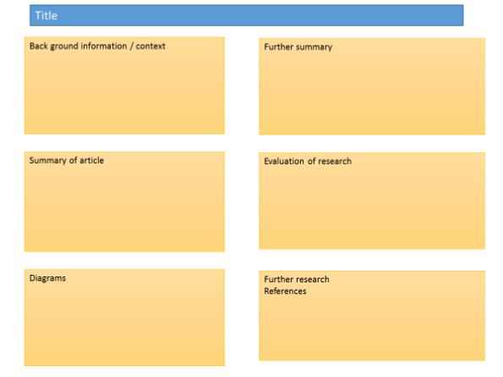
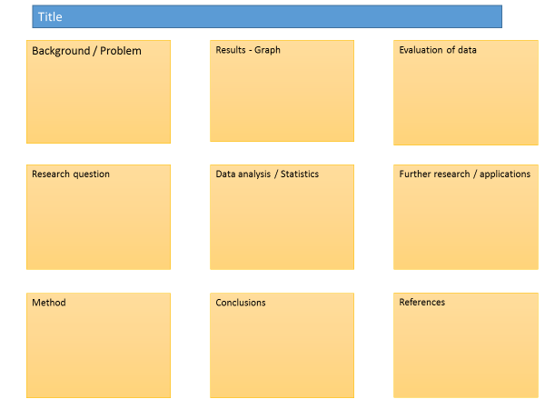

Posters need to be eye catching, but readable from a distance. If you use PowerPoint, start with a 4:3 slide (for easier printing, it can then be printed on A3) and use a 14-16 pt font. The first box could be larger to draw people in. You can use a background image, but pick a simple one that is of high quality. Select ‘text box fill’ and select ‘change the transparency’ to maintain the contrast and partially show the picture.

You can experiment with different layouts and you should include images. Avoid a chaotic layout. Posters are read from top left column downwards.

Remember to include the authors and references.
Finally, look at the examples given on the University of Texas website which also offers an evaluation of each. www.tinyurl.com/postereg

Cells types.

Background

All living things are made up of cells. The structures of different types of cells are related to their functions. Eukaryotic cells have features in common, such as a nucleus, cytoplasm, cell membrane, mitochondria and ribosomes. Plant and algal cells also have a cell wall, and often have chloroplasts and a permanent vacuole. Prokaryotic cells have different structures to animal and plant cells.

Source articles:
http://www.bbc.co.uk/schools/gcsebitesize/science/add_edexcel/cells/cells2.shtml
https://www.ck12.org/biology/prokaryotic-and-eukaryotic-cells/lesson/Prokaryotic-and-Eukaryotic-Cells-BIO/
https://www.cliffsnotes.com/study-guides/biology/biology/the-biology-of-cells/prokaryote-and-eukaryote-cell-structure
https://www.ck12.org/book/CK-12-Biology-Advanced-Concepts/section/11.13/

Use other sources as necessary.
https://www.youtube.com/watch?v=fLThq5t4Ku0

Task:
Produce a scientific poster on the differences between prokaryotes and eukaryotes.

Recall | State what eukaryote and prokaryote mean.
Describe | Describe the functions of the organelles within a prokaryote and a eukaryote.
Compare | Compare the different types of prokaryotes and eukaryotes and how they are specialised for their function.
Evaluate | Explain how prokaryotes can be used in industry.

PiXL Independence – Level 5
Video summaries
GCSE Biology – Cell biology

Cornell Notes
At A level and University, you will make large amounts of notes, but those notes are only of use if you record them in a sensible way. One system for recording notes is known as the Cornell notes system. This method encourages you to select relevant information, rather than trying to write a transcript of everything said. More importantly, it forces you to spend a few minutes reviewing what you have written, which has been scientifically proven to aid learning and memory retention.
The ideal is to write everything on one page, but some students may prefer to type and others will handwrite their notes. Whichever option you use, remember the aim is to summarise and condense the content with a focus on the objectives that you are trying to learn and understand.

There are three main sections to the Cornell notes:
- Cue/ Objectives – This can be done before or after the lecture. You may have been provided with the objectives or you may need to decide what they were. You may want to make the link to your learning if this is an additional task or lecture you are viewing, such as this video.
- Notes – In this space you record concisely, simply the things you are LESS likely remember - The NEW knowledge.
- Summary – The most important step that is carried out after the lecture or video. This helps to reinforce learning.

Background
The following short videos present two topics that link to your learning. The first video is where Hank describes mitosis and cytokinesis - the series of processes our cells go through to divide into two identical copies. The second video is a by Susan Soloman who describes stem cells as "our bodies' own repair kits." She advocates research using lab-grown stem cells. By growing individual pluripotent stem cell lines, her team creates testbeds that could accelerate research into curing diseases - and perhaps lead to individualised treatment, targeted not just to a particular disease but a particular person based on their genetics.
Source articles:
Video 1 – Mitosis- splitting up is complicated.
Crash course biology: https://www.youtube.com/watch?v=L0k-enzoeOM
Video 2 – The promise of research with stem cells. Crash course biology: https://www.ted.com/talks/susan_solomon_the_promise_of_research_with_stem_cells

Task:

You need to produce a set of Cornell notes for the videos given above.
Use the following objective to guide your note taking, this links to your learning.

- Explain what mitosis is and why it is important.
- Explain what stem cells are and discuss the impact that the use of stem cells could have on the future of medical treatments.

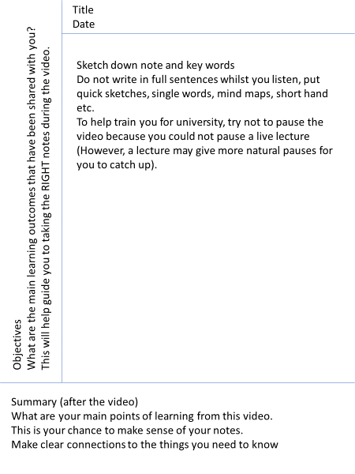

Objectives: | Title:  Date:
Summary:

Objectives: | Title:  Date:
Summary:

Commissioned by The PiXL Club Ltd.

This resource is strictly for the use of member schools for as long as they remain members of The PiXL Club. It may not be copied, sold, or transferred to a third party or used by the school after membership ceases. Until such time it may be freely used within the member school.

All opinions and contributions are those of the authors. The contents of this resource are not connected with, or endorsed by, any other company, organisation or institution.

PiXL Club Ltd endeavour to trace and contact copyright owners. If there are any inadvertent omissions or errors in the acknowledgements or usage, this is unintended and PiXL will remedy these on written notification.

